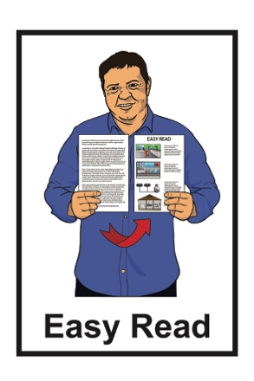

Cabinet paper summary:

Designing a redress system for people abused in care
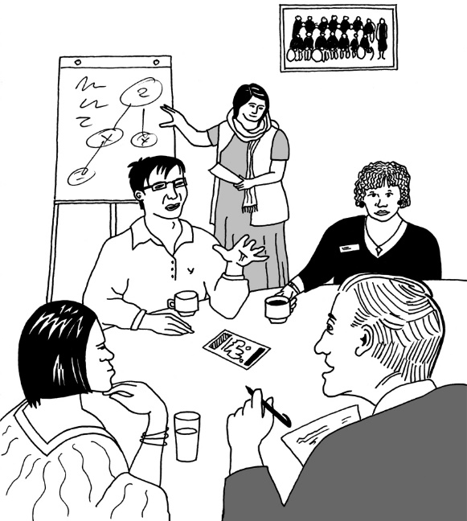
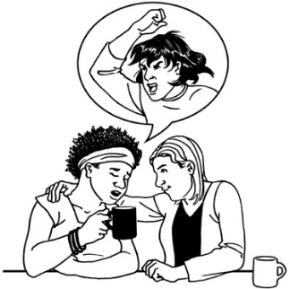

February 2023
What is this document about?

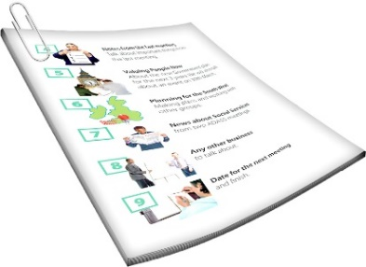
This document is an Easy Read summary of a cabinet paper.

A summary is a shorter form of a document that tells you the most important ideas.

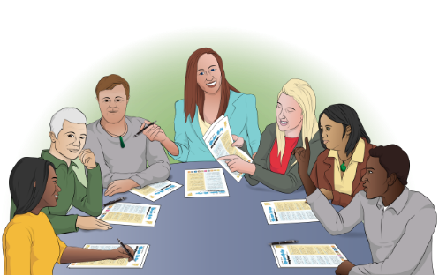
A cabinet paper has information in it that Cabinet needs to:
- know
- make a decision about.

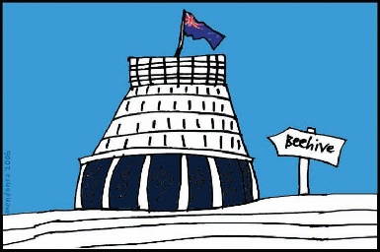
Cabinet is a group of people called ministers who work in Government.

These ministers meet to make important political decisions.

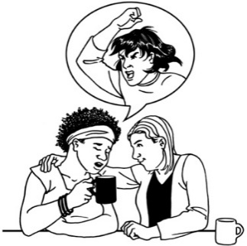
This cabinet paper is about making a redress system for people who were abused in care.

We will explain what these words mean in pages 4 to 6 of this document.

This cabinet paper is from Chris Hipkins who was the Minister for the Public Service when it was written.

Andrew Little is now the Minister for the Public Service.

You can see the full version of the cabinet paper at:
www.abuseinquiryresponse.govt.nz/documents
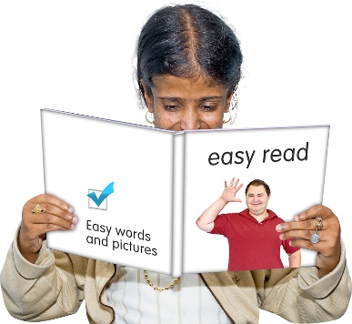

The cabinet paper is not in Easy Read.

What is a redress system?

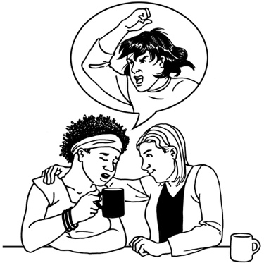
Redress means someone:

- agrees that something bad has happened

- does something to try to:
- put things right

- make up for any harm that has been done.

Redress can be things like:
- saying sorry
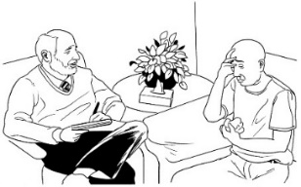
- giving money as a way of saying sorry
- giving other kinds of support like counselling.
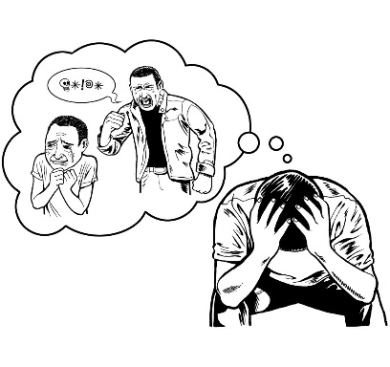
The redress system this paper is about is for people who were abused while living in care.

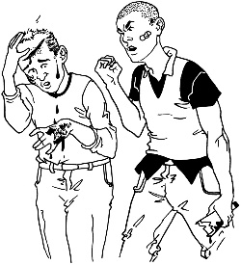
Abuse can be:

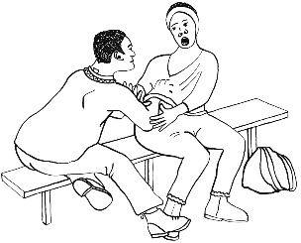
- physical like a person kicking / hitting you

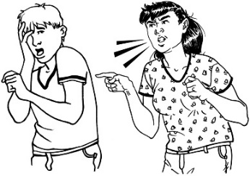
- sexual like if someone does sexual things to you that you do not want them to

- emotional like yelling or saying things to you that are not nice
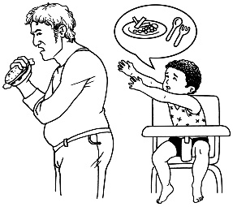
- neglect like not giving you the things / care you need.

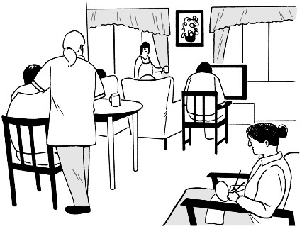
Living in care means that the Government or a faith-based institution was in charge of your care / looking after you.

Faith-based institutions are run by religious groups like churches.

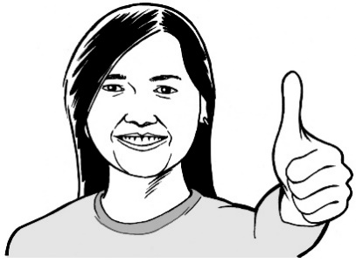
Cabinet has already said yes to making a new redress system that is:

- independent

- focused on survivors.
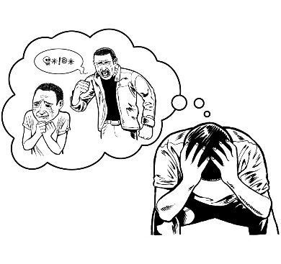

In this document survivors are people who have survived being abused.

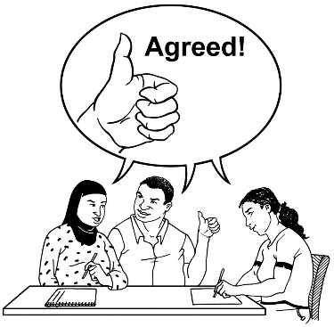
Cabinet has also said yes to some projects to make the way redress happens now better for survivors.

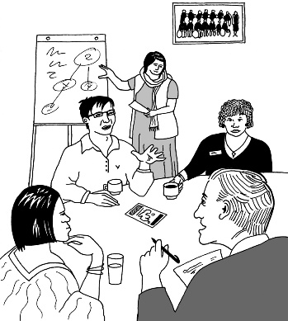
It is important to work out the best way for the new redress system to work.

The Royal Commission and Crown Response

The Royal Commission of Inquiry into Abuse in Care is looking into abuse that happened to people in care.

The Royal Commission of Inquiry into Abuse in Care is also called the Commission.

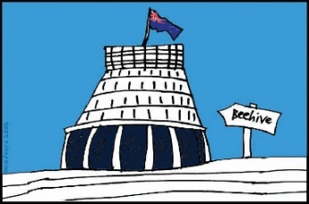
The Commission is not part of the Government.

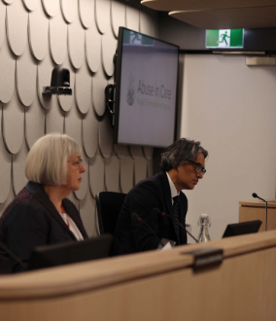
The Government cannot tell the Commission what to do.

The Commission is not part of any faith-based organisations like churches.

The Crown Response to the Royal Commission of Inquiry into Abuse in Care is sometimes called the:
- Crown Response
- CRU.

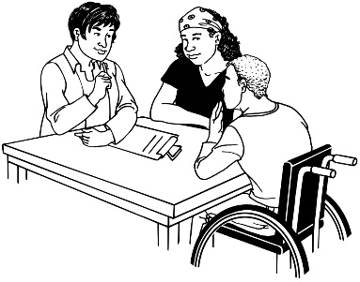
The CRU is a group of government officials that looks after the:

- communication between the Government and the Commission
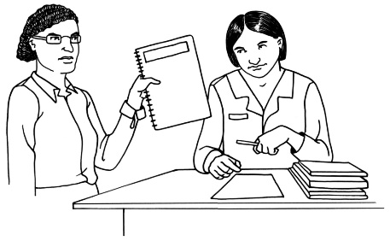
- Government response to what the Commission finds out.

The response is what the Government will do because of what the Commission finds out.

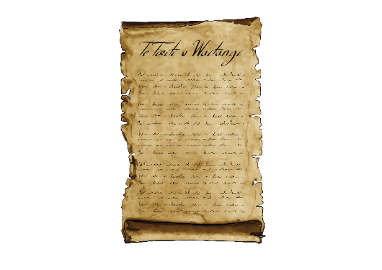
The Crown Response needs to do more work to make it clear:
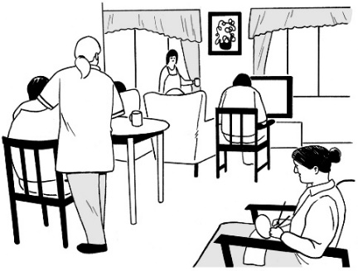
- how the Treaty of Waitangi is important to the redress system
- what the redress system will do to stop harm to people who are in care now.

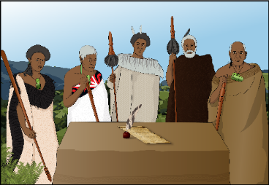
The Treaty of Waitangi / Te Tiriti o Waitangi is a legal document that was signed in 1840.
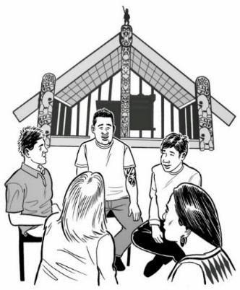

The Treaty / Te Tiriti is important to New Zealand.

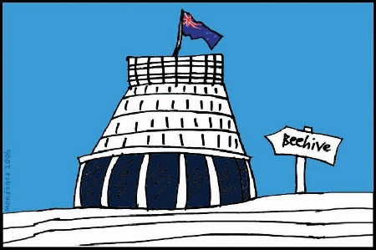
The Treaty of Waitangi is about Māori and the New Zealand Government:
- making decisions together
- protecting things that are important to Māori.

The following 3 sections on pages
11 to 22 of this document are a summary of things Chris Hipkins said should happen to make sure the new redress system works well.

The design group

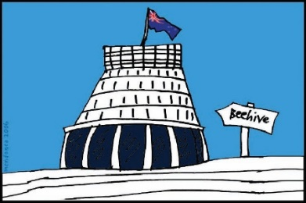
There should be a design group to come up with a new redress system.

The Crown Response will give the design group some ideas to get started.
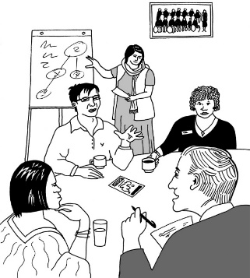

The design group will then make its own recommendations.

Recommendations are things that should be done to make things better for people.

Ministers will then make final decisions based on what the design group recommends.

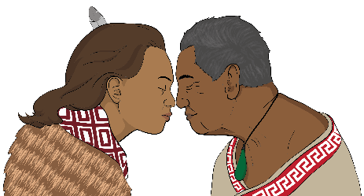
The design group should have:

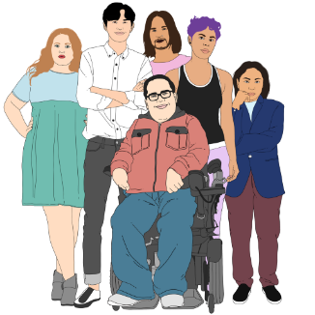
- 10 people
- strong Māori leadership
- people of different genders
- people who are survivors
- people who are experts.

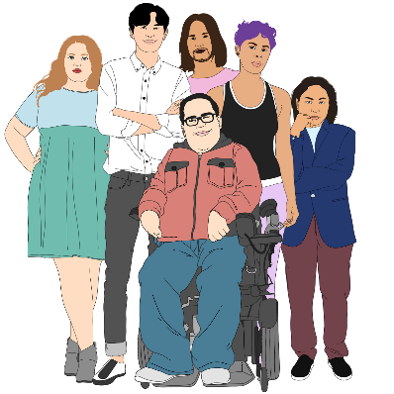
Gender is if you are:
- a man
- a woman
- another gender like nonbinary.
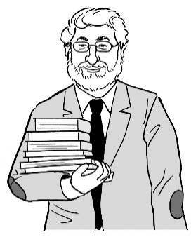

Experts are people who know a lot about something.

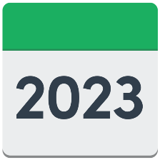
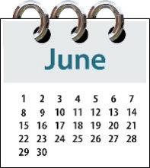
The design group will make a high-level proposal by June 2023 for how the redress system should work.

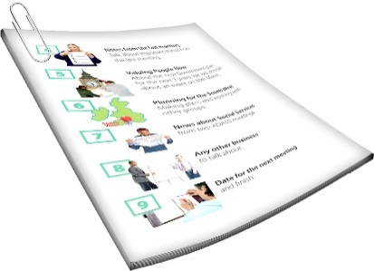
A high-level proposal is a document that:
- says the important things about how things will work
- does not include all the details or smaller things about how it will work.

The high-level proposal will include:
- what the design group thinks about the ideas the new system is based on
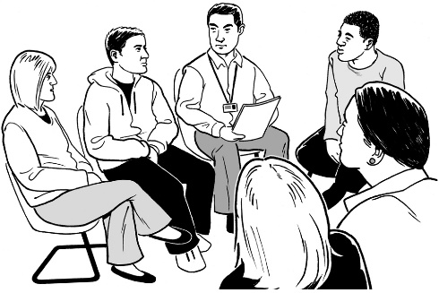
- what the design group thinks about what is included in the redress system
- how the system can safely support survivors to get redress

- what types of services / support are included
- what the design group think of some of the work by the Crown Response towards making this new redress system
- what important things need to be thought about in the next part of planning.

The advisory group

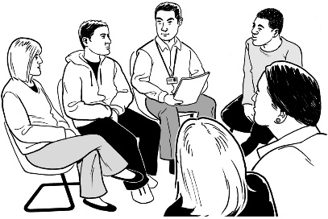

There should be an advisory group to support the design group.

This is because different groups of survivors have their own views about what should be included in the new redress system.

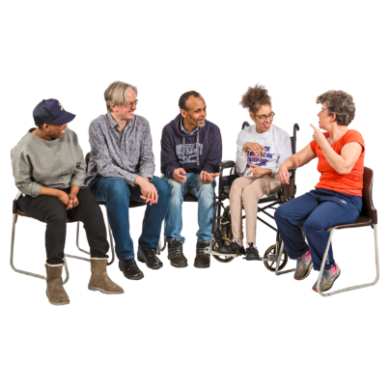
The advisory group will:
- have 20 people
- give advice to the design group.

The advisory group should include people who are:

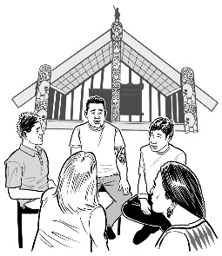
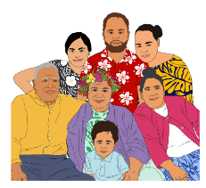
- of different genders
- Māori
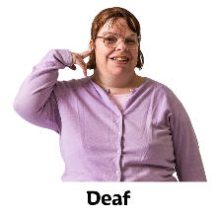
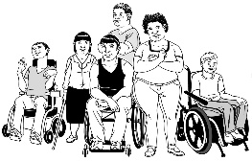
- Pasifika
- disabled
- Deaf
- rangatahi / young people
- LGBTTQIA+
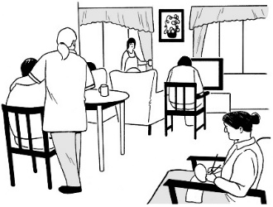
It should also include people who were abused in:
- state care
- faith-based care.
LGBTTQIA+ stands for people who are:

- lesbian

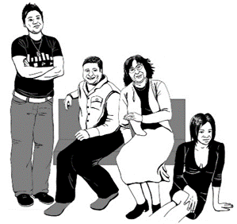
- gay

- bisexual

- transgender
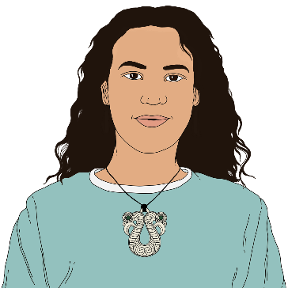
- takatāpui

- queer
- questioning which means not sure what words fit them best

- intersex
- asexual

- plus other people who fit in similar groups.
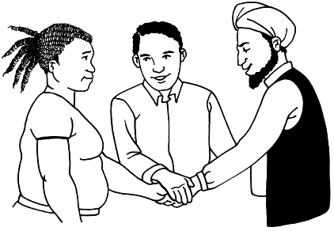
The people who are part of the advisory group should be able to work together in smaller groups.

People for the advisory group can be nominated from anywhere in New Zealand.

Being nominated means someone says you would be a good person to have in the group.

Cabinet paper recommendations

The cabinet paper recommendations are things that I (Chris Hipkins) think should happen.

My recommendations are to the Cabinet Social Wellbeing Committee.

The Cabinet Social Wellbeing Committee thinks about plans to make sure everyone has a good standard of living.

It is also called the SWC.

Standard of living means things like:
- having enough money for good food
- having a safe place to live.

I recommend that the SWC agree that the new redress system should include:
- people who have been in care not run by the state
- people who are experiencing abuse now
- people who might experience abuse later.

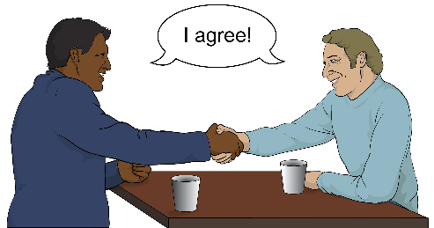
I recommend that the SWC:
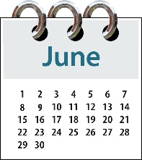
- agree with what I have suggested about the design group
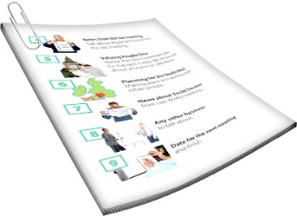
- agree that the design group should make proposals by June 2023
- agree that the Crown Response will draft the terms of reference for the design group
- agree to a way of choosing who will be in the:
  - design group
  - advisory group.

To draft something means to write the first version of it.

The terms of reference mean the things that will be included in what the group looks at.

I would like the SWC to agree the CRU does more thinking to tell me about:
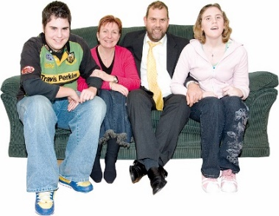
- what kinds of abuse should be covered by the redress system
- if the new system should include whānau of survivors.

I also recommend the SWC agree that I will choose the Chairperson of the groups.

I will discuss my choice with the Minister for Māori Crown Relations.

This information has been written by the New Zealand Government.

It has been translated into Easy Read by the Make it Easy Kia Māmā Mai service of People First New Zealand Ngā Tāngata Tuatahi.
The ideas in this document are not the ideas of People First New Zealand Ngā Tāngata Tuatahi.
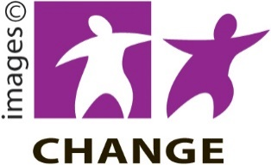
Make it Easy uses images from:

- Changepeople.org

- Photosymbols.com

- SGC Image Works

- Huriana Kopeke-Te Aho.

All images used in this Easy Read document are subject to copyright rules and cannot be used without permission.

