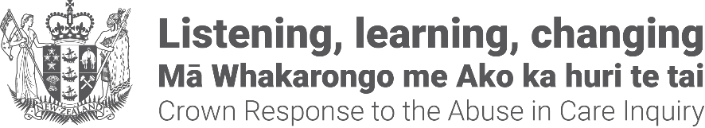

How the Government is helping and listening to the Abuse in Care Royal Commission of Inquiry

Note: Large Print produced by Blind Citizens NZ. Logo at the top right of the page is the Crown Response to the Abuse in Care Inquiry.

About the Crown Response Unit
The Crown Response Unit makes sure all the different parts of government work together to help the Abuse in Care Royal Commission of Inquiry.
The Crown Response Unit is a part of the government that looks after the:
- communication between the Government and the Royal Commission
- Government listening to what the Royal Commission finds out and making changes to make things better for people who were in care.

About the Abuse in Care Royal Commission of Inquiry
The Royal Commission is a special group of people who is finding out:
- what happened;
- why it happened;
- ways to make sure it does not happen again.

The Royal Commission is not part of:
- the Government;
- faith based places like churches.

The Government cannot tell the Royal Commission what to do.
The Royal Commission was set up because a lot of people are angry about abuse that happened to people being cared for in places run by:
- the government;
- churches.

Abuse is when people are:
- not been treated well;
- hurt by others.

The abuse happened to:
- children;
- vulnerable adults.

A vulnerable adult is a person who needed:
- more care than other people;
- support to stay safe.

People are angry because they feel little has been done to:
- talk about the abuse;
- make sure that abuse like this does not happen again;
- look after the survivors of the abuse.

Survivors are people who have had abuse happen to them.
Many of the survivors are:
- Māori people;
- Pacific people;
- Deaf and disabled people.
The Royal Commission started in 2018.
The Royal Commission will give the Government its last report in March 2024.

What the Royal Commission has said about redress
The Royal Commission has found that many survivors have found it very hard to get redress. Redress means making things right for people who have been abused in care.
In December 2021, the Royal Commission gave the Government its report on redress.
The report is about how to make things right for people if they were abused in care.
Making things right can include lots of different things like:
- being told sorry;
- being given money;
- being given help to make life better.

The Royal Commission said there needs to be a new redress system to help survivors.

A redress system is a place survivors can go to have things made right. The Royal Commission said the new redress system cannot be run by the places run by the government and churches where the abuse happened.
The new redress system will take time to make.
The Royal Commission has said the Government needs to work on four other things:
- setting up a service so survivors can talk about the abuse that happened to them;
- making it easier for survivors to get the records about their time in care. Records are files and papers that were made about children and vulnerable adults when they were in care;
- making fast payments to very sick or old survivors;
- a public apology to survivors. The public apology is the Government saying sorry to everyone who was abused.

The Government’s response
The Crown Response Unit was set up to make sure the different parts of government work together to:
- give the Royal Commission any information it asks for;
- answer any questions the Royal Commission has;
- listen to what the Royal Commission says to make it better for survivors;
- listen to what the Royal Commission says to make sure abuse does not happen again.

Following the report on redress by the Royal Commission the Crown Response Unit is working to:
- Set up the new redress system to make things better for survivors
- Make it easier for survivors to get their records. Records are files and papers that were made about children and vulnerable adults when they were in care.
- Set up the service so survivors can talk about the abuse that happened to them.
- Get ready for the public apology. The public apology will be made in 2024 after the Royal Commission has given the Government its last report.

The government has set up groups of survivors to make plans for how the new redress system is:
- easy for people to find;
- safe for survivors to use;
- can help survivors in the best ways.

Other parts of the government have done work so very sick or old survivors can have faster payments.

End of information: How the Government is helping and listening to the Abuse in Care Royal Commission of Inquiry

