A research report about Māori in state care from 1950 to 1999
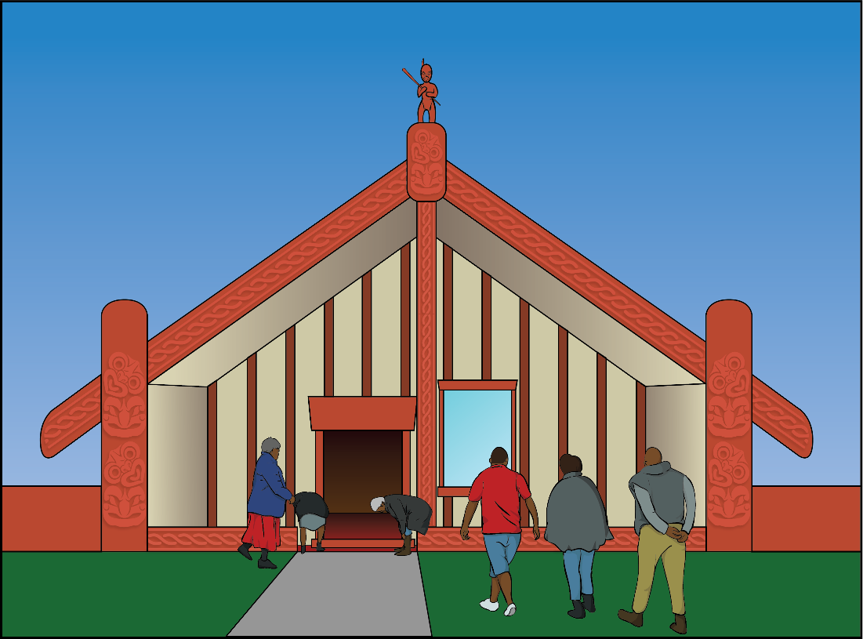

Published in Easy Read:
December 2021
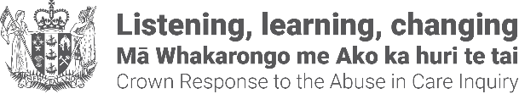
What is in this document?

Page number:

Before you read this.…………………..3

What this document is about……........5

What the research looked at…….……8
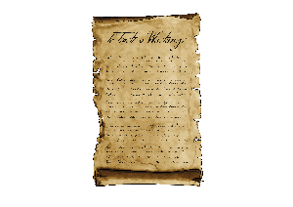

How the research was done.……......10

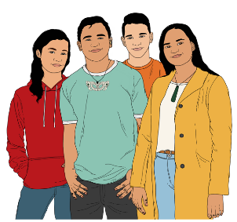
Māori and colonisation.......................15

Māori in state care…………..….........20

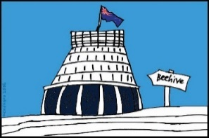
Institutional racism…………..….........28
Page number:

Changes that did not work………......31
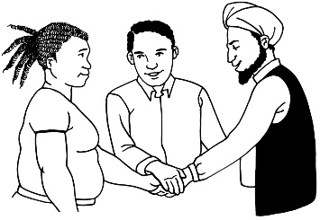

What should happen next..................36

Where to find more information……..37

Before you read this

This is a long document.

While it is written in Easy Read it can be hard for some people to read a document this long.

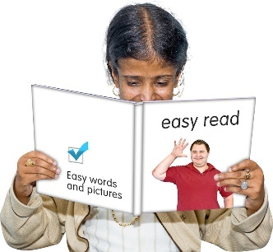
Some things you can do to make it easier are:

- read a few pages at a time
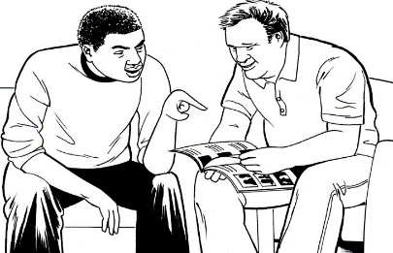
- have someone help you to understand it.

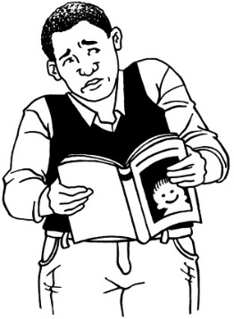
Some of the information in this document may upset people when they are reading it.

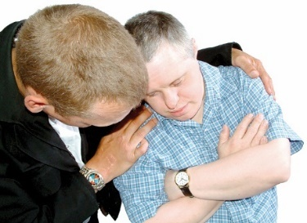
This information is not meant to scare or upset anyone.

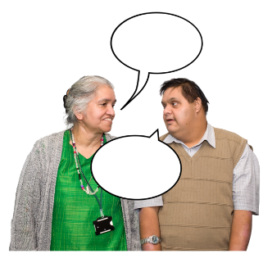
If you are worried or concerned after reading this document you can talk about it with:

- your whānau / family
- your friends
- your support workers.

What this document is about

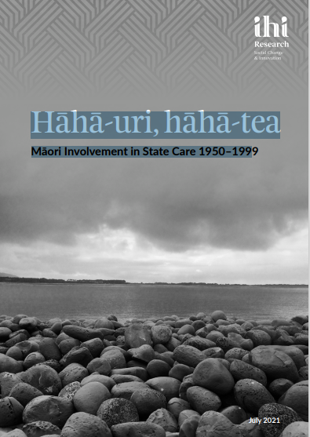
This document is a summary of a research report called:

Hāhā-uri, hāhā-tea:
Māori Involvement in State Care 1950–1999.

A summary:

- is shorter than the full report
- tells you the main ideas.

Research is about looking at
something closely to get a better
understanding of it.

The research report was written by Ihi Research.

Ihi Research is a group of researchers in Christchurch.
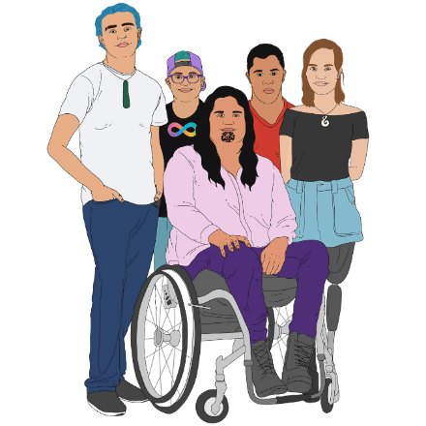

The Crown Response to the Abuse in Care Inquiry asked Ihi Research to look into the over-representation of Māori in state care.

The Crown Response to the Abuse in Care Inquiry is a group of government officials that:
- give information from government to the Royal Commission of Inquiry into Abuse in Care
- is the government contact for the Royal Commission of Inquiry into Abuse in Care.
The Royal Commission of Inquiry into Abuse in Care is looking into abuse that happened to people in care.

Being in care means that the government or a faith-based institution were in charge of the care.

Faith-based institutions are run by religious groups like churches.

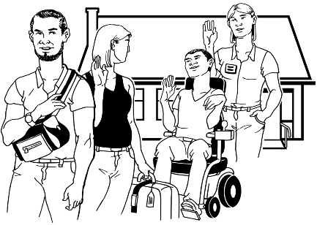
Over-representation means that there are a lot more of 1 group of people than there should be in things like state care.

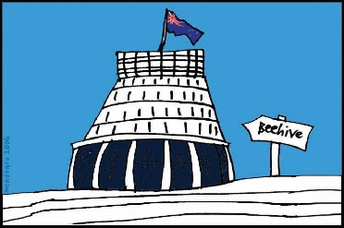
State care is when a child is placed in care that is managed by the government.

What the research looked at

1950
1990
The research looked at Māori in state care from 1950 to 1990.

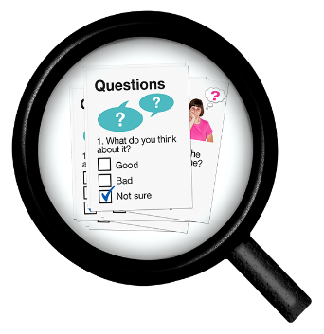
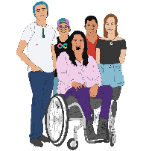
The research was done from a Māori-centred perspective.

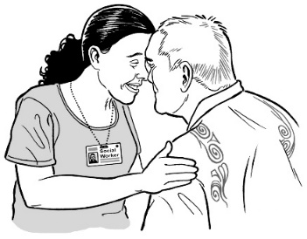
A Māori-centred perspective means that the research:
- had Māori be a part of it
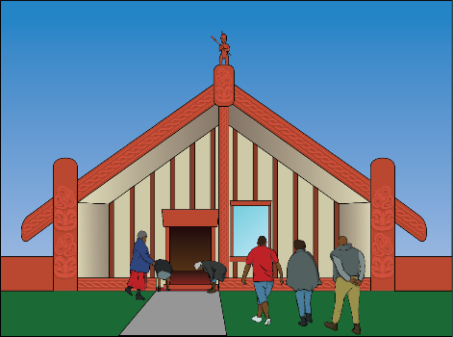
- followed Māori ways of doing research

- put Māori at the centre of the research.

The research looked at things like:

- why Māori are over-represented in state care
- how being in state care has harmed Māori

- what has been done to change Māori being over-represented in state care.
How the research was done

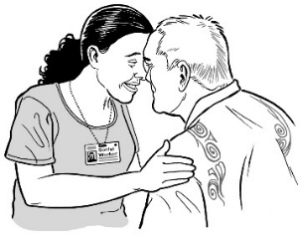
To do the research Ihi Research got information about Māori in state care from:
- Archives New Zealand
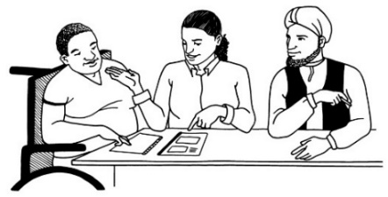
- Māori public servants
- non-Maori public servants
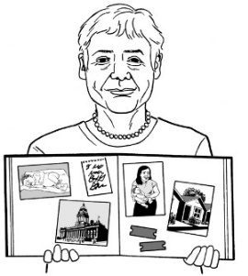
- stories from people who have lived in state care.

Archives New Zealand is a place that stores important government information like:

- written documents

- photos

- videos.
Public servants are people who work for the government.

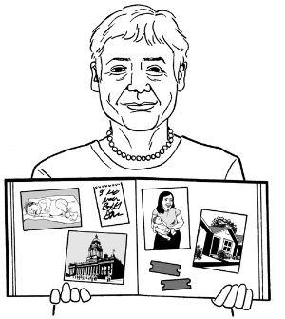
The stories from people who lived in state care that Ihi Research looked at were:
- already written
- not the same stories used by the Royal Commission.
Ihi Research found it was hard to collect information because many records:
- had missing information
- did not match the information on other records
- did not record the ethnicity of people.
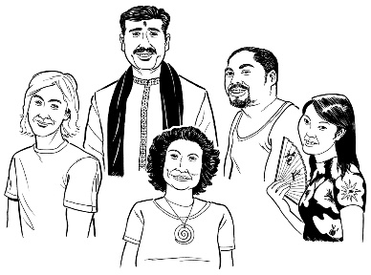
Ethnicity is groups of people who share the same culture:
- Māori
- Pacifica
- Asian.

Ihi Research also found it was hard to collect information because many records:
- recorded the wrong ethnicity of people
- have been lost.

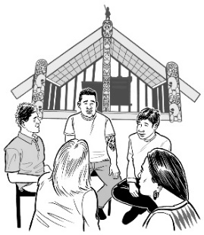
Ihi Research also found that the information about Māori:

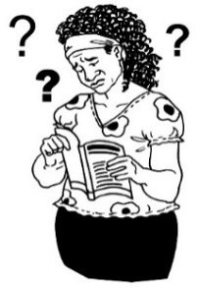
- was not very well recorded
- was written in racist ways.

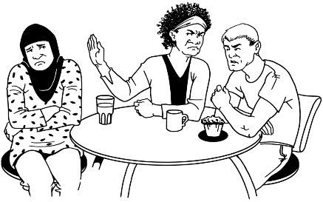
Racist is when someone is treated unfairly because of their skin colour or their culture.

Ihi Research also found that:
- criminal records of Māori had been well collected
- welfare records of Māori had not been well collected.

Criminal records have information about any crimes that a person has been found guilty of in a court.

A crime is when you do something that is against the law like stealing.
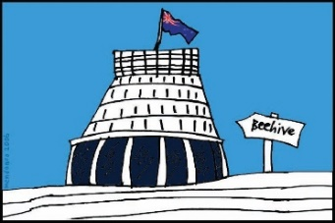
Welfare means government agencies like child protection services.
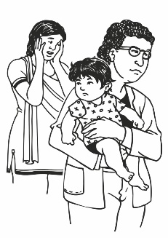

Welfare records have information about people going into care.

Ihi Research thinks this means that the government could have collected better information about Māori but they chose not to.

Māori and colonisation
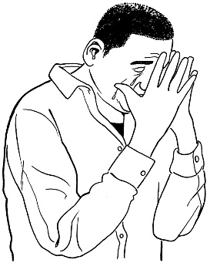
Ihi Research found that colonisation has caused a lot of trauma to Māori.

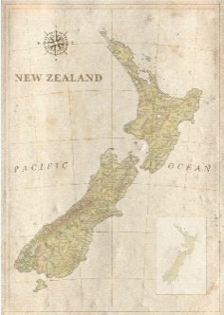
Colonisation is what happened when Europeans came to New Zealand.

Colonisation meant Māori:
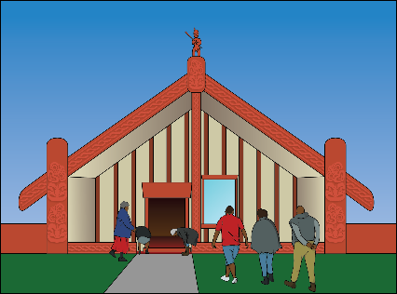
- had almost all their land taken
- were stopped from living the way they used to

- had to follow government rules that were not good for them.

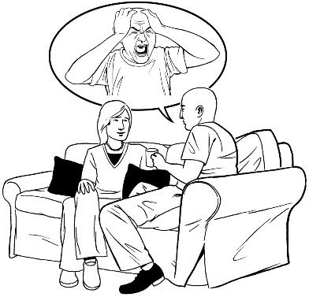
Trauma is when something very upsetting happens that hurts someone for the rest of their life.

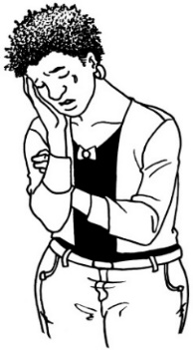
Ihi Research found that colonisation meant Māori:
- lost their connections to their:

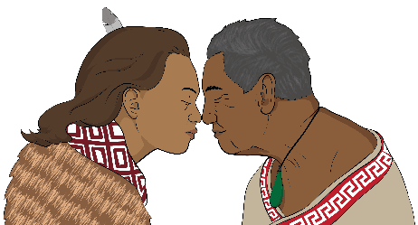
- whānau / family

- iwi / tribe

- culture
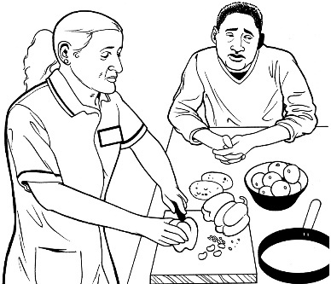
- were seen to not be important by the state care system.

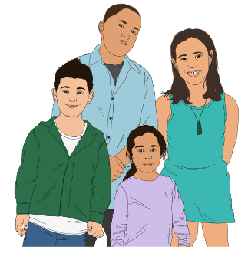
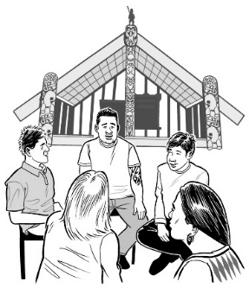
Ihi Research found that Māori over-representation in state care is because of the effect colonisation had on:
- traditional whānau ways of living
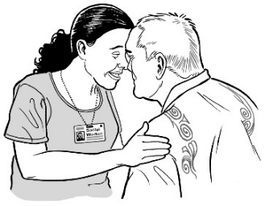
- traditional ways Māori raise their tamariki / children
- the place of wāhine / Māori women.
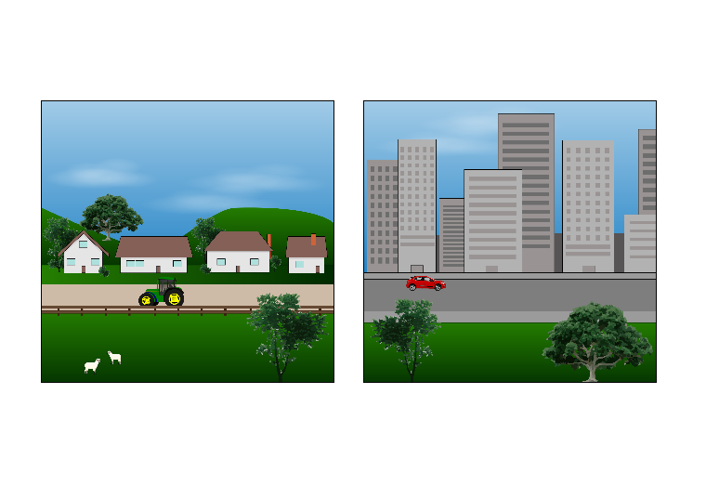

Ihi Research found that many Māori moved to
- towns
- cities.

Moving to cities caused many Māori to lose their:
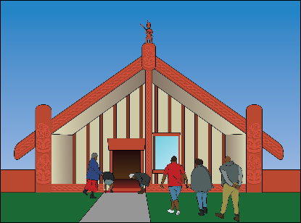
- connection to their whenua / land
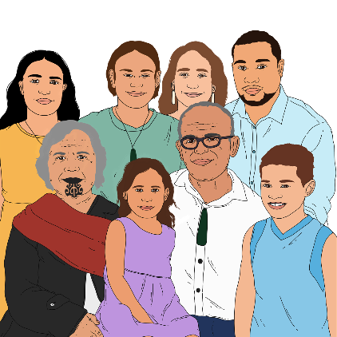
- connection to their hapū / extended family
- connection to their whānau
- access to traditional resources.
A racist view of whānau way of life led to:
- many Māori living in state care
- more problems for Māori like family violence.

Family violence is when someone is hurt by:
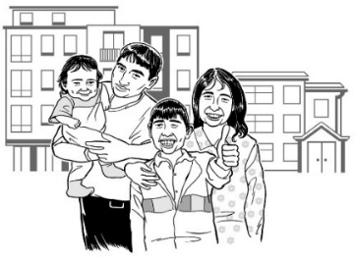
- their partner
- someone in their family
- someone they live with
- someone they have a close personal relationship with like:
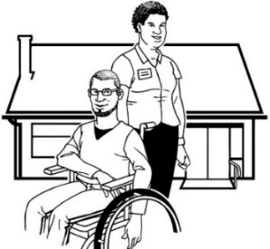
  - someone they are dating
  - a carer.

Māori in state care

When Ihi Research looked at information from 1980 to 1999 it showed that Māori were
over-represented in:
- substitute care
- young people committing crimes
- young people being sent to psychiatric institutions.
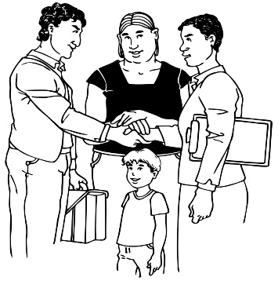
Substitute care is when tamariki / children are sent to live with people who are not part of their whānau / family.

Committing a crime is when you do something that is against the law like stealing.
Psychiatric institutions were hospitals where people who had mental health issues stayed.
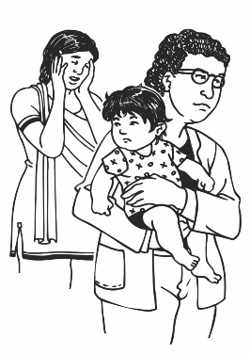
Many Māori were sent into state care through:
- welfare

- the youth justice system.

Youth justice is a court system
for tamariki / children and
rangatahi / young people who may have committed a crime.

In doing their research Ihi Research found that:
1964
1989
- from 1964 to 1989 Māori youth went to court a lot more than non-Māori youth
1964
1974
- from 1964 to 1974 Māori youth were sent to court twice as much as non-Māori youth

- over half the tamariki / children taken into care after having been to court between 1970 and 1989 were Māori.
1970
1989

Ihi Research also looked at a study that looked at the records of all boys born in 1957.
1957
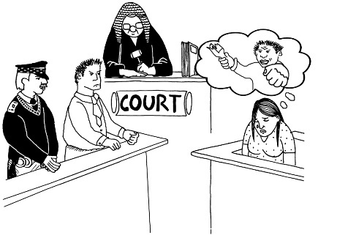

The study looked at how many of the boys had been to court by the age of 24.
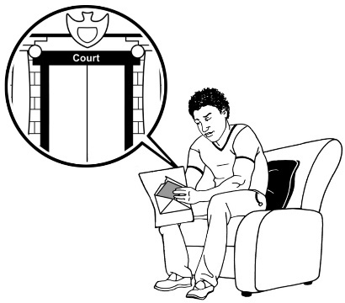
The study found that a lot more Māori boys had been to court than
non-Māori boys.

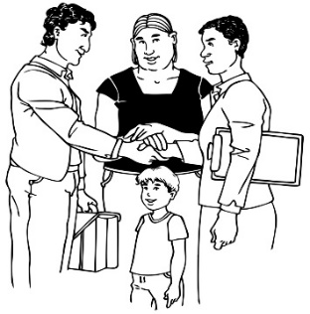
A study done in 1998 showed that far more Māori tamariki/ children lived in state care away from their whānau / family than non-Māori tamariki / children.

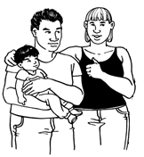
The way adoption worked treated Māori differently because of their race.

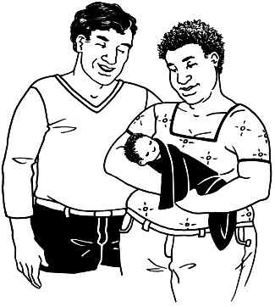
Adoption is when a child is:
- raised by someone who is not their birth parents

and

- the person / people raising the child become the legal parents of the child.
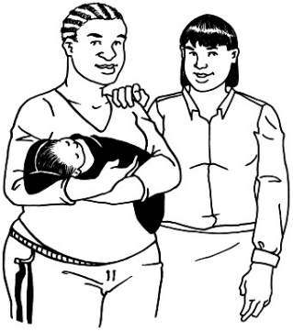

Legal parents are the people who New Zealand law says are the parents of the child.

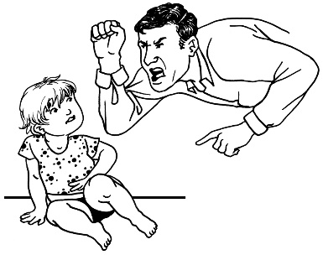
Māori pēpi / babies were more likely to be adopted by people who did not have good parenting skills to take care of them.
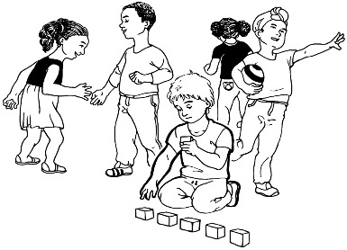
Ihi Research also found that tamariki / children were more likely to go into:
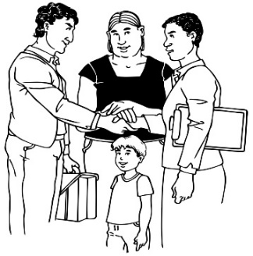
- residential care
- foster care.

Residential care is when a lot of tamariki / children live together for a long time

They are taken care of by paid staff.

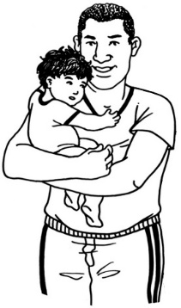
Foster care is when a foster parent looks after a child for a certain amount of time without becoming the legal parent of the child.

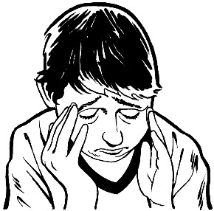
There was very little support for many of these tamariki / children.

Being in state care meant many tamariki / children did not get a good education.

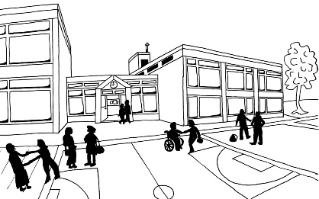
Many tamariki / children could not do well in school.
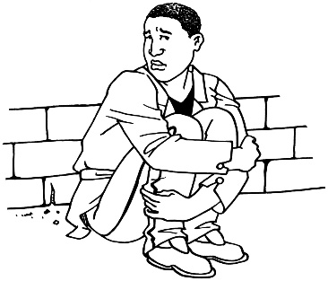
By not doing well in school these tamariki / children had less of a chance to have a good life.

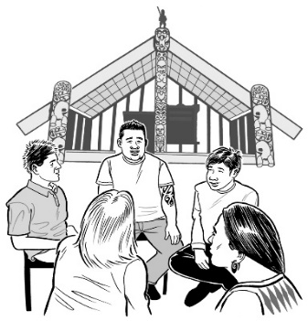
Tamariki / children who were admitted to state care lost their connection to the whenua / community.
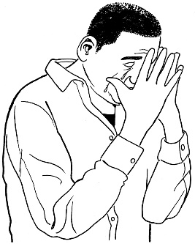
Tamariki / children who returned to their communities as adults often:
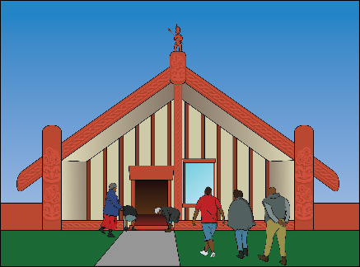
- came back hurt
- were traumatised
- had been kept away from their culture.

Institutional racism

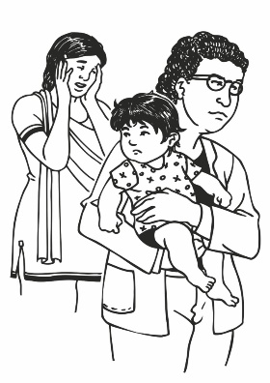
Institutional racism is when government agencies treat people badly because of their ethnicity.

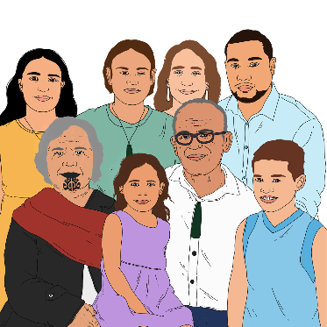
Institutional racism in government agencies caused Māori to be
over-represented in state care.

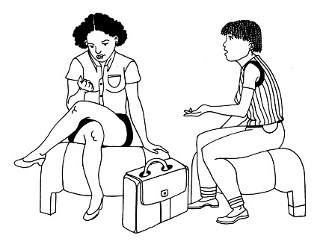
The voices of Māori were not listened to much in:
- making decisions
- programmes for the state care system
- the way state care is run.

Programmes for Māori were not provided in:
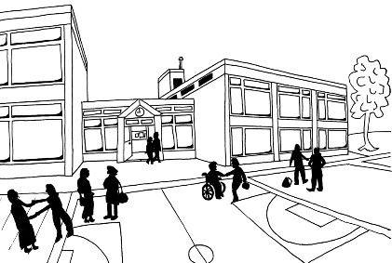
- schools for people with disabilities
- psychiatric residences
- residential institutions.

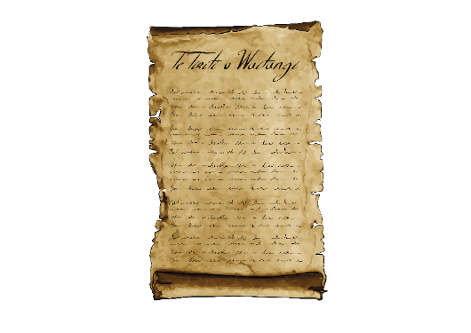
The state care system did not do what is agreed in Te Tiriti o Waitangi / The Treaty of Waitangi.

The Treaty of Waitangi / Te Tiriti o Waitangi is a legal document that was signed in 1840.

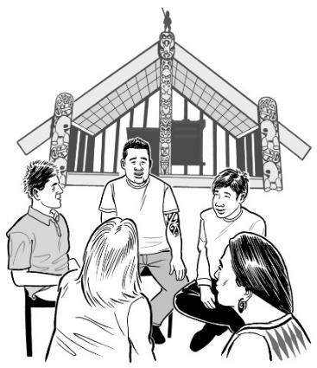
The Treaty / Te Tiriti is important to New Zealand.

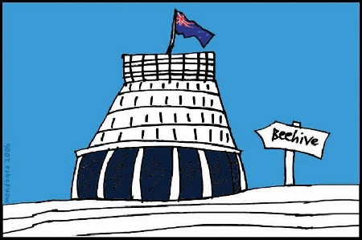
It is about Māori and the New Zealand Government:
- making decisions together
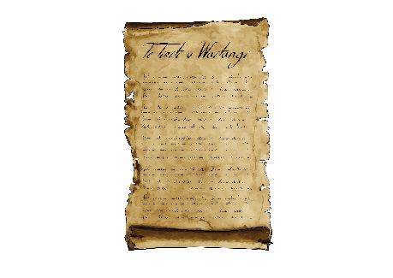
- protecting things that are important to Māori.

The use of Te Tiriti o Waitangi has only started recently because of Māori activists.

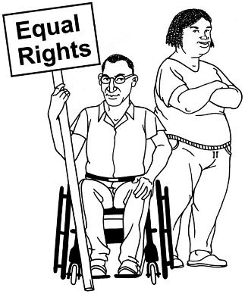
An activist is a person who speaks up about things they think need to change.

Changes that did not work

People have tried to fix Māori over-representation in state care since 1980.

Most of the things that have been tried did not work.

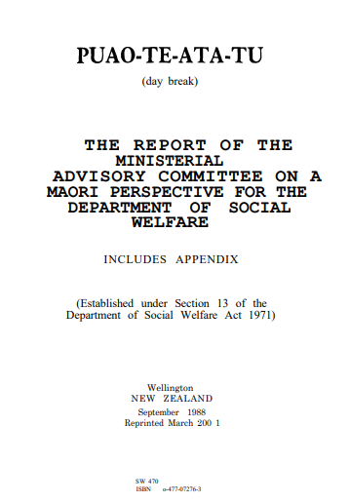
In 1988 the Puao-te-Ata-Tu report was the first government report that said there were problems within the Department of Social Welfare.

The Department of Social Welfare was a government agency that looked after the state care services.

After that report there was a change from residential institutions to using a Mātua Whāngai programme.

The Mātua Whāngai programme used community-based options for state care.

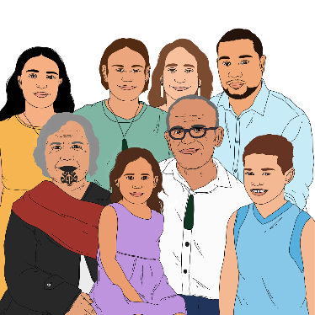
In 1989 the Children, Young Persons and their Families Act made changes to state care so that it:
- worked better with different cultures
- was easier to use for everyone
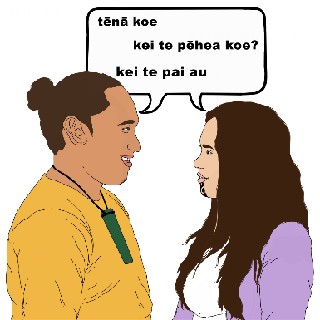
- was whānau based

- had more Māori workers working with whānau.

In 1992 the Mātua Whāngai programme was closed as there was not enough money to run the programme.

Advocates have also worked hard for changes like:
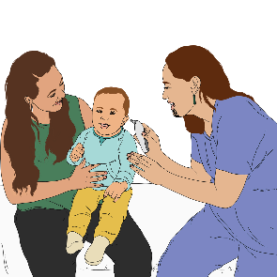
- closing institutions
- getting respect for the rights of tamariki / children and their whānau.

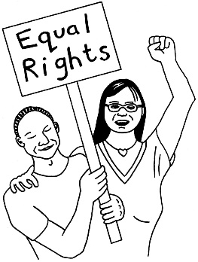
Advocates are people who fight for the rights of other people.

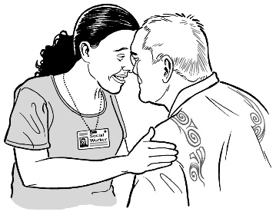
Māori organisations have tried to have rangatiratanga.

Rangatiratanga is the right of Māori people to:

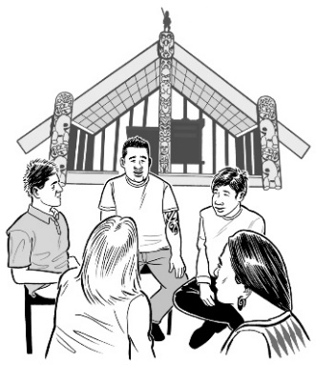
- decide how services like state care should work for Māori

- run the state care services for Māori.

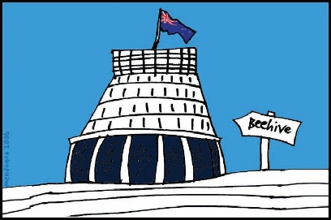
It is very hard for Māori organisations to have rangatiratanga when state care is still run by the government.

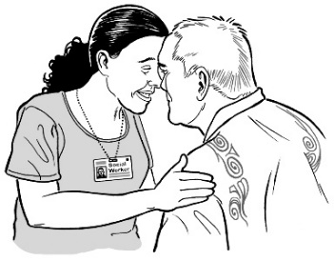
In state care there is not enough:
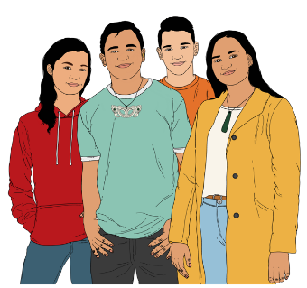
- Māori staff
- support for tamariki / children
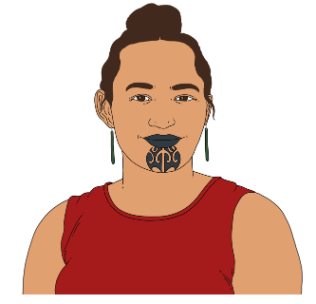
- support for rangatahi / young people
- support for Māori staff.

Māori staff:
- do not get enough training
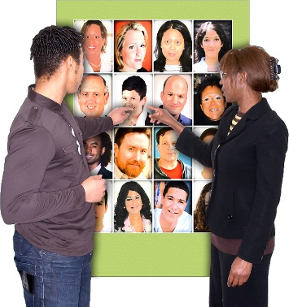
- have too much to do.

There are also lots of staff changes.

What should happen next

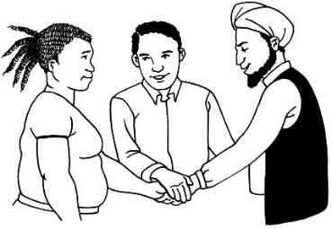
Ihi Research said that in working out what is needed to make things better the government needs to work with:

- Māori

- iwi
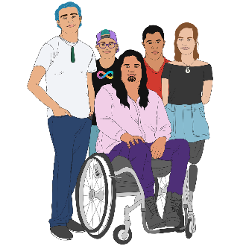
- survivors

- people who have been in state care.

Where to find more information

You can find the full research report on the Ihi Reserach website:

www.ihi.co.nz/what-we-do/hahaurihahatea

You can also email:

catherine@ihi.co.nz

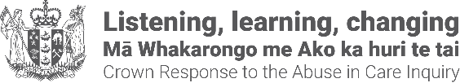
This information was provided by Crown Response to the Abuse in Care Inquiry.
It has been translated into Easy Read by the Make It Easy service of People First New Zealand Inc. Ngā Tāngata Tuatahi.
The ideas in this document are not the ideas of People First New Zealand Ngā Tāngata Tuatahi.
Make It Easy uses images from:

- Changepeople.org

- Photosymbols.com

- Sam Corliss

- Huriana Kopeke-Te Aho.

All images used in this Easy Read document are subject to copyright rules and cannot be used without permission.

