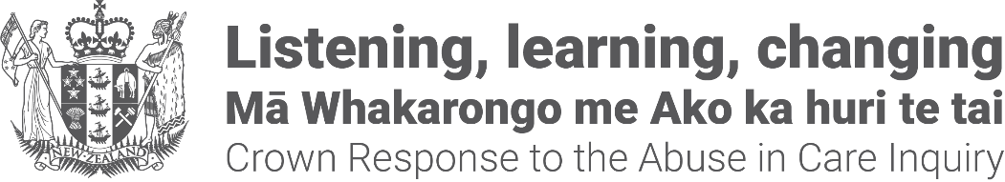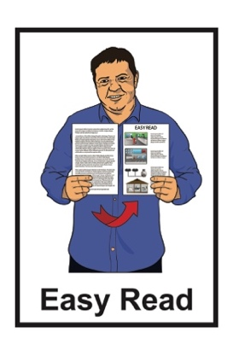

Crown Response to the Abuse in Care Inquiry: Pānui / Newsletter



Published: August 2024

# Before you start



This pānui / newsletter talks about:

abuse

death / dying.

This information may upset some people when they are reading it.

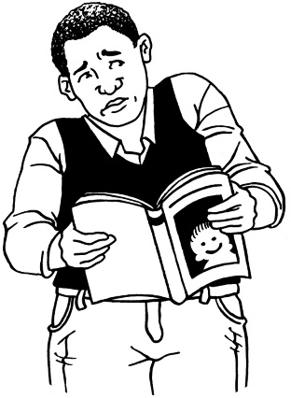

This information is not meant to scare anyone.

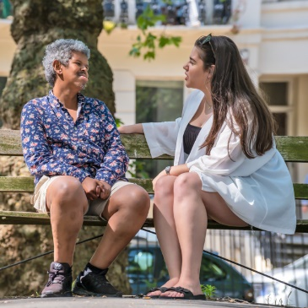If you are upset after reading this document you can talk to your:

* whānau / family
* friends.

You can also contact the Survivor Experiences Service for support.

There is more information on how to contact the Survivor Experiences Service on **pages 17 to 21** of this pānui / newsletter.

# About this newsletter



This Easy Read pānui / newsletter is from the **Crown Response Unit.**

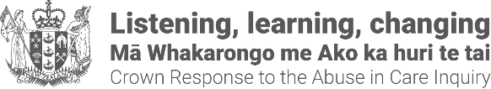The **Crown Response Unit** is called the **CRU** for short.

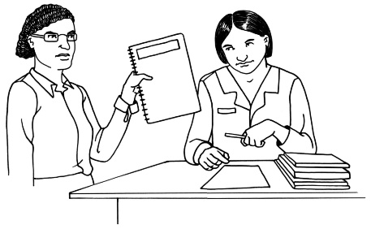The **CRU** works on the Government **response** to what the **Royal Commission of Inquiry into Abuse in Care** found out.

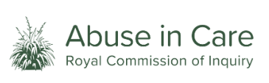The **Royal Commission of Inquiry into Abuse in Care** was looking into abuse that happened to people

in state or faith-based care.

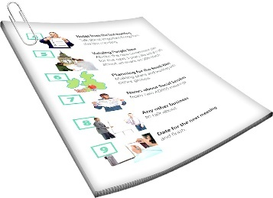

In this document we will call it the **Royal Commission** for short.

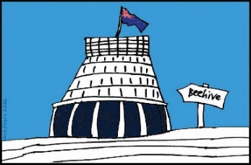The **response** is what the Government will do because of what the Royal Commission found out.



The Royal Commission called people who have been through abuse in care **survivors.**

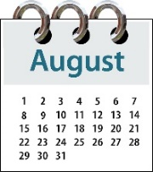

This pānui / newsletter is from

August 2024.



You can find more Easy Read pānui / newsletters from other months at this **website:**

**https://abuseinquiryresponse.govt.nz/news/alternative-formats/#easy-read**

# Urgent payments for terminally ill

# Lake Alice survivors

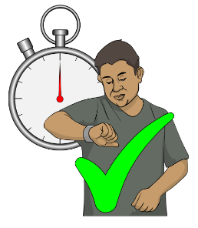

**Urgent payments** means money   
that must be given to those who   
need it as soon as possible.

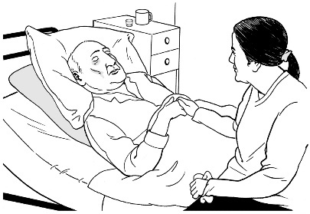

**Terminally ill** means someone is so sick they are likely to die very soon.

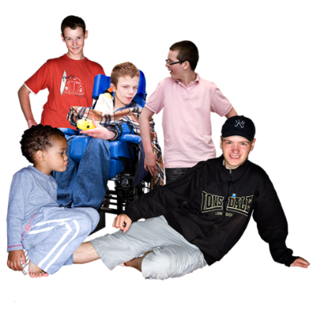**Lake Alice** Child and Adolescent

Unit was a care unit for:

children

adolescents / young people.



There is more information about Lake Alice on **pages 12 to 14**.

The Government has said it will give urgent payments of **20 thousand dollars** to some terminally ill survivors of Lake Alice.



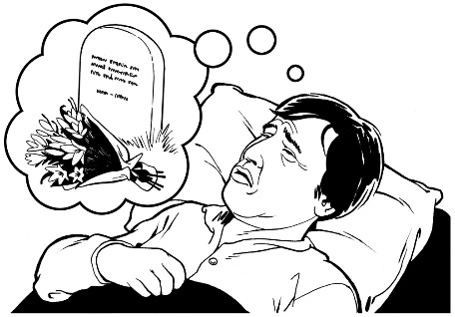This payment is to support survivors with:

care they may need at the end of their life

paying any funeral costs.

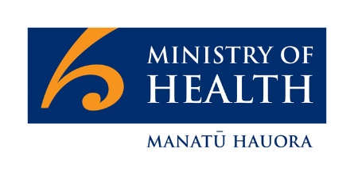The Ministry of Health will give the money to survivors.

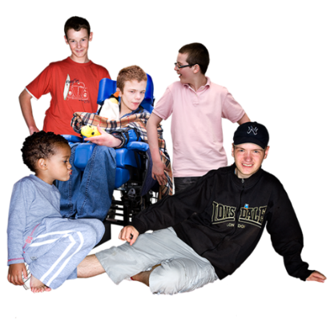The survivors who can get this payment are people who were:

aged up to 17 years old when they were placed in Lake Alice

in Lake Alice:

* from 1972

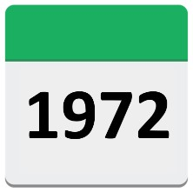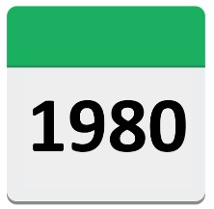

* to 1977.

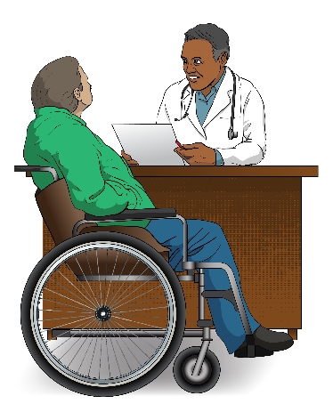Survivors will need to show a letter from a medical professional like a doctor that says they:

have a terminal illness

are not likely to live longer than 6 months.

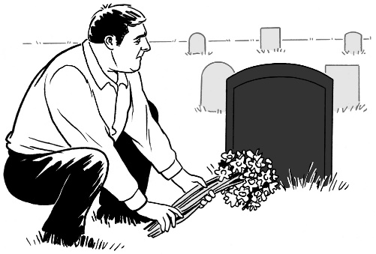Sadly some survivors may die in the time between:

making a claim

getting their payment.



If a survivor dies before they can get their payment the money will be given to the person who is looking after their **estate**.



Here **estate** means all the

money / things that someone owns   
at the time they die.

Survivors will not have to pay any **tax** on the payment.

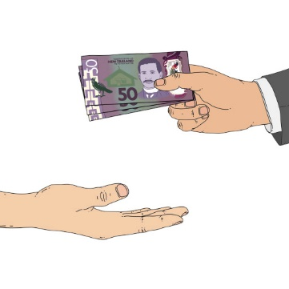

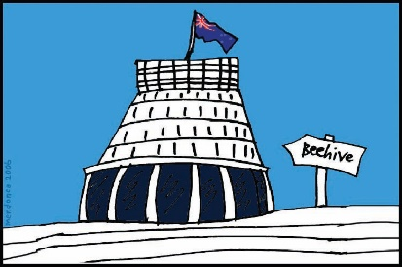

**Tax** is money you must pay to the government.



The payment will not affect any other **benefits** the survivor gets.



A **benefit** is money from the government for people to live on.

# How to apply for the urgent payment

Survivors of Lake Alice who have a terminal illness can apply for the urgent payment by contacting the **Ministry of Health**.



You can contact the   
Ministry of Health by:

**email** at**:**

[**healthlegalexecutiveassistant@health.govt.nz**](mailto:healthlegalexecutiveassistant@health.govt.nz)

**phone** on:

**04 4962000**

You can also send a letter to:



**The Historic Abuse Resolution Service**

**Postal — Health Legal**

**Ministry of Health**

**PO Box 5013**

**Wellington 6145**

# What Royal Commission and survivors said about Lake Alice

The Lake Alice unit was open for   
8 years.



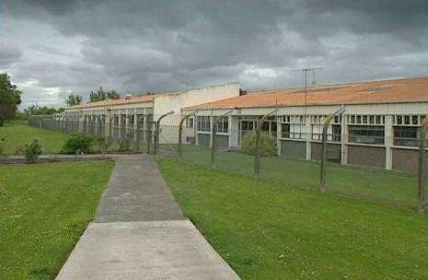

It was part of the Lake Alice **Psychiatric** Unit at Manawatū Hospital.

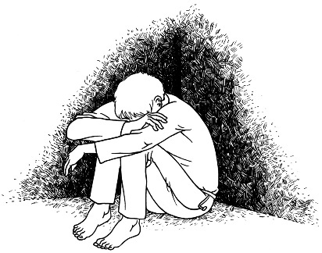

**Psychiatric** means things to do with **mental illness.**

**Mental illness** means a condition that can affect the way a person:

acts

thinks.

The Lake Alice unit was set up to

treat children and young people who

had:

mental distress

mental illness.

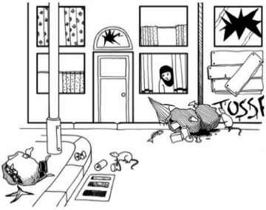

Many children and young people at the Lake Alice unit:

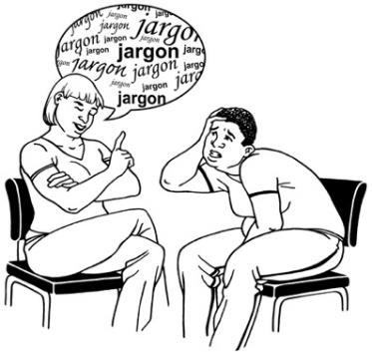came from poor parts of the community

had problems with their:

*  speech
* behaviour.

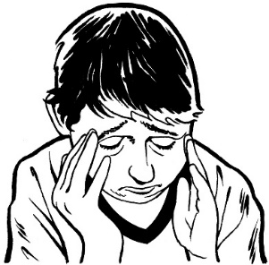The Royal Commission found that very few of the 3 hundred and 62 children who were at Lake Alice during this time had any mental illness.



The Royal Commission report shows that many survivors at Lake Alice hospital were **tortured.**



Being **tortured** is when someone does something to someone else on purpose to hurt them very much.

# Government acknowledges

# Lake Alice survivors

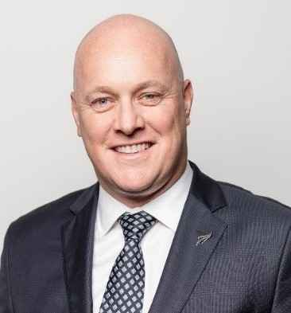

The Prime Minister of New Zealand is Christopher Luxon.

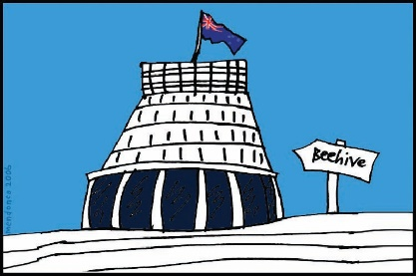On 22 July 2024 the Prime Minister said the Government **acknowledges** that torture happened at Lake Alice.

**Acknowledge** means that you:

say yes that you know   
something has happened

understand that something that happened is true.

The Minister who put together the Crown Response to the Abuse in Care Inquiry is Erica Stanford.



Minister Stanford is making sure that the Government is doing work now to make sure survivors get what they should.

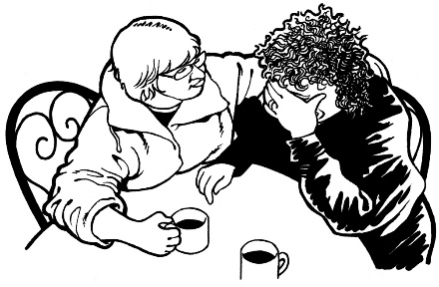

This also includes a way of giving **redress** to survivors at Lake Alice hospital who experienced torture.

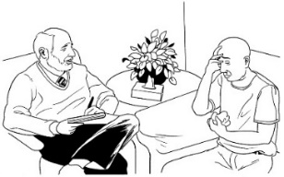

**Redress** means someone:

* says yes they know that   
  something bad has happened
* 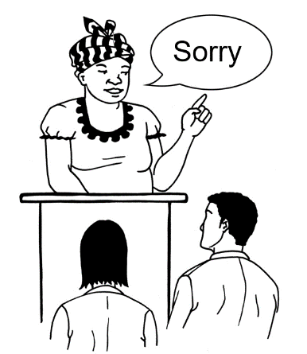does something to try to put   
  things right.

# Support with your care records from the Survivor Experiences Service

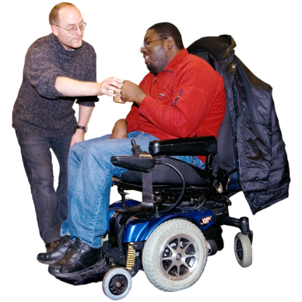

The **Survivor Experiences Service** is a support service for people who were abused in care.

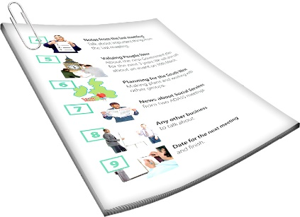

The Survivor Experiences Service can also now support survivors to get their **care records**.

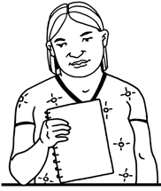

**Care records** are documents that have information about people who have been in care.

The Survivor Experiences Service is also known as the **SES** for short.

The Survivors Experience Service can support you with:

finding out what kind of records have information about you

finding out which organisations hold your records

getting your records

understanding the information in your records

choosing what you want to do with the information you get.



The SES can also ask for your records for you if you want.

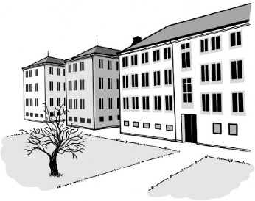

This is so you do not have to deal with organisations who were part of your abuse.

You can find out more about how the Survivor Experiences Service can support you with your care records on their **website** at:

**<https://survivorexperiences.govt.nz/records-support/>**



You should get in touch with the Survivors Experience Service to get support with your care records.



In New Zealand you can **phone**:

**0800 456 090**

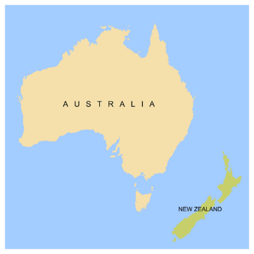

If you are calling from Australia you can **phone:**

**1 800 456 032**

You can call this number:



between **8:30 am** to **4:30 pm**



from **Monday** to **Friday.**



These times are for the New Zealand time zones.

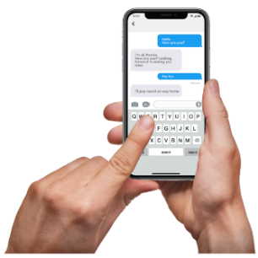You can also send a **text** to the Survivor Experiences Service.

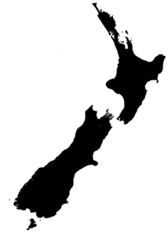

In New Zealand you can send a **text** to:

**8328**

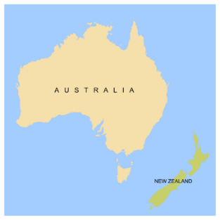

If you are texting from Australia you can send a **text** to:

**+61 438 384 957**

It does not cost any money to   
call / text the SES.





You can also send the Survivor Experiences Service an **email** at:

[**contact@survivorexperiences.govt.nz**](mailto:contact@survivorexperiences.govt.nz)

You can use the New Zealand Relay Service to contact the SES if you are:

* Deaf / hearing impaired
* deafblind
* find it hard to speak.

You can find more information about the New Zealand Relay Service at their website:

[**https://www.nzrelay.co.nz**](https://www.nzrelay.co.nz)

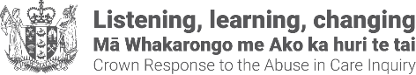This information has been written by the Crown Response Unit.

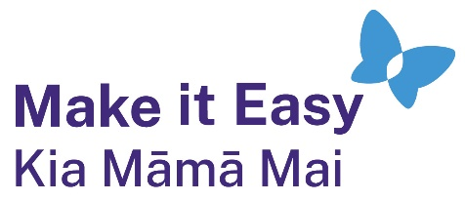It has been translated into Easy Read by the Make it Easy Kia Māmā Mai service of People First New Zealand Ngā Tāngata Tuatahi.

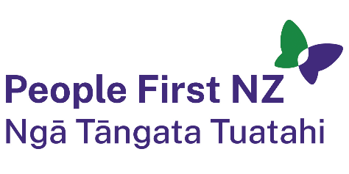

The ideas in this document are not the ideas of People First New Zealand Ngā Tāngata Tuatahi.

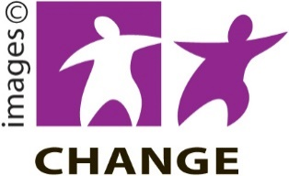

Make it Easy uses images from:

* Changepeople.org

Photo SymbolsPhotosymbols.com

* SGC Image Works
* Huriana Kopeke-Te Aho
* T. Wood.

  
All images used in this Easy Read document are subject to copyright rules and cannot be used without permission.