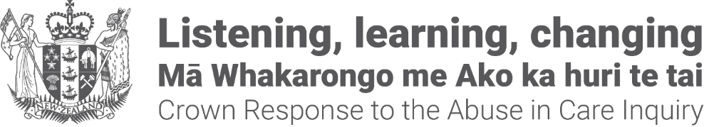
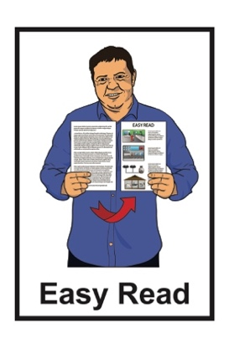

Crown Response to the Abuse in Care Inquiry: Pānui / Newsletter


Statements from the Government in response to the release of the final report from the
Royal Commission of Inquiry – Abuse in Care
Published: July 2024

Before you start


This pānui / newsletter talks about abuse.

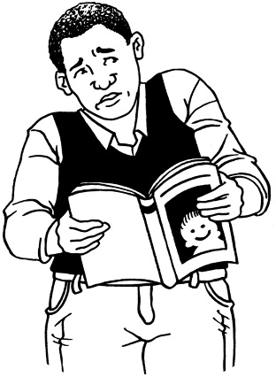

This information may upset some people when they are reading it.

This information is not meant to scare anyone.

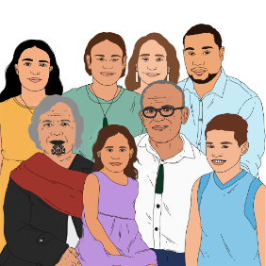
If you are upset after reading this document you can talk to your:

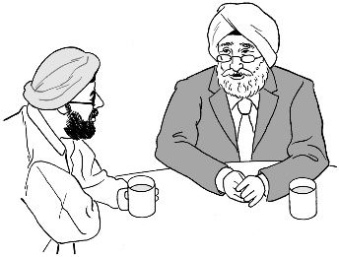
- whānau / family
- friends.


You can contact the Survivor Experiences Service for support.

In New Zealand you can phone:
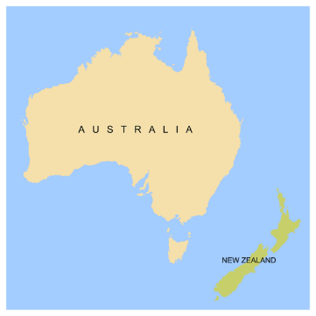
0800 456 090

If you are calling from Australia you can phone:

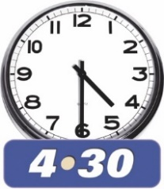
1 800 456 032

You can call this number:
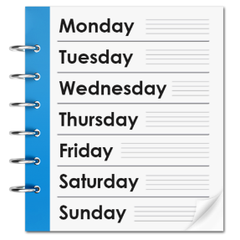
between 8:30 am to 4:30 pm
from Monday to Friday.



These times are for the New Zealand time zones.


You can also send a text to the Survivor Experiences Service.


In New Zealand you can send a text to:

8328
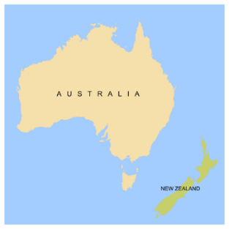
If you are texting from Australia you can send a text to:

+61 438 384 957


It does not cost any money to
call / text the Survivor Experiences Service.


You can also send the Survivor Experiences Service an email at:

contact@survivorexperiences.govt.nz

What you will find in here

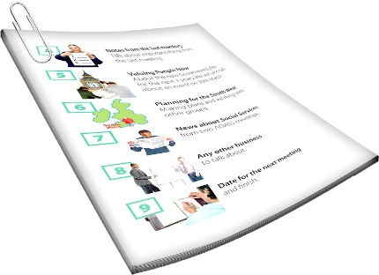
Page number:

About this newsletter 6


What is the Royal Commission
of Inquiry into Abuse in Care? 9
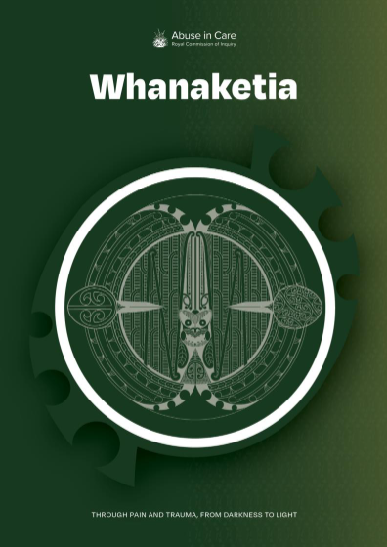

Final report from the
Royal Commission of Inquiry 12

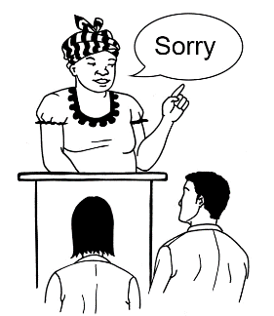
Public apology from the
Prime Minister 14

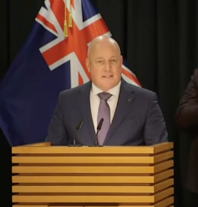
The Prime Minister’s Speech 17

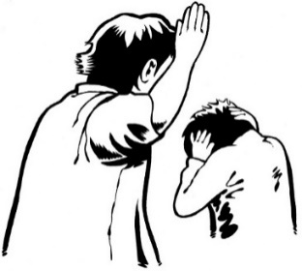
Page number:

Acknowledging torture at
Lake Alice 21

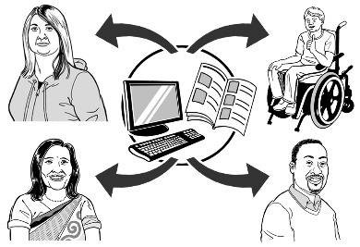
Press releases 27

About this newsletter

This Easy Read pānui / newsletter is from the Crown Response Unit.

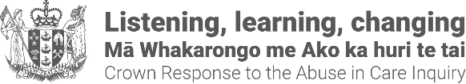
The Crown Response Unit is called the CRU for short.

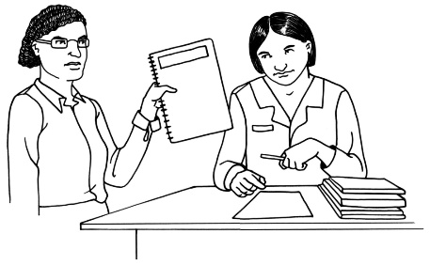
The CRU works on the Government response to what the Royal Commission of Inquiry into Abuse in Care found out.

The Royal Commission of Inquiry into Abuse in Care is explained on pages 8 to 10 of this document.

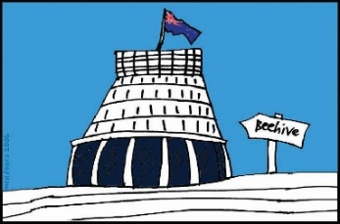
The response is what the Government will do because of what the Royal Commission found out.

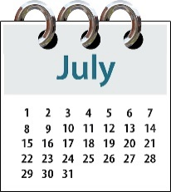
This pānui / newsletter is from
July 2024.


You can find more Easy Read pānui / newsletters from other months at this website:
https://abuseinquiryresponse.govt.nz/news/alternative-formats/#easy-read

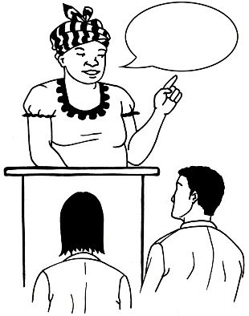
This pānui / newsletter includes quotes from some people in Government.

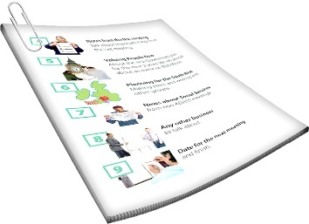
A quote is an exact copy in writing of what someone has said.

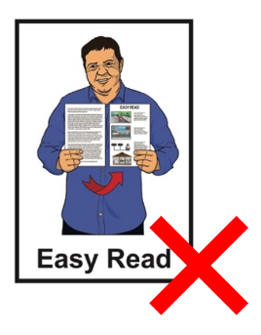
The quotes are in yellow boxes like this.

The quotes are not in Easy Read.

What was the Royal Commission

of Inquiry into Abuse in Care?

The Royal Commission of Inquiry into Abuse in Care was looking into abuse that happened to people
in care.

It has now finished its work.

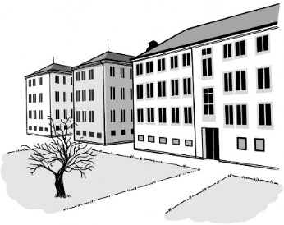
In this document being in care means that the Government or a faith-based institution was in charge of your care.


Faith-based institutions are run by religious groups like churches.


Abuse can be:
- physical – a person kicking or hitting you
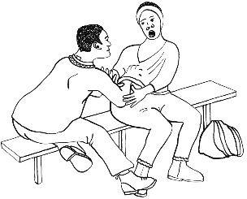
- sexual – a person doing sexual things to you that you do not want them to like:

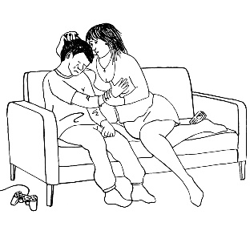
- touching your body or private parts

- kissing you

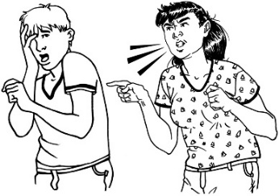
- making you have sex with them – this is called rape
- emotional – a person yelling or saying things to you that are not nice
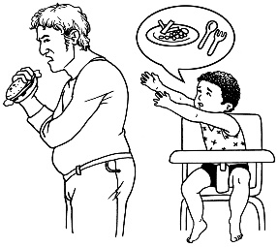
- neglect – a person not giving you the things or care you need.

The Royal Commission was not part of the Government.

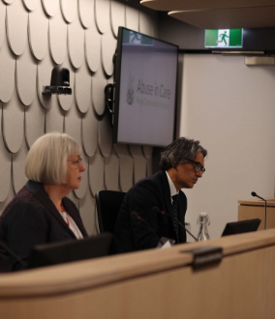
The Government cannot tell the Royal Commission what to do.


The Royal Commission was not part of any faith-based organisations like churches.


The Royal Commission calls people who have been through abuse in care survivors.

Final report from the
Royal Commission of Inquiry

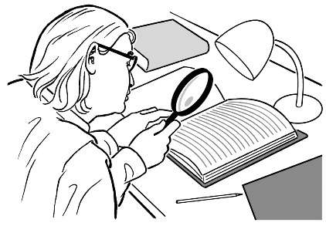
The Royal Commission of Inquiry was set up to look into abuse in care.

It finished its work on 25 June 2024.

Now it has done its work it has made a final report.

The report is called:

Whanaketia – Through Pain and Trauma, From Darkness to Light.


The final report was published on
24 July 2024.


The full report was put on the Royal Commission of Abuse in Care website so everyone can read it.

You can read the full report at:

https://www.abuseincare.org.nz/
reports/whanaketia

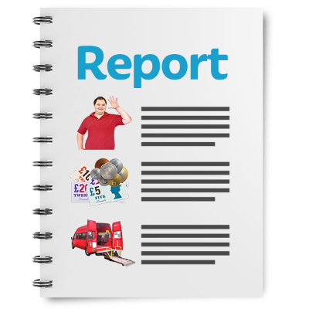
You can also find Easy Read documents about what the Royal Commission found out on this website:

https://www.abuseincare.org.nz

Public apology from the Prime Minister


The current Prime Minister of Aotearoa New Zealand is
Christopher Luxon.

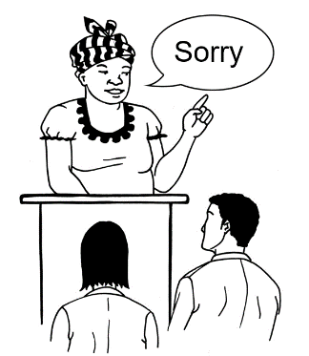
The Prime Minister has said he will make a public apology to survivors of abuse in care.


A public apology is when someone says sorry to a group of people in a way that means everyone can be a part of what is said.


The public apology will happen on
12 November 2024.

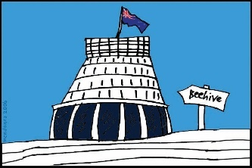
It will take place at Parliament.
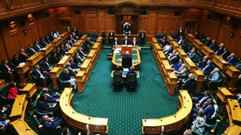
Other people from Government will be asked to be at Parliament when the public apology happens.


There will be more information about the public apology in the next few months.

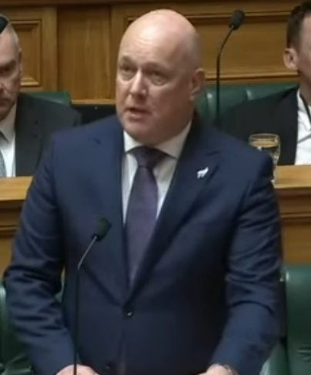
The Prime Minister said on
22 July 2024 that:

“I do want to personally acknowledge the courage of nearly 3 thousand survivors who shared their experiences of abuse and neglect with the commission”

and

“It is important the Crown addresses and acknowledges the experiences of abuse in care at a national level.”


Acknowledge means that you:
say yes that you know something has happened
understand that something that happened is true.
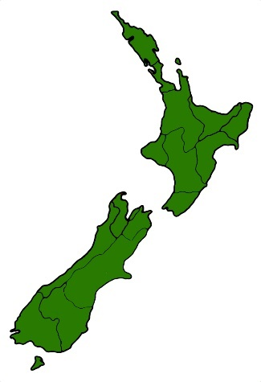

It is important that the Prime Minister has told everyone in New Zealand that the Government acknowledges the harm that happened to survivors.

The Prime Minister’s Speech

The report from the Royal Commission was tabled to Parliament on 24 July 2024.

Tabled to Parliament means that a document / information is put on the table in the middle of Parliament chambers.

This makes a document / information available to all Members of Parliament.

The Prime Minister made a speech in Parliament about the report on the same day.

In his speech the Prime Minister told the survivors:

“I cannot take away your pain, but I can tell you this:

You are heard and you are believed.”

The Prime Minister also said:

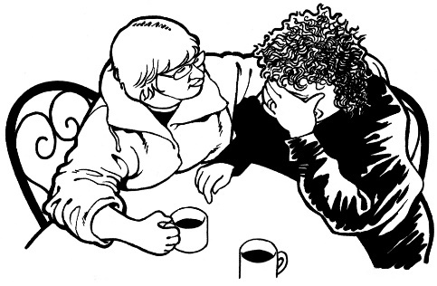
“We like to think that abuse like this doesn’t happen here in New Zealand.

But it did and it is a shameful chapter of our history that we must confront.”

and
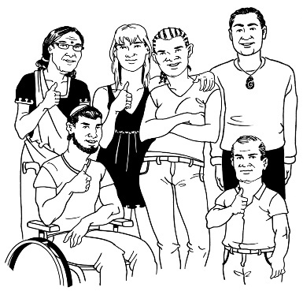
“It is important that, as a country, we bring to the surface and understand the hard truths of what happened so we can try and move forward together.”

Here confront means that everyone in New Zealand must acknowledge what has happened to make sure it can never happen again.


You can read the full speech online at:

https://tinyurl.com/44b9zua8

The full speech is not in Easy Read.


You can also watch a video of the Prime Minister’s speech on YouTube at:

https://tinyurl.com/y9d7sprb

You can also read an Easy Read summary of the Royal Commission report at:

www.abuseincare.org.nz
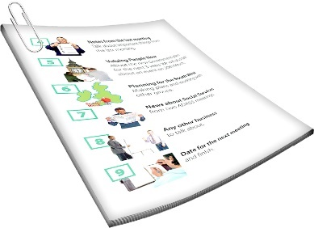

A summary is a shorter version of a report.

Acknowledging torture at Lake Alice


The Royal Commission report shows that some survivors at Lake Alice hospital experienced torture.

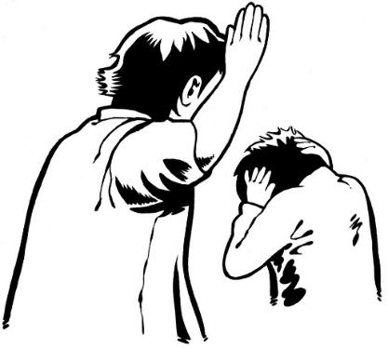
Torture is when someone does something to someone else on purpose to hurt them very much.

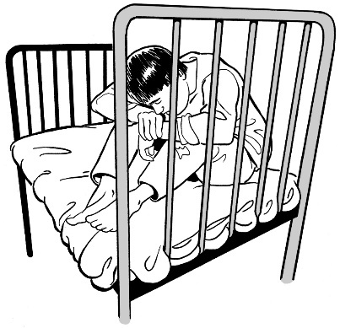
In some cases the staff who worked at Lake Alice did as much as they could to make things very painful for children and young people.
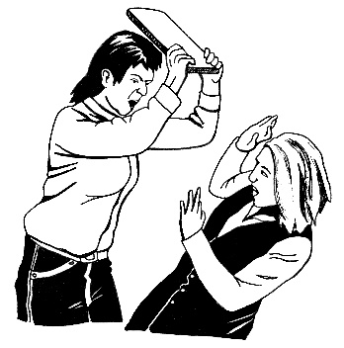

They often used different things to hurt people with.

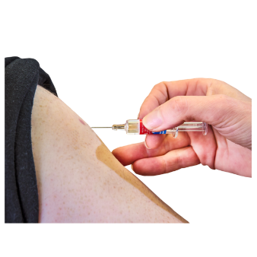
The staff at Lake Alice injected some people with very painful medicine even though they did not need it.


Injected means medicine is put into a syringe with a needle so it can be put into your body.

They also gave people electric shocks.

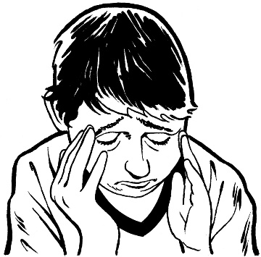
These things were not done for medical reasons.

These things were done to:

punish people
scare people.

The Prime Minister said in his speech that the Government officially acknowledges that torture happened at Lake Alice.

The Prime Minister said:

“A terrible injustice was done in the name of State care.

It is now the responsibility of the State to make redress and this Government will ensure it happens.”

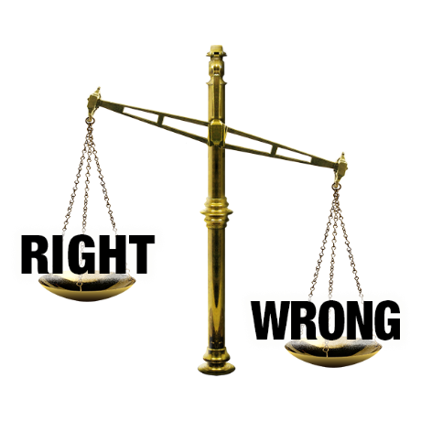
Injustice means something that:
is wrong
is unfair
goes against what the law says should happen.

Responsibility means someone has to do / look after something.

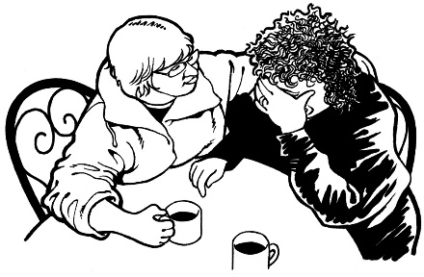
Redress means someone:
- agrees that something bad has happened
- does something to:
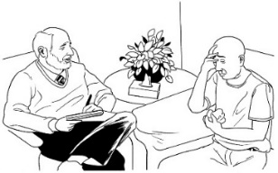
- try to put things right
- make up for any harm that has been done.


sorry
Redress could be things like:
saying sorry
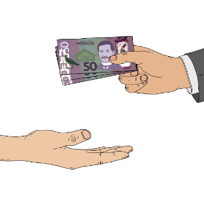
giving money as a way of saying sorry
other support like counselling.

The Prime Minister also said sorry to the survivors of Lake Alice in his speech.

The Prime Minister said:


“What happened was wrong. You knew then it was wrong, and all these years later, the State also acknowledges it was wrong.

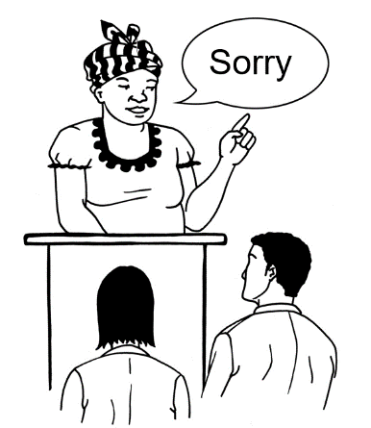
Today, I humbly stand before you in this house to offer a long overdue apology to the survivors of Lake Alice.

I am sorry that it has taken so long for this acknowledgement of torture.”

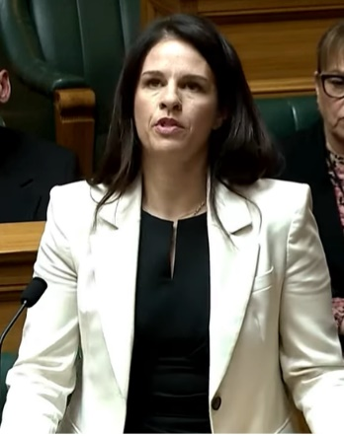
The Minister who is leading the work of the government to respond to the Abuse in Care Inquiry is Erica Stanford

Minister Stanford is making sure that the Government is doing work now to make sure survivors get redress.



You can read the full report about Lake Alice on the Royal Commission website at:

https://tinyurl.com/5n7bwfz9

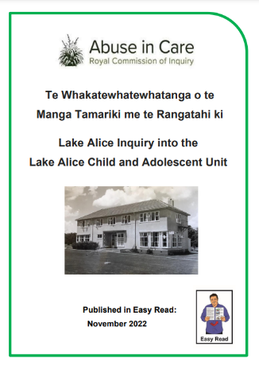
You can read an Easy Read summary of the report at:

https://tinyurl.com/5cyjdarj

Press releases

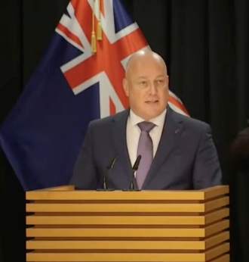
The Prime Minister and Minister Stanford made 2 press releases together to officially acknowledge:
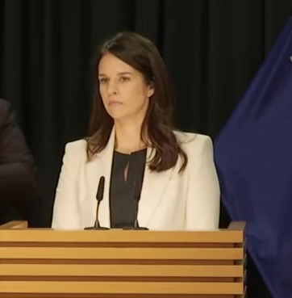
the torture at Lake Alice
survivors.

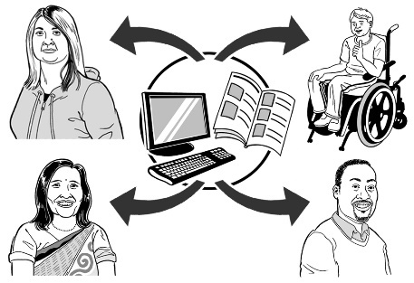
A press release is an official statement given to people who work in the news / media so they can share it with everyone.

You can watch a video of the press releases on YouTube at:
https://tinyurl.com/58dhv6y7

Lake Alice press release

About what happened at Lake Alice the Prime Minister said:

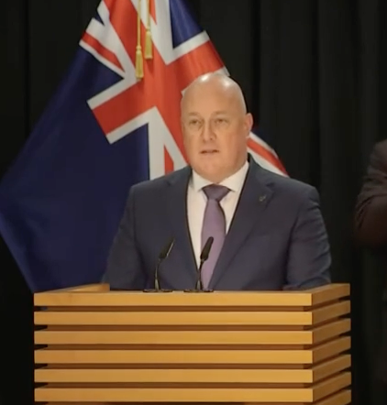
“What the Lake Alice survivors went through was profoundly disturbing.

It is reprehensible that this has occurred in New Zealand.”


Profoundly disturbing means something is:
very bad
upsetting to think about.

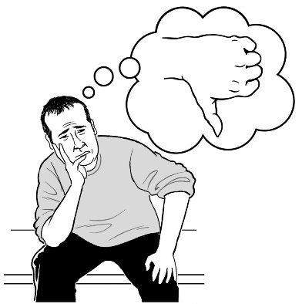
Reprehensible means something is so bad:
it cannot be forgiven
there is no good reason / excuse for it to happen.

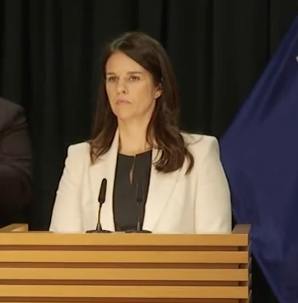
Minister Stanford said:

“Many of the Lake Alice survivors are in fragile health and some have passed away.

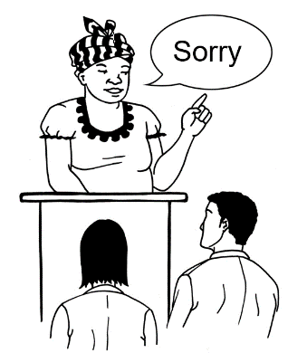
To their families and whānau, I am sorry that they are not here to hear the State admit to what we should have many years ago.”

You can read the full press release about Lake Alice at:

https://tinyurl.com/mrxt876v

The full press release is not in Easy Read



Acknowledging survivors press release

The Prime Minister said:

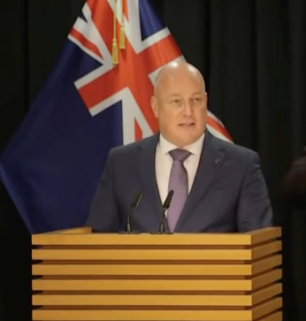
“I would like to acknowledge the two thousand and 4 hundred survivors.

Thank you for your strength, your bravery and your honesty.”

About the public apology that will happen in November Minister Stanford said:
sorry

“This is a significant event, and the Government is working with survivor groups to deliver an event that gives it the dignity it deserves.”

Significant means something that is very important.

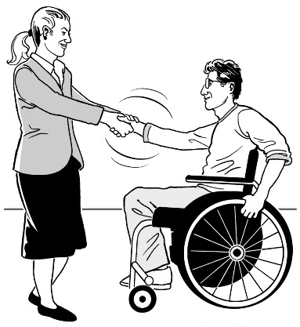
Dignity means thinking about how people feel so that they are treated well / in the right way.

You can read the full press release acknowledging survivors at:

https://tinyurl.com/4ttwu46r

The full press release is not in Easy Read.

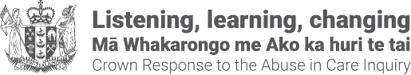
This information has been written by the Crown Response Unit.

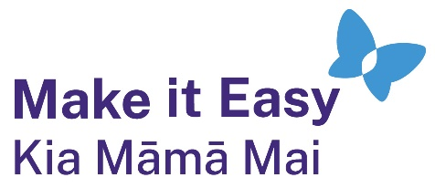
It has been translated into Easy Read by the Make it Easy Kia Māmā Mai service of People First New Zealand Ngā Tāngata Tuatahi.

The ideas in this document are not the ideas of People First New Zealand Ngā Tāngata Tuatahi.

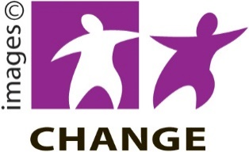
Make it Easy uses images from:

- Changepeople.org


            - Photosymbols.com



- SGC Image Works
- Huriana Kopeke-Te Aho
- T. Wood.

All images used in this Easy Read document are subject to copyright rules and cannot be used without permission.

