

Crown Response to the  
Abuse in Care Inquiry:  
Pānui / Newsletter

Man siting on a chair reading a document.


Published: March 2024

# About this pānui / newsletter



This Easy Read pānui / newsletter is from the **Crown Response Unit.**

The **Crown Response Unit** is called the **CRU** for short.

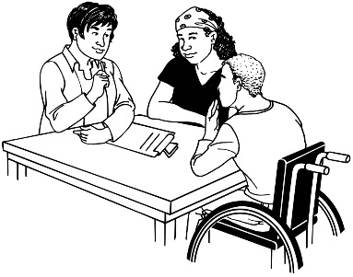The **CRU** is a group of people who work for the Government who look after:

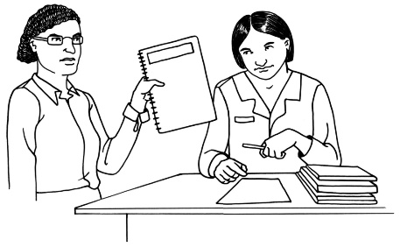contact between the Government and the Royal Commission of Inquiry into Abuse in Care

the Government response to what the Royal Commission finds out.

The **Royal Commission of Inquiry into Abuse in Care** is explained on **pages 4 to 6** of this document.

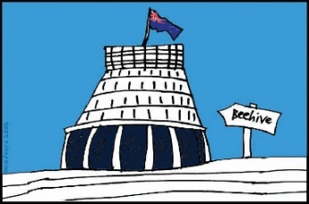The **response** is what the Government will do because of what the Royal Commission finds out.



This pānui / newsletter is from March 2024.

You can find more pānui / newsletters from other months at this **website:**

**https://tinyurl.com/5dmmevus**

Some of the information in this pānui / newsletter may upset people when they read it.



This information is not meant to upset anyone.

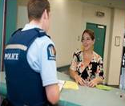If you do not feel safe right now call the police on **111.**

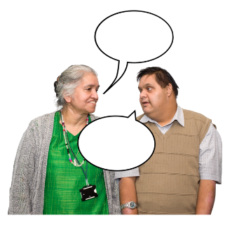If you are worried or concerned after reading this you can talk about it with:

your family / friends

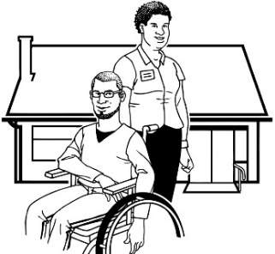your support workers.

# What is the Royal Commission of Inquiry into Abuse in Care?

The **Royal Commission of Inquiry into Abuse in Care** is looking into abuse that happened to people

**in care**.



In this document being **in care** means that the Government or a **faith-based institution** was in charge of looking after you.



**Faith-based institution**s are run by religious groups like churches.

**Abuse** can be:

* **physical** – a person kicking or hitting you
* 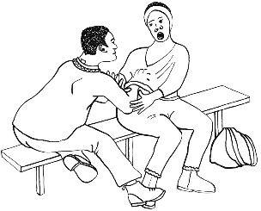**sexual** – a person doing sexual things to you that you do not want them to like:
* 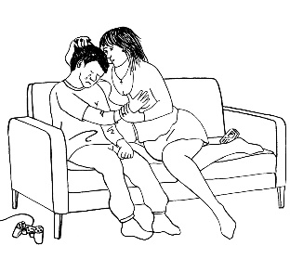touching your body or private parts
* kissing you
* making you have sex with them – this is called rape
* **emotional –** a person yelling or saying things to you that are not nice
* 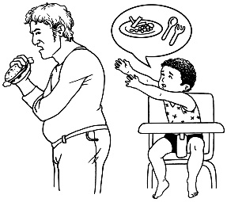**neglect** – a person not giving you the things or care you need.

The Royal Commission is not part of the Government.



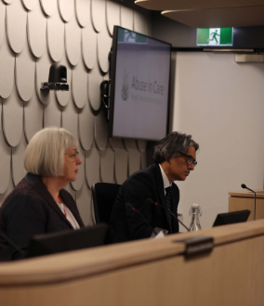

The Government cannot tell the Royal Commission what to do.



The Royal Commission is not part of any faith-basedorganisations like churches.



The Royal Commission calls people who have been through abuse in care **survivors.**

# Royal Commission extension of time



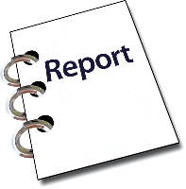The Abuse in Care Royal Commission of Inquiry final report is due on 28 March 2024.

****In February the Royal Commission wrote to the **Internal Affairs** **Minister**.

The **Internal Affairs Minister** is called **Brooke van Velden.**

In this pānui / newsletter when we say **the Minister** we mean the Internal Affairs Minister Brooke van Velden.

The Royal Commission asked the

Minister for an **extension** to complete

the final report.



An **extension** means asking for more time.

The date the Royal Commission is due to complete the final report is 28 March 2024.

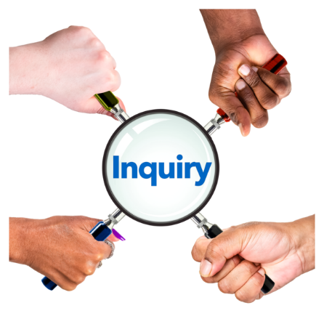The Royal Commission needs more time to complete the report so that all survivors experiences are:

* well understood
* included in the recommendations.

**Recommendations** are the things that the Royal Commission says should happen to make things better for people in care.



The Minister has told the Royal Commission:

the new date for the final report will be 26 June 2024

there will be no more extensions

to give any recommendations by 30 May 2024.



The CRU will start work from the 30 May 2024:

to respond to the recommendations

on the **apology.**

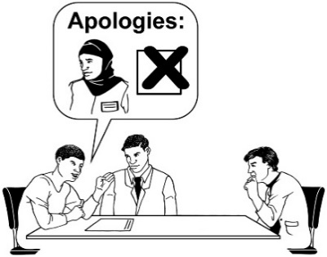

An **apology** is when someone says sorry for what has happened.

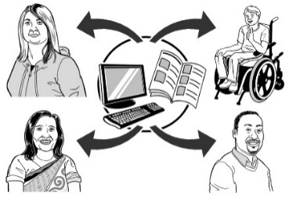The extension has not slowed down the work the CRU has done:

about keeping care records safe

to set up the **Survivor Experiences Service**

on the **Rapid payment process**.

The **Survivor Experiences Service** is explained on page 15.



The **rapid payment process** is

explained on page 19.

You can find more about the extension at this **website:**

**https://tinyurl.com/5n6hu9j7**

# Update on the Crown response work on care records



The CRU is working with **Te Rua Mahara o te Kāwanatanga** **Archives New Zealand** to make it easier for survivors to access their **records** about their time in care.

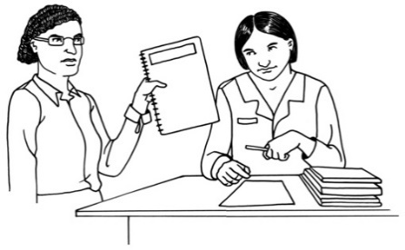**Records** are things that people write down about another person.

**Care records** are the things written down about people in care.



In this panui / newsletter we call **Te Rua Mahara o te Kāwanatanga Archives New Zealand** **Archives New Zealand** for short.

**Archives New Zealand** looks after government records so they can be used in the future.



Archives New Zealand did a **consultation** to create a plan on how to keep care records safe.

A **consultation** is when a group meets with lots of different people to learn about what they:

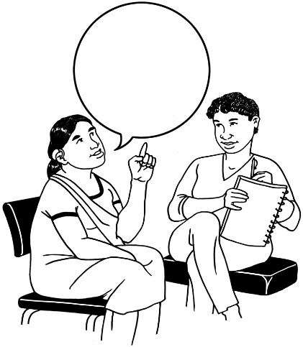

think

know

can do.

Archives New Zealand has used **feedback** from the consultation to support the Government to know what kinds of care records:

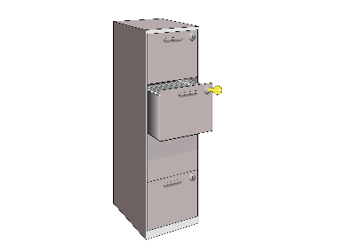are important to keep safe

should be kept for a long time.



**Feedback** is when you tell someone what you think about something.

The feedback will also help other organisations to keep care records safe.

You can find more about keeping care records safe at this **website:**

**https://tinyurl.com/28zpdykx**

# Update on the Crown response work on the Survivor Experiences Service

The **Survivor Experiences Service**

started in July 2023.

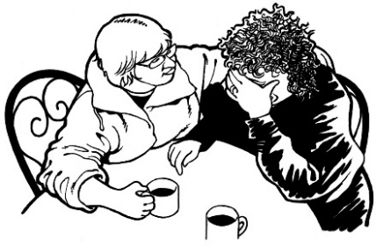The **Survivor Experiences Service**

is for:

people who have experienced abuse while in care

people to talk about what happened to them

whānau / family of survivors.

You can find more about the Survivors Experiences Service at this **website:**

**www.survivorexperiences.govt.nz**



The information on this website is not

in Easy Read.

The CRU and the Survivor Experiences Service are working with people:

who have communication support needs

with a learning disability

with **cognitive impairment**

who are **neurodivergent**.

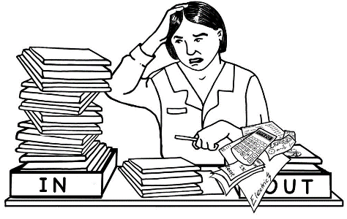**If a person has a cognitive impairment** it means they find it hard to:

remember things

work out how to do some things

do some things.

**Neurodivergent** means people whose brains work in a different way to most people.

Every **neurodivergent** person is different.

The CRU is getting feedback from the:

Deaf community

disabled community.

The feedback with help the CRU understand how the Survivor Experiences Service can better meet the needs of the:

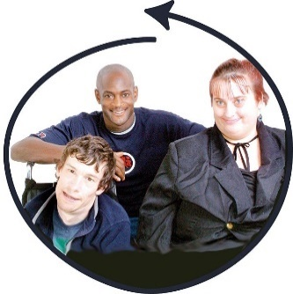Deaf community

disabled community.



This work will be completed by the end of April 2024.

The CRUwill write a report for the

Survivor Experiences Service about the feedback.

# Update on the Crown response work on rapid payments



**Rapid payments** is money that is

given to survivors more quickly as

part of **redress**.

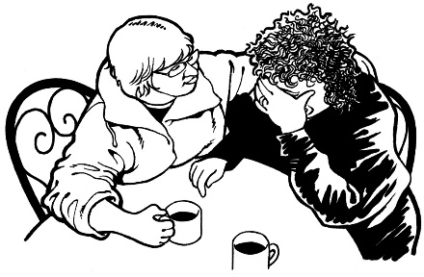**Redress** means someone:

agrees that something bad has happened

does something to try to:

* 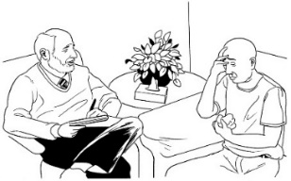put things right
* make up for any harm that has been done.

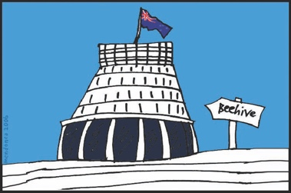The Ministry of Social Development

is carrying on offering rapid payments

as part of redress.



The Ministry is making payments first

to Survivors who:

are old

are ill

have been waiting a long time.

You can find more about rapid

payments at this **website:**

**https://tinyurl.com/4dzabn3t**



The information on this website is not in Easy Read.

# Update on the Crown response work on apologies and redress

The CRU has written papers for

the new Government about:

the apology

redress system.



The papers have information that

the new Ministers will need to know.



You can read the full report online

at this **website:**

**https://tinyurl.com/yszepmde**

The report is not in Easy Read.

# Where to get support

The Government understands that:

news of the extension may be upsetting to some survivors

the final report is important so that survivors can start to recover from their experiences.



You can contact the Royal Commission Contact and Support Centre:

if you have any questions about the things you have read in this panui / newsletter

to find out how to get support if you feel upset.

You can contact the Contact and Support Centre up to the 26 June 2024.

You can get in touch with the Contact and Support Centre by:

****calling:

**0800 2228 727**

sending an email to:

**contact@abuseinquiryresponse.govt.nz**

**After 26 June 2024** if you want to share your experiences in care you can contact the **Survivor Experiences Service** by:



calling:

**0800 456 090**

sending a text message to:

**8328**

sending an email to:

**contact@survivorexperiences.gov.nz**

 If you find it hard to use the phone the

New Zealand Relay service is for people

who are:

Deaf / hard of hearing

deafblind

speech impaired / find it hard to talk.

You can find more about the New

Zealand Relay service at this

**website:**

**www.nzrelay.co.nz**

This information has been written by the Crown Response Unit.

It has been translated into Easy Read by the Make it Easy Kia Māmā Mai service of People First New Zealand Ngā Tāngata Tuatahi.

The ideas in this document are not the ideas of People First New Zealand Ngā Tāngata Tuatahi.



Make it Easy uses images from:

* Photo SymbolsChangepeople.org

Photosymbols.com

* SGC Image Works
* Huriana Kopeke-Te Aho
* T. Wood.

  
All images used in this Easy Read document are subject to copyright rules and cannot be used without permission.