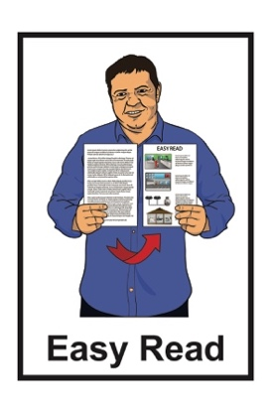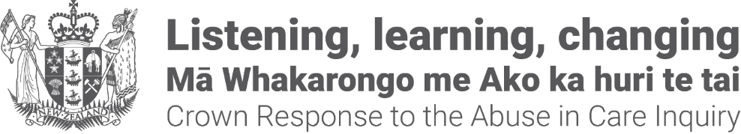

Crown Response to the  
Abuse in Care Inquiry:  
Pānui / Newsletter

A person reading a document


Published: May 2024

# About this pānui / newsletter

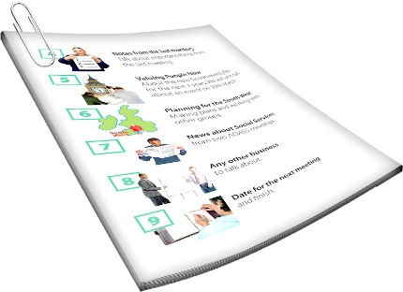

This Easy Read pānui / newsletter is from the **Crown Response Unit.**

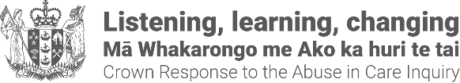The **Crown Response Unit** is called the **CRU** for short.

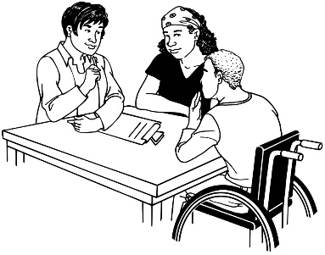The **CRU** is a group of people who work for the Government who look after:

* 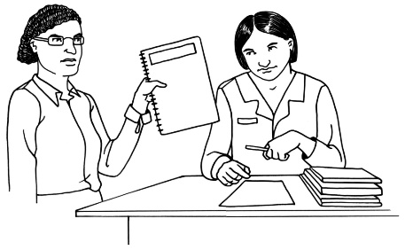contact between the Government and the **Royal Commission of Inquiry into Abuse in Care**
* the Government **response** to what the **Royal Commission** finds out.

The **Royal Commission of Inquiry into Abuse in Care** is explained on **pages 4 to 6** of this document.

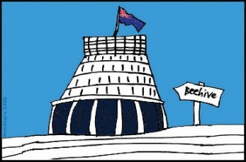The **response** is what the Government will do because of what the Royal Commission finds out.

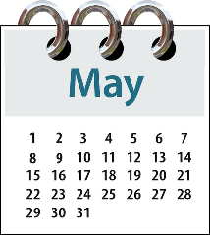

This pānui / newsletter is from May 2024.

You can find more pānui / newsletters from other months at this **website:**

**https://tinyurl.com/yszepmde**

Some of the information in this pānui / newsletter may upset people when they read it.

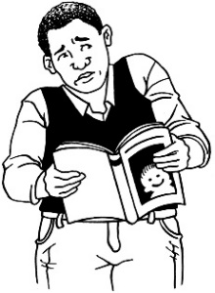

This information is not meant to upset anyone.

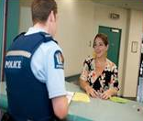If you do not feel safe right now call the police on **111.**

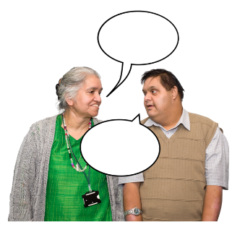If you are worried or concerned after reading this you can talk about it with:

* your family / friends
* 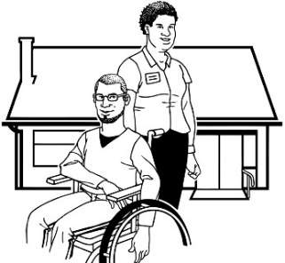your support workers.

# What is the Royal Commission of Inquiry into Abuse in Care?

The **Royal Commission of Inquiry into Abuse in Care** is looking into abuse that happened to people

**in care**.

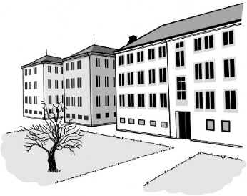

In this document being **in care** means that the Government or a **faith-based institution** was in charge of your care.



**Faith-based institution**s are run by religious groups like churches.

**Abuse** can be:

* **physical** – a person kicking or hitting you
* 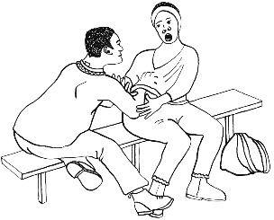**sexual** – a person doing sexual things to you that you do not want them to like:
* 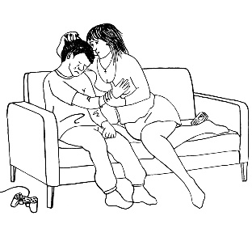touching your body or private parts
* kissing you
* 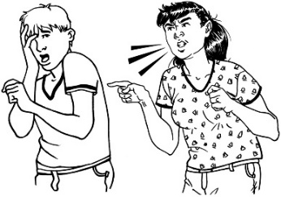making you have sex with them – this is called rape
* **emotional –** a person yelling or saying things to you that are not nice
* 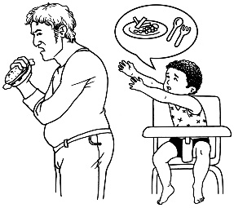**neglect** – a person not giving you the things or care you need.

The Royal Commission is not part of the Government.



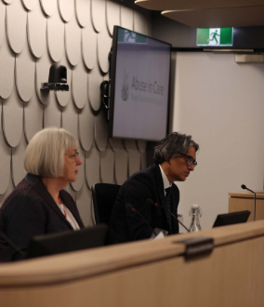

The Government cannot tell the Royal Commission what to do.



The Royal Commission is not part of any faith-basedorganisations like churches.



The Royal Commission calls people who have been through abuse in care **survivors.**

# Update on the Crown response work programme

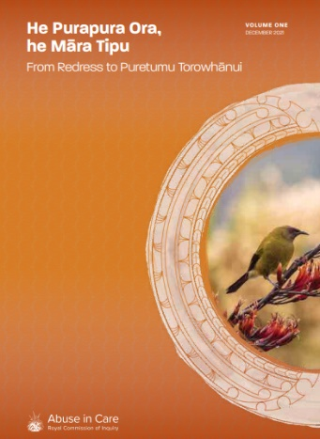In 2021 the Royal Commission wrote a report about **redress**.

The report is called **He Purapura Ora, he Māra Tipu from Redress to Puretuma Torowhānui.**

**Redress** means someone:

* agrees that something bad has happened
* does something to:
* try to 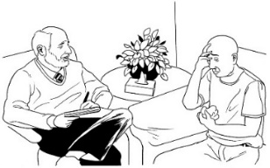put things right
* make up for any harm that has been done.

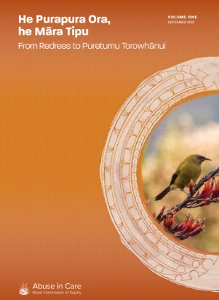In this panui / newsletter when we say **the redress report** we mean **He Purapura Ora, he Māra Tipu from Redress to Puretuma Torowhānui.**

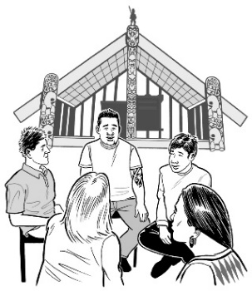

**Puretumu torowhānui** is te Reo Māori phrase that means what making things right should be like.



The redress report made **recommendations** about redress.

**Recommendations** are the things that the Royal Commission thinks should happen.

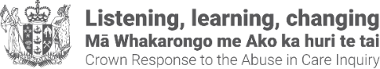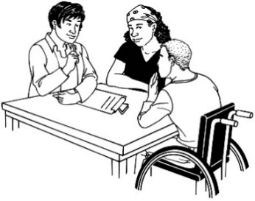The CRU is working on the things the Royal Commission recommended in its redress report.

The Royal Commission of Inquiry will send out its final report on 26 June 2024.



# Update on the Crown response work on care records



The redress report found that many survivors found it hard to access their **care records**.

**Records** are things that people write down about another person.

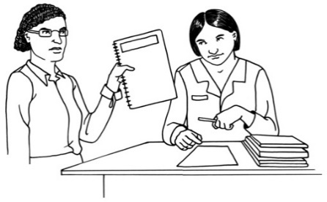

**Care records** are the things written down about people in care.

Some of the things that survivors found difficult are:

* having to wait for a long time to get the information they wanted
* finding lots of information missing from their care records
* information had been taken out of their care records.



The CRU is setting up a website for:

* survivors
* people who have had experiences in care
* 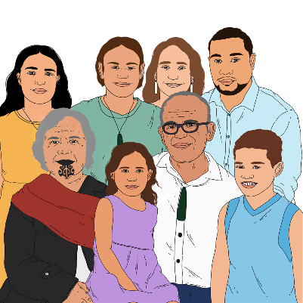family / whānau
* support people.

The website will help people who have had experiences in care access their records.

On the website there will be

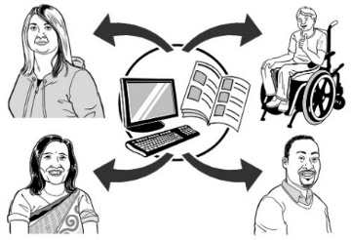information about:

* how to access your records
* where to access your records
* your rights to access your records
* what will happen when you ask for your records.



You will not be able to access your care records from the website.

Your personal records will not be stored on the website.

The CRU is working with the **Citizen’s Advice Bureau New Zealand** to:

* make the website
* run the website.

**The Citizen’s Advice Bureau** support you to find the right support service.

The website should be ready to use by December 2024.

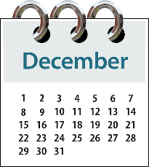

# Setting up a Ministerial group to run the Crown response



The **Minister** for the Crown

response is calledMinister Erica

Stanford.



A **Minister** is someone who works in Government.



Minister Stanford has set up

a Ministerial group.

The Ministerial Group:

* A group of people sitting in a room

  Description automatically generatedis made up of all the Ministers whose work is part of the care system
* will make sure that Ministers work well together on the Crown response to the Abuse in Care Royal Commission of inquiry.



Minister Stanford is the **chair** of the Ministerial Group.

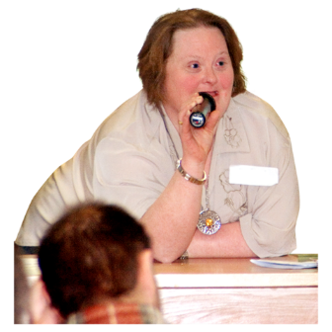

The job of the **chair** is to lead the

group doing the Crown response

work.



The group has been set up now to

start the response before the final

report from the Royal Commission.

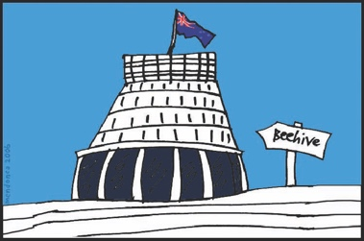The Ministerial Group is made up of

Ministers who work in lots of different

parts of the Government.

The Ministers in this Ministerial Group include:

* Minister of Health and   
  Minister for Pacific Peoples
* Minister of Justice
* Minister for Social Development and Employment and   
  Minister for Disability Issues
* Minister of Corrections and Minister of Police
* Minister for Māori Development Minister for Whānau Ora and Minister for Māori Crown Relations: Te Arawhiti.

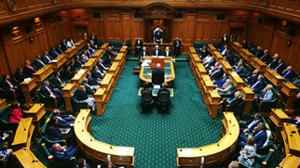The Ministers in this Ministerial Group also include:

* Minister for ACC   
  Minister for Mental Health and Minister for Youth
* Associate Minister of Health
* Minister for Children and   
  Minister for the Prevention of Family and Sexual Violence.

# Where to find more information

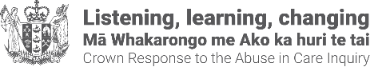You can find more information about the CRU on their **website**:

**www.abuseinquiryresponse.govt.nz**



You can find more information about

the Royal Commission of Inquiry into

Abuse in Care on their **website**:

**www.abuseincare.org.nz**

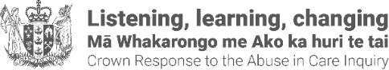This information has been written by the Crown Response Unit.

It has been translated into Easy Read by the Make it Easy Kia Māmā Mai service of People First New Zealand Ngā Tāngata Tuatahi.



The ideas in this document are not the ideas of People First New Zealand Ngā Tāngata Tuatahi.



Make it Easy uses images from:

* Photo SymbolsChangepeople.org

Photosymbols.com

* SGC Image Works
* Huriana Kopeke-Te Aho
* T. Wood.

  
All images used in this Easy Read document are subject to copyright rules and cannot be used without permission.