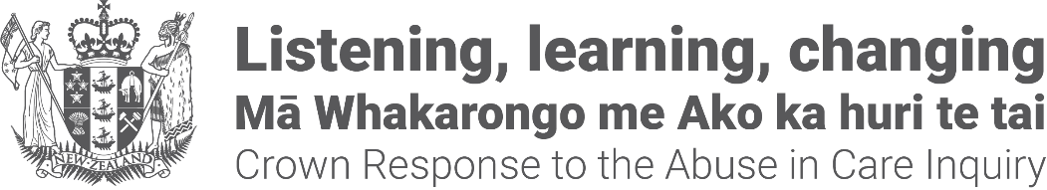
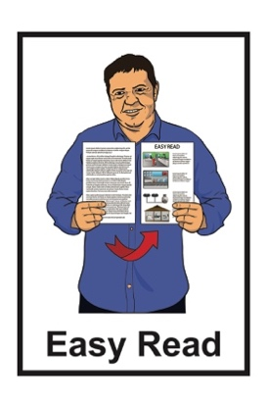

Crown Response to the Abuse in Care Inquiry: Pānui / Newsletter
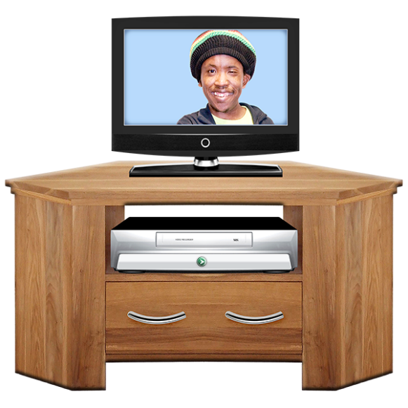
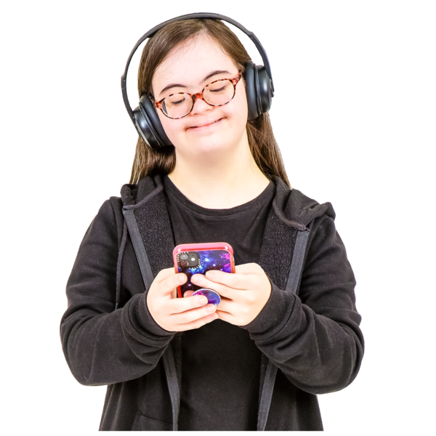

Where to watch or listen to the

Public Apology being held

12 November 2024

Updated: November 2024

Before you start

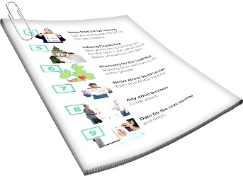
This is a long document.


It can be hard for some people to read a document this long.

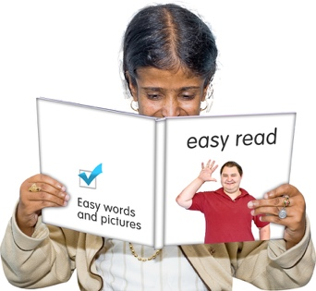
Some things you can do to make it easier are:
read it a few pages at a time
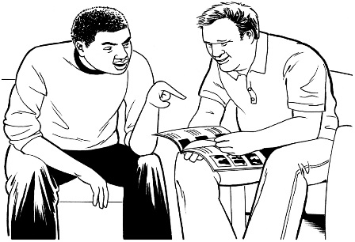
set aside some quiet time to look at it
have someone read it with you to support you to understand it.

What you will find in this document

Page number:
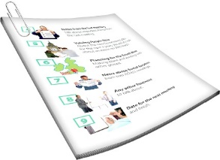

About this newsletter 4

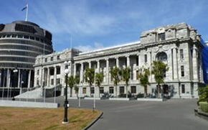
Going to the public apology
event 6


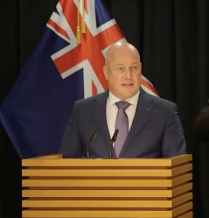
Watching the public apology
event online 8


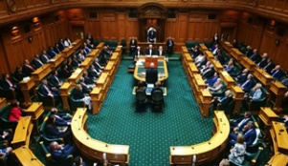
Watching the public apology
event on television 13

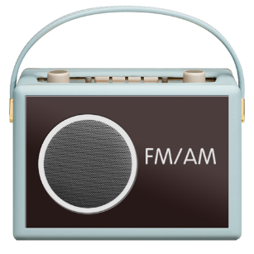
Listening to the public apology
event on the radio 14

Page number:
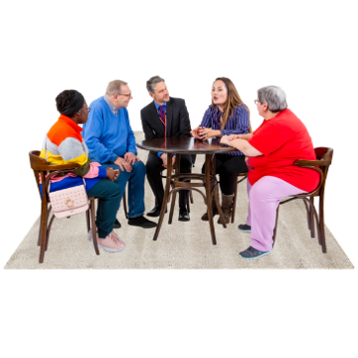

Concurrent events 17

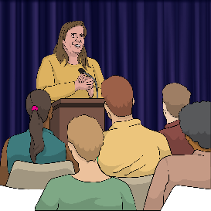
What will happen on the day
of the apology event 19

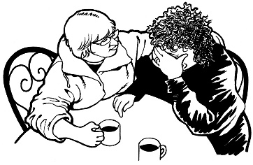
Wellbeing support at the
apology events 22


Wellbeing support before and
after the apology event 25

About this newsletter

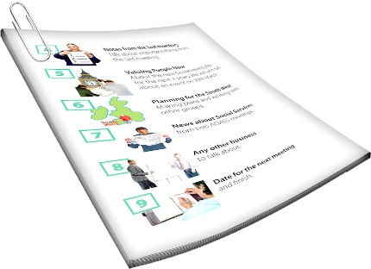
This Easy Read pānui / newsletter is from the Crown Response Unit.

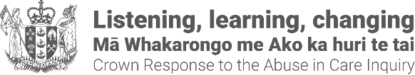
The Crown Response Unit is called the CRU for short.
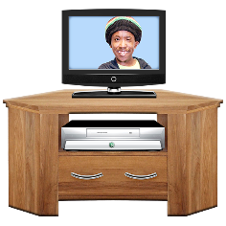
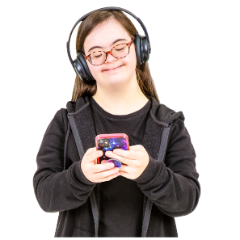

This pānui / newsletter is about how to watch / listen to the public apology for abuse in care.

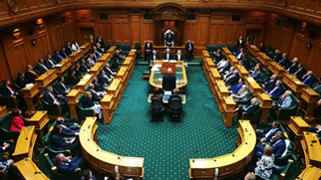
The public apology for abuse in care is when the government says sorry for what happened to people who were abused in care.

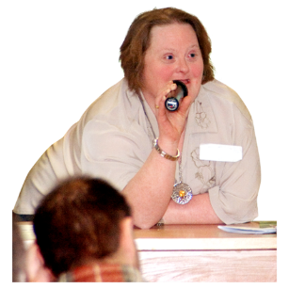
In this document we will call the:

Sorry!
public apology for abuse in care the apology
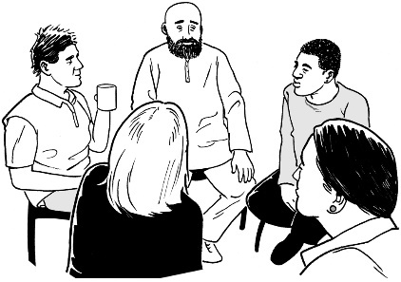
events held at parliament / in other places by the CRU apology events.

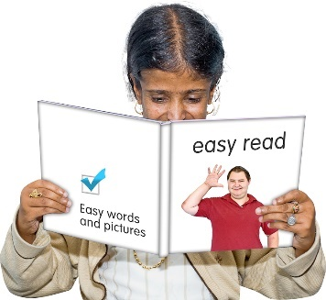
You can find more Easy Read
pānui / newsletters from other months at this website:


https://abuseinquiryresponse.govt.nz/news/alternative-formats/#easy-read

Going to the public apology event

On 12 November 2024 there will be a formal public apology event at Parliament.

Sorry!
A formal public apology event is when there is an event at Parliament where the Prime Minister says sorry for something bad that has happened.
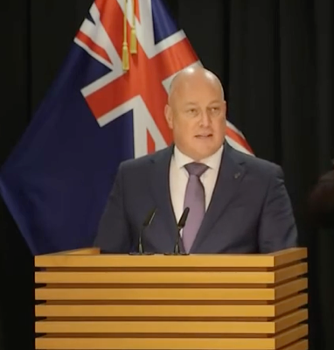

The apology will be made by Prime Minister Christopher Luxon.

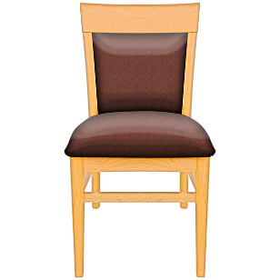
There are no more spaces for people to book to go to the apology event at Parliament.

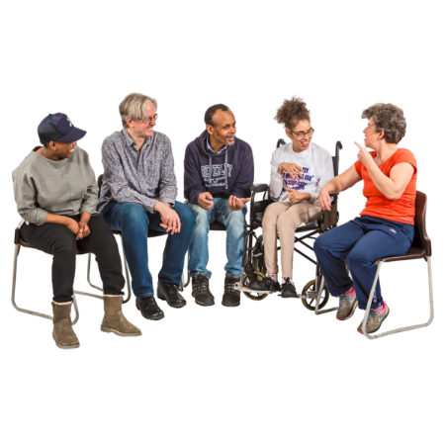
There are other ways to be part of the apology like:
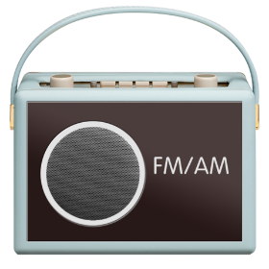
going to an event planned by the CRU to watch the apology with other people

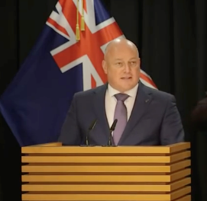
listening to the apology on the radio
watching the apology event on:
- television
- the internet.

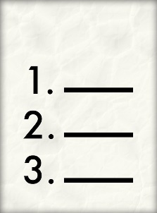
You can find the plan for the apology event at Parliament on pages 19 and 21 of this document.

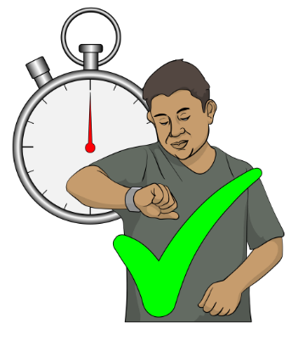
This plan will tell you what time things will happen.

Watching the apology event online

There will be a livestream of the apology event on Vimeo.

A livestream is when something is:



recorded
and
played online at the same time.

Livestreams let you watch things as they happen.

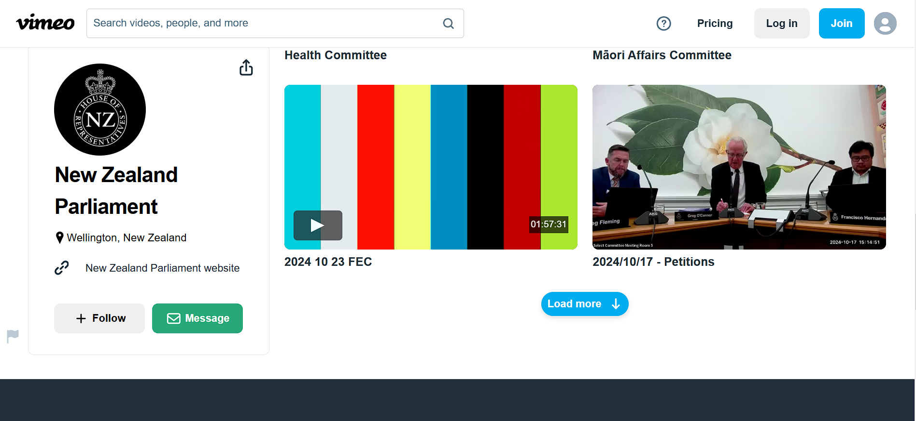
Vimeo is a website for watching videos online using a device like a:



computer
smartphone
tablet.

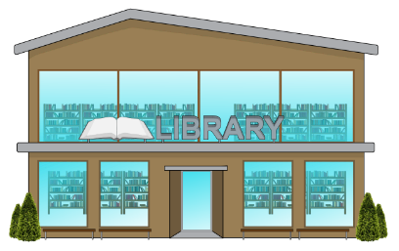
You can use a computer at your local public library if you do not have any of these devices.

You can watch the public apology on Vimeo at:

https://vimeo.com/1016895724/9e0ba34462

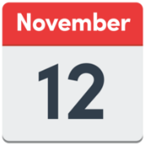
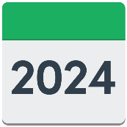
This link will start working on the day of the public apology.

The Vimeo livestream will have captions that tell you what people are saying by writing it on the screen.
Hello

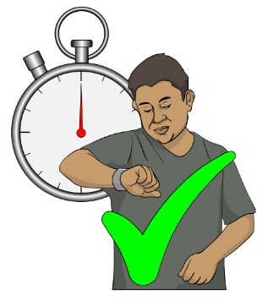
You can use the Vimeo link to watch the apology later if you:
want to watch it again
cannot watch it when it is live.


Watching the livestream on Vimeo will not cost you any money except what you pay for your:

internet connection
phone data.

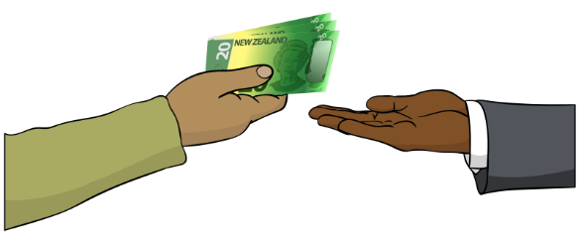
If someone tells you that you need to pay money to watch the apology it is a scam.
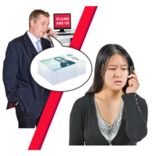
A scam is a plan to trick people to get their:
money / things
information.



Sometimes scammers will lie to trick you by using the names of:
people you trust
groups you trust.

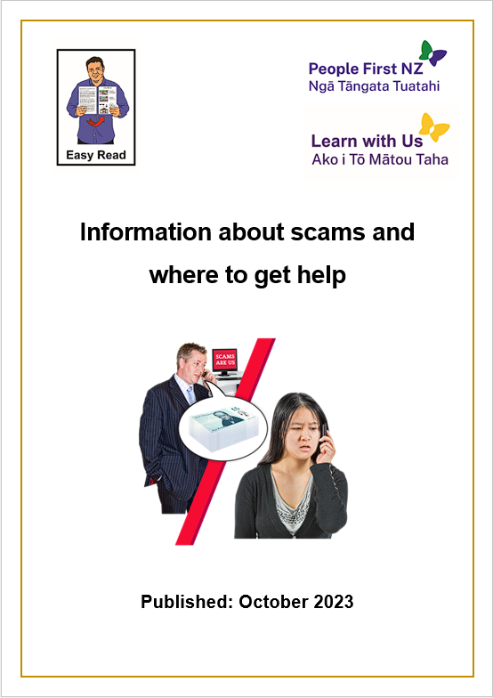
You can read more about scams in the Easy Read document:

Information about scams and where to get help.


You can find this document in the People First Easy Read Library at:

https://bit.ly/48viWyE

Watching the apology event on television

You can watch the apology event live on television on the Parliament TV channel.


Freeview
31
Parliament TV can be found on:
Channel 31 on Freeview
SKY
86
Channel 86 on SKY.
Closed Captions

You can use closed captions when watching Parliament TV.

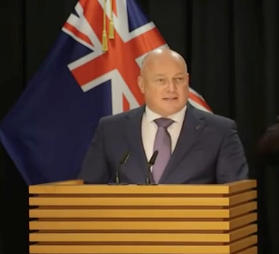
Hello everyone
Closed captions write on the screen what people in the video are saying / sounds that are happening.

Listening to the apology event on the radio
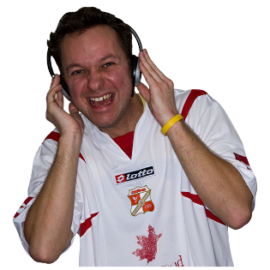

You can listen to the apology event on Radio New Zealand National.

In this document we will call Radio New Zealand National RNZ.
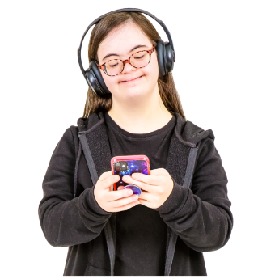

You can listen to RNZ:
on your radio

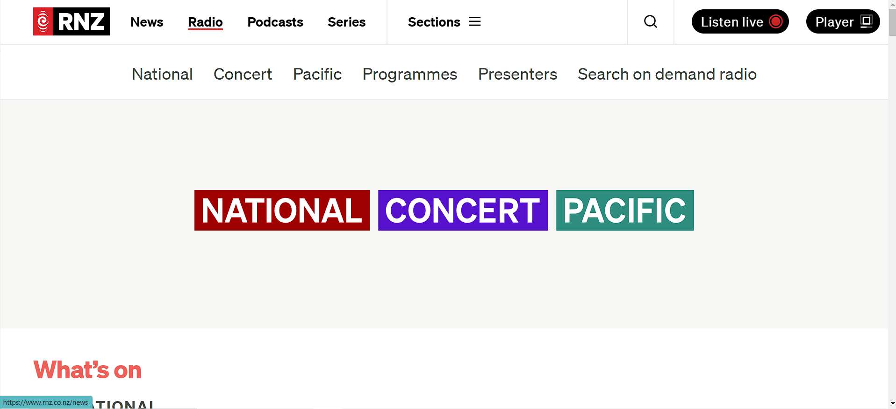
on the Radio New Zealand website
on Sky Digital
RNZ
on Freeview.

You can find out what frequency you need for your radio on the RNZ website at:
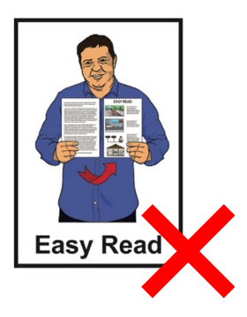
https://www.rnz.co.nz/listen/amfm

This website is not in Easy Read.

A frequency is the number you need to set your radio to so you can listen to the radio station you want.
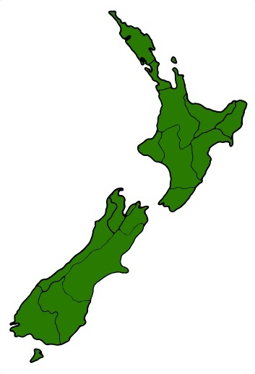

Different parts of the country use different frequencies to listen to the same radio station.


You can listen to RNZ online at:

https://bit.ly/4eVPZy4

You can listen to RNZ on your TV on:
Freeview
50
Channel 50 for Freeview
SKY Digital
421
Channel 421 for Sky Digital.


RNZ
Some parts of the country cannot get RNZ on television.

Concurrent events

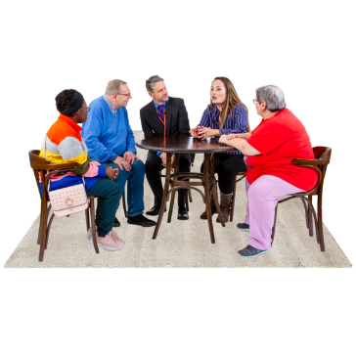
There will be concurrent events for those who:
do not have a place at the parliament event
cannot go to parliament.

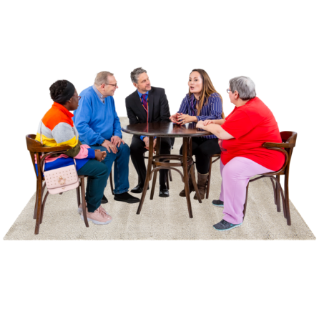
A concurrent event is an event about the apology that is happening at the same time as the apology in Parliament.

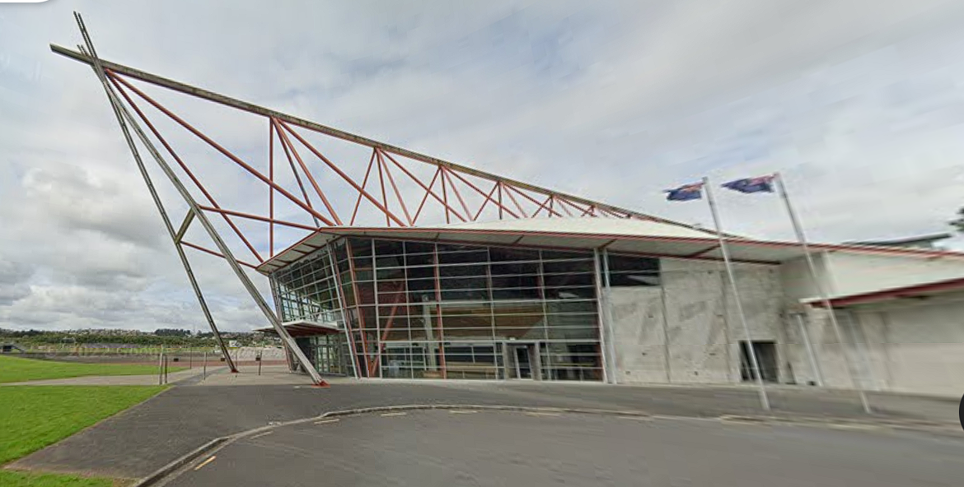
The CRU will run concurrent events in:
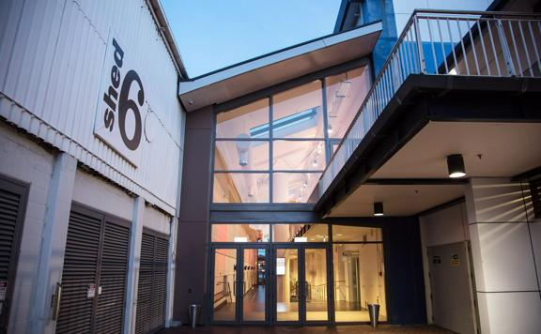
Auckland at the Due Drop Events Centre
Wellington at the TSB Arena in Shed 6 on Queens Wharf
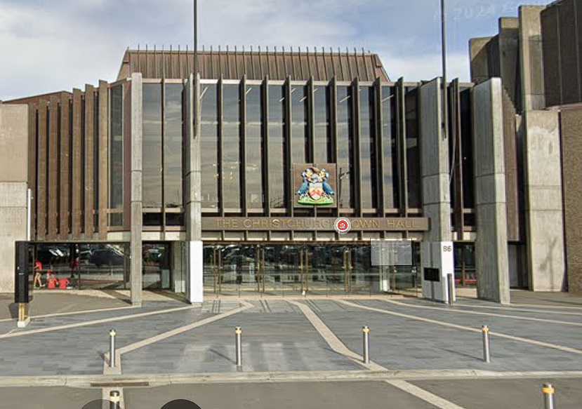
Christchurch at the Christchurch Town Hall in the Limes Room.

Registrations to go to the concurrent events is now closed.

What will happen on the day of the apology event
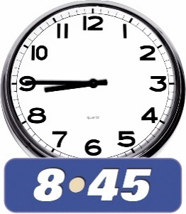
The plan for the apology event is:

8:45am to 9:30am –

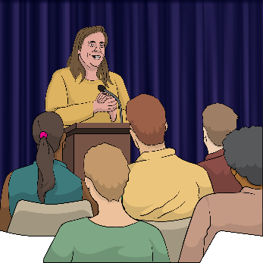
Mihi Whakatau / Welcome
This will happen:
in Parliament
at other events.
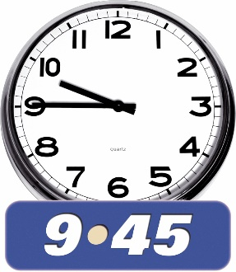

9:45am to 11:00am –

Pre-apology event
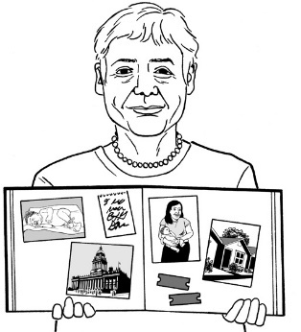
apologies from Chief Executives
stories from survivors of abuse in care.
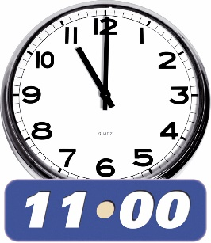
11:00am to 11:30am
Break
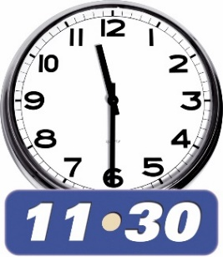
11:30am to 12:20pm –
Formal apology
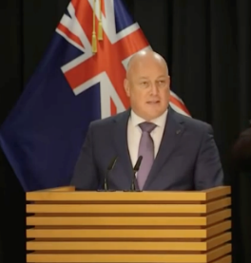
formal apology by Prime Minister Christopher Luxon
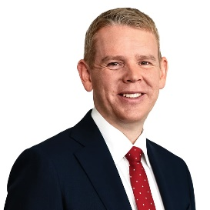
supporting statement from the Leader of the Opposition party Chris Hipkins.
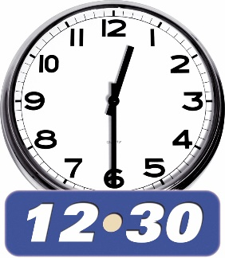

12:20 pm
Livestream finishes.

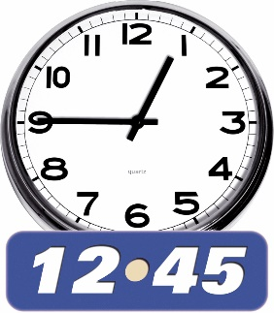
12:45 pm – Lunch

Lunch will be held:
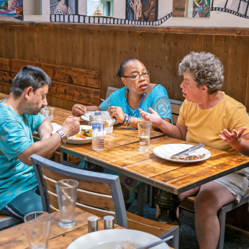
at Parliament
at other events.

Wellbeing support at the apology events

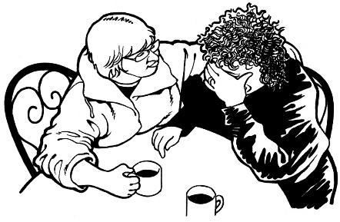
We know that people who come to the apology events may need some support.

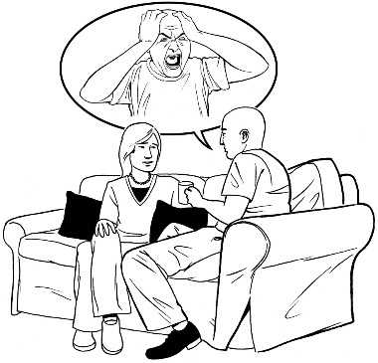
Tautoko Mai will be at the events to offer support to people who want / need it.

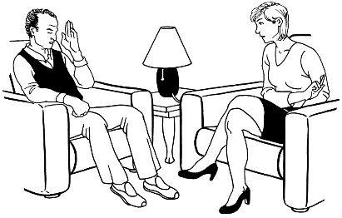
Tautoko Mai is a service that supports survivors of sexual harm.

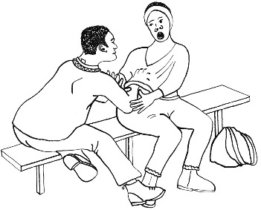
Sexual harm means any sexual action that causes someone to be hurt like being sexually abused.


There will be support people like:
mental health nurse practitioners who are nurses that support people who are having a hard time with how they are thinking / feeling
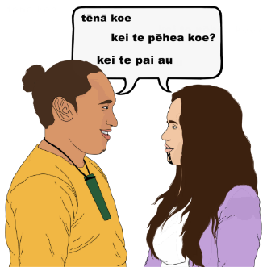
Rongoa Māori / traditional Māori healing providers
counsellors

social workers.


There will also be Support Specialists who are people who:
understand what survivors of abuse in care have been through
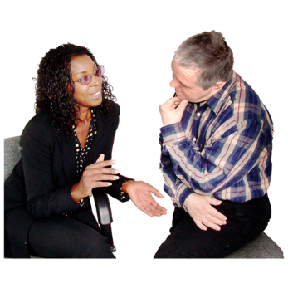
are there to support survivors of abuse in care.

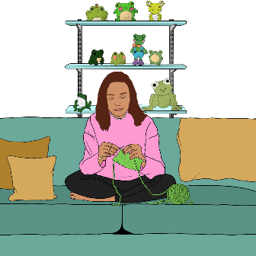
At each event there will be spaces for people to:
have some time alone
speak with wellbeing providers.




At each event there will be:
water stations
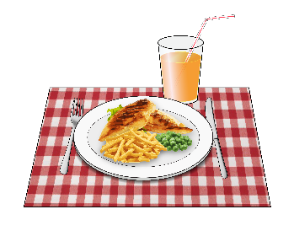
tea / coffee
kai / food.

Wellbeing support before and after the apology event

Some people may need support:
before the apology event
after the apology event.


If you feel you need support you can contact Safe to Talk.

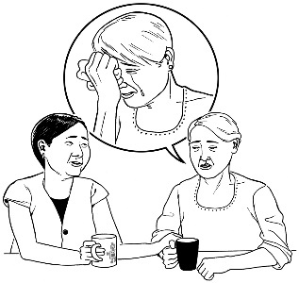
Safe to talk is a sexual harm helpline you can contact if you need to talk to someone about things like:

abuse you have experienced
how you are feeling about the apology.

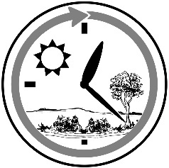
You can contact them at any time of:
day
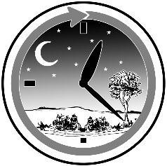
night.


It will not cost you any money to contact Safe to Talk.

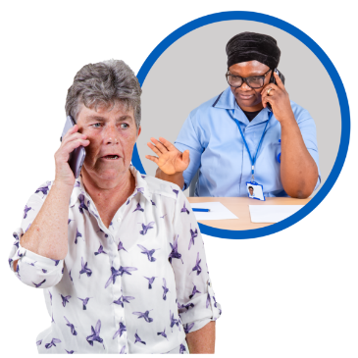
You can contact them by:
phone:

0800 044 334
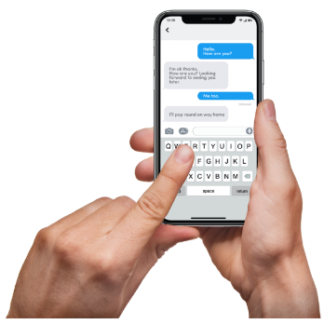
text:

4334
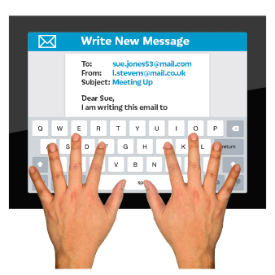
email:

support@safetotalk.nz

You can find out more about Safe to Talk on their website at:

https://www.safetotalk.nz/


If you find it hard to use the phone the New Zealand Relay service is for people who are:

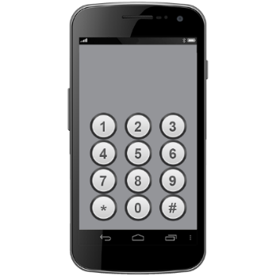
- Deaf / hard of hearing

- deafblind

- speech impaired / find it hard to talk.


You can find out more about the New Zealand Relay service at:

www.nzrelay.co.nz

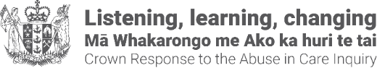
This information has been written by the Crown Response to the Abuse in Care Inquiry.

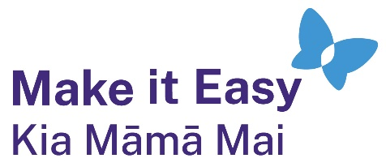
It has been translated into Easy Read by the Make it Easy Kia Māmā Mai service of People First New Zealand Ngā Tāngata Tuatahi.
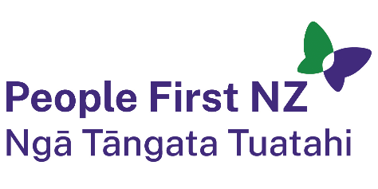
The ideas in this document are not the ideas of People First New Zealand Ngā Tāngata Tuatahi.
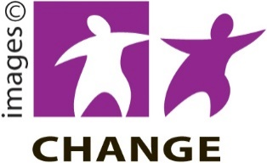
Make it Easy uses images from:
- Changepeople.org


            - Photosymbols.com

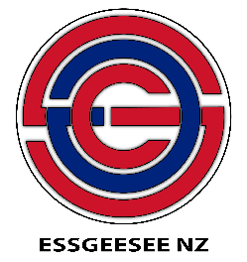

- SGC Image Works
- Huriana Kopeke-Te Aho
- T. Wood.

All images used in this Easy Read document are subject to copyright rules and cannot be used without permission.

