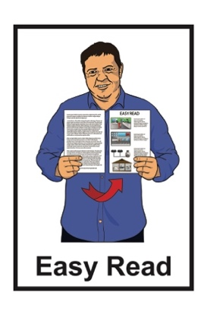

Registration of interest to the  
Abuse in Care –

Public apology event



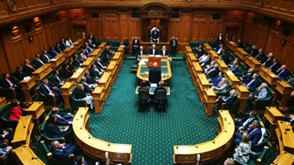

Published: September 2024

# What is in this document



This Easy Read document is from the **Crown Response to the Abuse in Care Inquiry**.

The **Crown Response to the Abuse in Care Inquiry** is working on the Government **response** to the **Royal Commission of Inquiry into Abuse in Care**.

The **response** is what the Government will do because of what the Royal Commission of Inquiry into Abuse in Care found out.

The **Royal Commission of Inquiry into Abuse in Care** was looking into abuse that happened to people in state or faith based care.

Part of the Government response is a **public apology** to **survivors** who were abused in state and faith based care.



Sorry



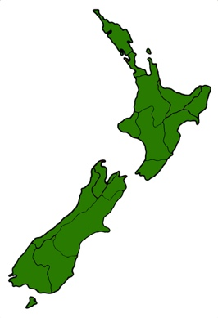An **apology** is when you say sorry.

**Public** means for the whole country.



A **public apology** is when someone says sorry to a group of people in a way that means everyone can be a part of what is said.

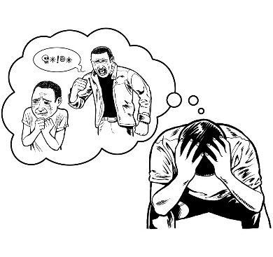

**Survivors** are people who have been though abuse in state or faith based care.

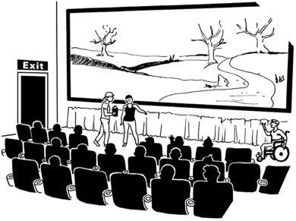There will be events around Aotearoa New Zealand to listen to / watch the public apology.

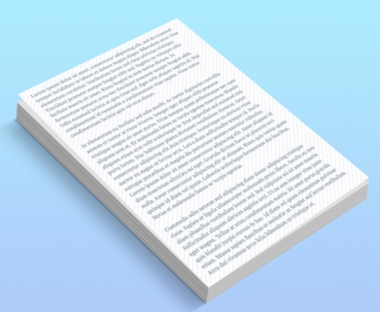

This document has information about how to go to these events.

# The public apology

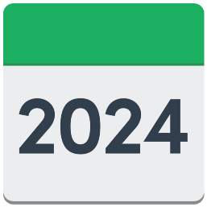

The public apology will be on

**12 November 2024**.

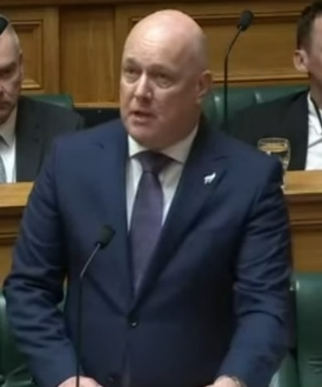The Prime Minister Christopher Luxon will give the apology.

The apology will be held in Parliament.



Some survivors will be able to go to Parliament to hear the apology.



There is not a lot of space in Parliament.

The apology will also be   
**live streamed** to events at:



Due Drop Events Centre

770 Great South Road

Manukau

Auckland

Shed 6



12 Queens Wharf

Wellington

Christchurch Town Hall

86 Kilmore Street

Christchurch.



**Live streamed** means it will be shown on screens at the same time it is happening.



These events are for survivors.

Survivors can bring 1 person to the event with them.

# Registration of interest



**Registration of interest** is to say that you would like to attend 1 of the public apology events.



You can register to be attend the public apology at either:

Parliament

1 of the livestream events.

Your registration of interest may go into a **ballot**.

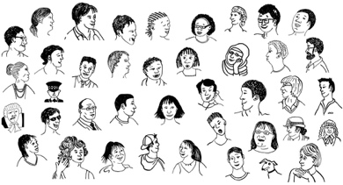

You can find more information about what a ballot is on **page 9**.

To register your interest you need to get in touch with the Crown Response Unit.



You need to get in touch with the Crown Response Unit by

**4:30pm on Monday 30 September**.



To register you interest you can get in touch with the Crown Response Unit by:

* 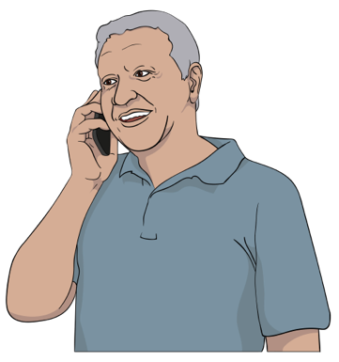**email**:

[**contact@abuseinquiryresponse.govt.nz**](mailto:contact@abuseinquiryresponse.govt.nz)

* **phone**:

**0800 717 017**

You can phone on:

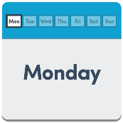

Monday to Friday

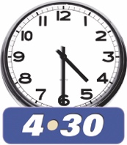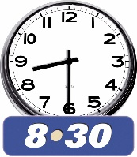

from 8:30am to 4:30pm

If you find it hard to use the phone the **New Zealand Relay** service is for people who are:

* Deaf / hard of hearing
* 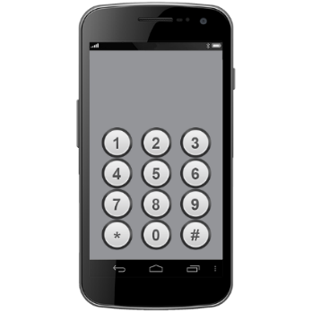deafblind
* speech impaired / find it hard to talk.

You can find out more about the New Zealand Relay service at:

**www.nzrelay.co.nz**

If there are not enough places at the event you want to go to there will be a **ballot**.

A **ballot** means all registrations of interest will be put together.

Names will then get **randomly** **picked** out of all the registrations of interest.



**Randomly picked** means everyone gets an equal chance of having their names picked out.

The Crown Response Unit will tell you if you have a place at an event by Saturday 12 October.

If you go to an event the Crown Response Unit will pay for your:

travel

food

accomodation / place to stay.

This information has been written by the Crown Response to the Abuse in Care Inquiry

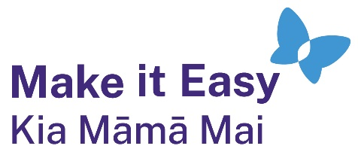It has been translated into Easy Read by the Make it Easy Kia Māmā Mai service of People First New Zealand Ngā Tāngata Tuatahi.



The ideas in this document are not the ideas of People First New Zealand Ngā Tāngata Tuatahi.

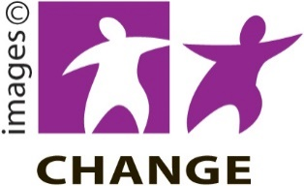

Make it Easy uses images from:

* Changepeople.org

Photo SymbolsPhotosymbols.com

* SGC Image Works
* Huriana Kopeke-Te Aho
* T. Wood.

  
All images used in this Easy Read document are subject to copyright rules and cannot be used without permission.