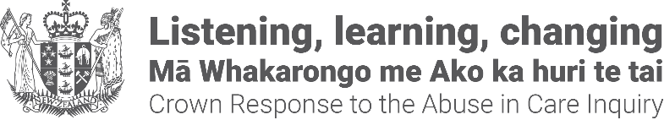

Urgent payments for terminally ill Lake Alice survivors and records support for survivors
Kia ora koutou,
This pānui/newsletter is from the Crown Response Unit, a government organisation set up to coordinate the Government response to the Abuse in Care Royal Commission of Inquiry. We will issue pānui when we can update you on progress on our work programme.
Please feel free to share this pānui to other survivors of abuse in care. They can sign up to receive the pānui at: contact@abuseinquiryresponse.govt.nz with 'pānui' in the email subject line.

Urgent payments for terminally ill Lake Alice survivors
The Government will make urgent payments of $20,000 to eligible survivors of Lake Alice who are terminally ill to help provide end of life care and assist with funeral expenses.
Eligible survivors are persons who were 17 years old or under and placed in Lake Alice between 1972 and 1977. These are survivors who are eligible to claim as part of the government’s existing Lake Alice settlement process.
The Royal Commission of Inquiry into Abuse in State and Faith-based Care’s final report found that most of the 362 children who went through the Lake Alice Child and Adolescent Unit between 1972 and 1978 did not have any form of mental illness.
The $20,000 rapid payment will be delivered through the Ministry of Health as it already operates a historic claims process for survivors of the Unit.
The only supporting material needed to apply for the payment would be a letter from a medical professional confirming a terminal diagnosis and prognosis of six-months or less,
The Minister responsible for coordinating the Crown Response to the Abuse in Care Inquiry, Erica Stanford confirmed the Government is also working at pace on a specific redress package for Lake Alice survivors to acknowledge the torture that took place.
If a survivor were to die after making an application but before a payment is provided, the payment will be made to the Executor or Administrator of the survivor’s estate, as is the case with existing claims processes.
The payment will be tax-free and will not affect the recipient’s benefit status or other entitlements.
To apply for the payment, eligible survivors need to contact the Ministry of Health:
- email: healthlegalexecutiveassistant@health.govt.nz
- call: (04) 4962000
- write: The Historic Abuse Resolution Service, Postal - Health Legal, Ministry of Health, PO Box 5013, Wellington 6145

Survivor Experiences Service now offers Records Support service
The Survivor Experiences Service is for people who were abused in state, faith-based, or other forms of care.
The Survivor Experiences Service can now help survivors request, receive and understand their care records.
They can:
- help you understand which records exist about you;
- help you understand which organisations hold your records;
- help you access them – we can request records on your behalf if you wish, so that you do not have to deal with organisations connected with your abuse;
- help you read and understand the information and language used in your records, if you wish;
- help you decide what you want to do with the information.

How to get records support
Contact to register with the Service and get records support:
- Phone - 0800 456 090 (NZ) 8:30am – 4:30pm Monday – Friday.
- Phone - 1-800 456 032 (AUS) 8:30am – 4:30pm NZT Monday – Friday.
- Email - contact@survivorexperiences.govt.nz
- Text - 8328
- If you are Deaf, hard of hearing, deafblind, speech impaired or find it hard to talk, you can use the New Zealand Relay Service - nzrelay.co.nz

More info can be found on its website: https://survivorexperiences.govt.nz/records-support/
or https://tinyurl.com/4ehe44bu
End of information: Urgent payments for terminally ill Lake Alice survivors and records support for survivors
This Large Print document is adapted by Blind Citizens NZ from the standard document provided by the Crown Response Unit

