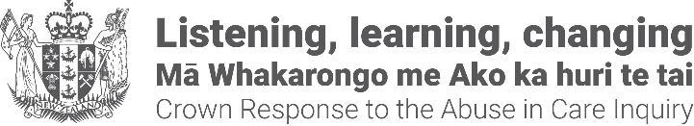
8 November 2024
Kia ora koutou,

This pānui/newsletter is from the Crown Response Unit. We are a Government organisation set up to coordinate the response to the Abuse in Care Royal Commission of Inquiry.

Overview of the public apology event
A formal public apology will be made to survivors of abuse in care at Parliament on 12 November 2024 by the Prime Minister of New Zealand, Christopher Luxon.
The livestream of the public apology event can be accessed here on the day from a computer, smartphone or online via a public library computer. You do not need to pay any money to watch a livestream (other than having access to the internet or data)
https://vimeo.com/1016895724/9e0ba34462
- You can also view it on Parliament TV – Channel 31 for Freeview users, or Channel 86 for SKY users.
- You can listen to it live on Radio New Zealand (RNZ); this webpage provides more information on how to listen: https://www.rnz.co.nz/listen/amfm
Approximate times for the day are as follows.

Time, Event and Location
- 8:45am - 9:30am, Mihi Whakatau in Parliament and concurrent locations.
- 9:45am -11am, Pre-apology event featuring Chief Executive apologies and survivor contributions in Parliament.
- 11:00am – 11:30am, Break
- 11:30am - 12:20pm, Formal apology by Prime Minister with supporting statement by Leader of Opposition
- 12:30pm, Livestream Ends.
- 12:45pm, Lunch in Parliament and concurrent locations.

Concurrent events
The locations for concurrent events are:
- Auckland: Due Drop Events Centre.
- Wellington: TSB Arena, Shed 6, Queens Wharf.
- Christchurch: Christchurch Town Hall, Limes Room.

Wellbeing support at the apology events
Tautoko Mai will provide wellbeing support for the event in Parliament and for the concurrent events.
Support providers may include a combination of practitioners:
- mental health nurse practitioners;
- rongoa Māori providers;
- counsellors;
- social workers;
- abuse in care specialist support practitioners.
Spaces have been set aside in each venue so attendees can spend time alone or to speak with wellbeing providers.
Water stations, tea/coffee and kai will be available at each event.
For people wanting to access wellbeing support prior to and after the apology event, a helpline, Safe to Talk is available 24/7:
- Phone 0800 044 334;
- Free txt 4334;
- Email support@safetotalk.nz

End of pānui/newsletter from the Crown Response Unit, a Government organisation set up to coordinate the response to the Abuse in Care Royal Commission of Inquiry.
This Large Print document is adapted by Blind Citizens NZ from the standard document provided by the Crown Response Unit.

