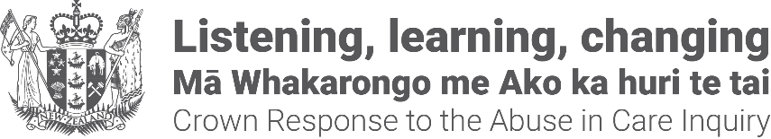

Register your interest to attend a public apology event on 12 November
Survivors of abuse in care and their ‘plus one’ are invited to register their interest to attend a public apology event at Parliament on Tuesday 12 November where the Prime Minister will formally apologise to survivors of abuse in care.
Due to the space available in Parliament, only a limited number of people can attend in this venue. The Government’s priority is to give as many survivors as possible the opportunity to attend an apology event.
The public apology will be live-streamed to the:
- Due Drop Events Centre, Auckland;
- Shed 6, Wellington;
- Christchurch Town Hall, Christchurch.
Please register your interest in attending Parliament or an event closest to where you live, by calling the Crown Response Unit:
Phone: 0800 717 017 (8:30am - 4:30pm Monday - Friday)
If you are Deaf, hard of hearing, deafblind, speech impaired or find it hard to talk, you can use the New Zealand Relay Service www.nzrelay.co.nz
Email: contact@abuseinquiryresponse.govt.nz
Registration closes 4.30pm Monday 30 September.
The Crown Response Unit will notify survivors the outcome of their registration of interest by 12 October.
If there are not enough places for the location you have chosen, a ballot process will be undertaken.
Accommodation, travel and food costs will be covered. Travel assistance will be provided in forms of air travel, petrol vouchers, gift cards, and train, and bus tickets.
End of information | Register your interest to attend a public apology event on 12 November
This Large Print document is adapted by Blind Citizens NZ from the standard document provided by the Crown Response Unit.

