How to nominate someone

to be part of the

Redress Design Group

and advisory groups

November 2022

Before you read this document

Some of the information in this document may make people upset when they are reading it.

This information is:

- not meant to scare anyone

- not true for everyone with disability.

If you are worried after reading this document you can talk about it with your:

- family

- friends.

What you will find in here

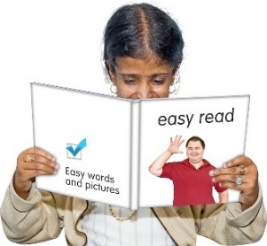
Page number:

What is this document about? 3

What will the Redress Design Group do? 6

What kind of people are we
looking for? 12

How to make a nomination 17

What is this document about?

This Easy Read document is about how to nominate people to be a part of the:
- Redress Design Group

- other groups working with the Redress Design Group.

When you nominate someone you suggest / put forward someone else for a:

- position like in a job

- role like being the leader of a group.

A person can also nominate themselves.
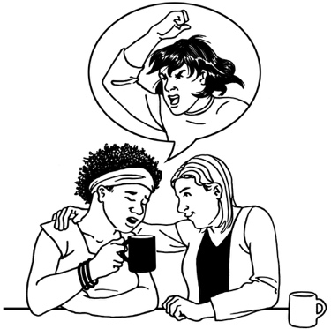
Redress means someone:

- agrees that something bad has happened

- does something to try to:
- put things right

- make up for any harm that has been done.

Redress can be things like:
- saying sorry
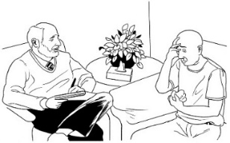
- giving money as a way of saying sorry
- giving other kinds of support like counselling.

The Redress Design Group will work together to decide the best ways of saying to sorry to people who were abused while living in state care.

Abuse can be:

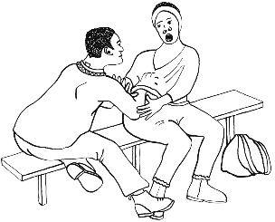
- physical like a person kicking / hitting you

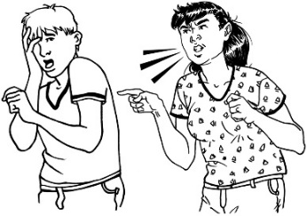
- sexual like if someone does sexual things to you that you do not want them to

- emotional like yelling or saying things to you that are not nice
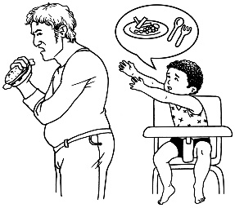
- neglect like not giving you the things / care you need.

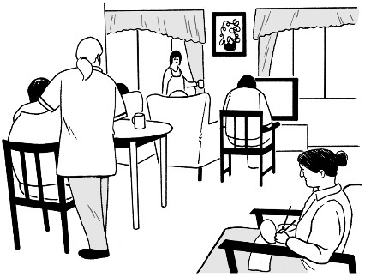
Living in state care means that the government or a faith-based institution was in charge of your care / looking after you.

What will the Redress Design Group do?

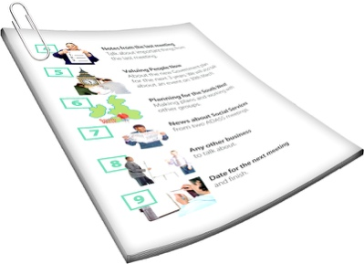
In this Easy Read document we will call the Redress Design Group the RDG for short.

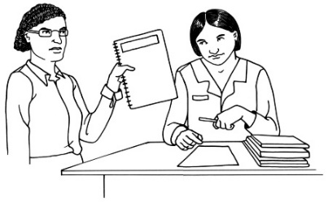
The RDG will work from recommendations made by the Royal Commission of Inquiry into Abuse in Care.

Recommendations are things that should be done to make things better for people.

The Royal Commission of Inquiry into Abuse in Care is an investigation by a group of experts.

Doing an investigation means looking more closely at things that have happened.

Experts are people who know a lot about certain subjects like how abuse can affect people.

The investigation looks at the experiences of people who lived in care between 1950 and 1999.

1999

1950

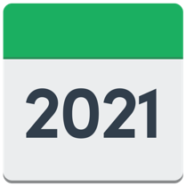
The Royal Commission made a report in December 2021 about what could be done to make things better.

The Royal Commission recommended that a redress system be put in place that was not part of:
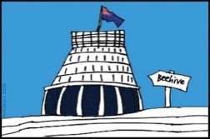
- the government

- churches.

The government agreed to put together the RDG to make a new redress system the best it can be.
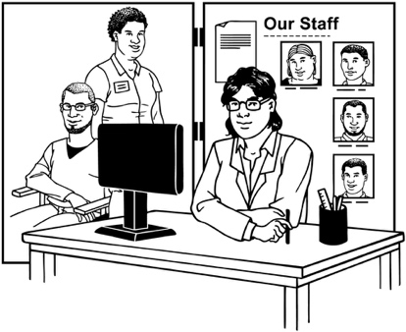
The main things the RDG will look at are:

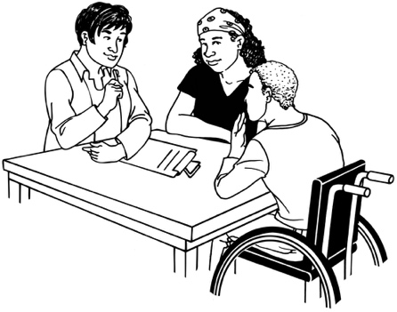
- the services / supports the system should provide

- how the system should connect with / support survivors

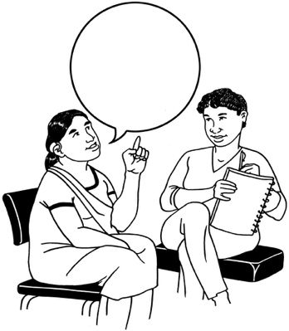
- how the system can say sorry to people in a way that is meaningful

- how the system could offer money to support survivors

- other issues important to making the system the best it can be for everyone.

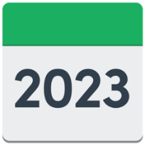
The RDG should be ready to start work by February 2023.

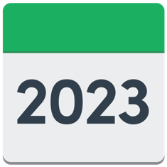
It is hoped that the RDG will finish its work by the middle of 2023.

The RDG will also be supported by some small advisory groups made up of survivors of abuse.

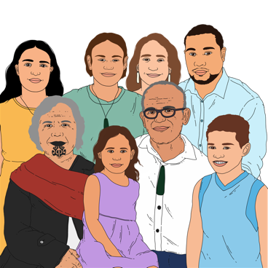
These advisory groups will include survivors from communities who were in state care / faith-based care who are also:

- Māori

- Pacific
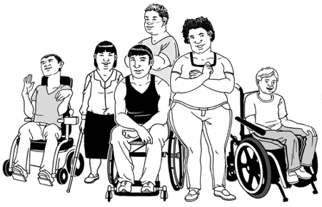
- Deaf / disabled

- young people.

Some experts may also be part of the groups.

The Māori name for the redress system is puretumu torowhānui.

What kind of people are we looking for?

The people we would like to be a part of the RDG should:

- be a survivor of state care / faith-based care themselves
- have experience of speaking up for survivors

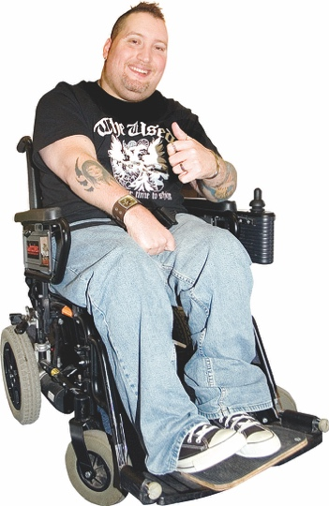
- have the skills / knowledge that means they understand how to put together good support systems / services.

The people you nominate should be able to show they have at least 1 of these skills / experiences.

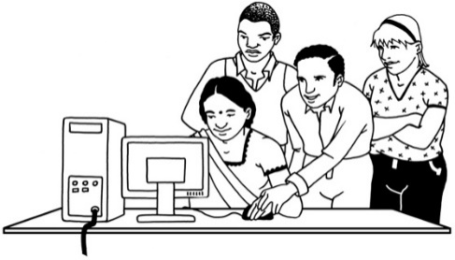
People who are part of the RDG should:

- be able to work well with other people to solve problems

- have a good understanding of how their experiences in care have affected them

- be able to show what kind of skills / experiences they have.

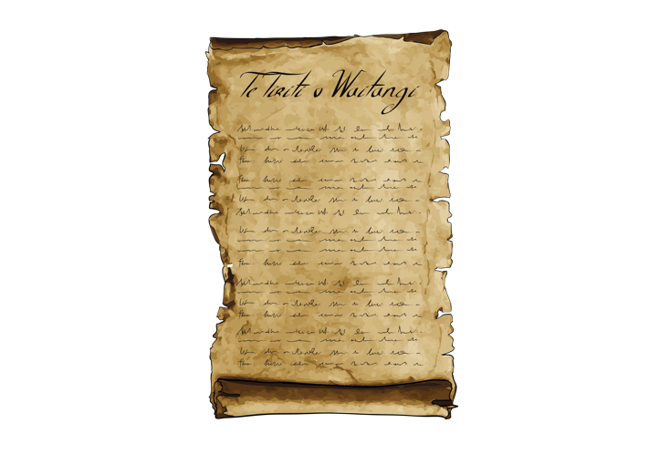
People who are part of the RDG should also have a good understanding of:

- Te Tiriti o Waitangi / The Treaty of Waitangi

- why Te Tiriti o Waitangi / The Treaty of Waitangi is important.

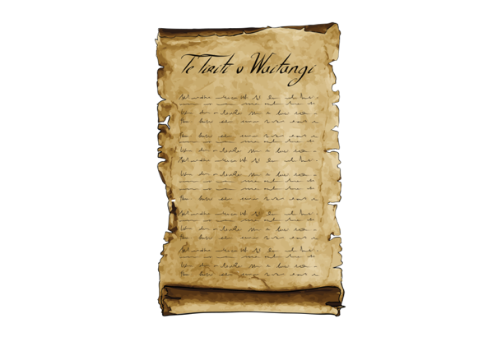
Te Tiriti o Waitangi / The Treaty of Waitangi is an important document that was signed in 1840.

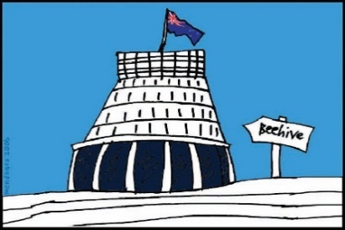
Te Tiriti / The Treaty is about Māori and the New Zealand Government:
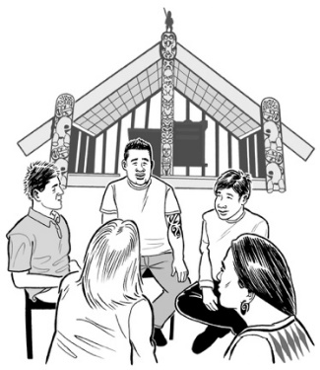
- making decisions together
- protecting things that are important to Māori.

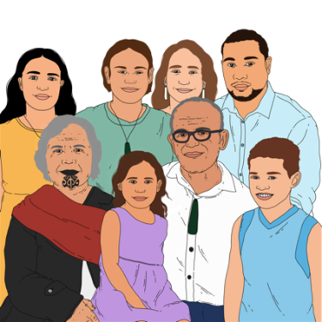
Te Tiriti / The Treaty promises Māori the same rights as all other people in New Zealand.

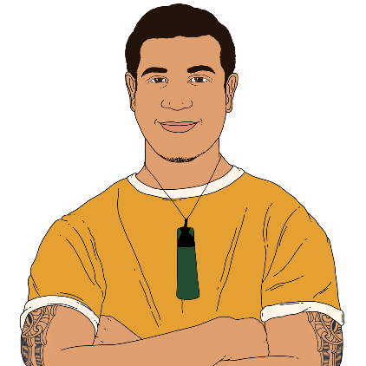
The RDG will have a strong focus on speaking up for Māori.

This is because there are more Māori in state care than other people.
The Crown Response Unit would like to see people nominated to be part of the RDG who are:

- disabled / Deaf

- part of the Rainbow Community / LGBTQIA+

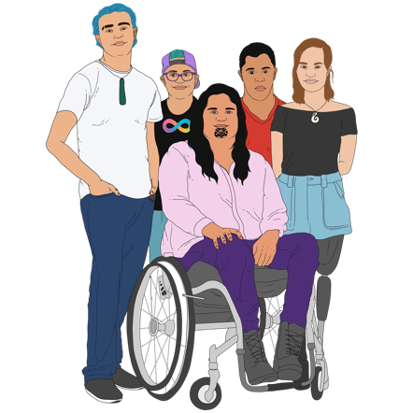
- whānau whaikaha / family of disabled people.

Supports will be put in place to make sure that people who are part of the RDG:

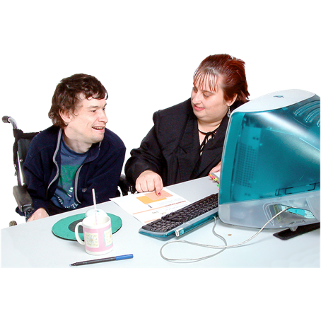
- can work the days / times that best suit them

- are given access to services / supports that can assist them with their work needs.

How to make a nomination

You can nominate:

- yourself

- someone else.

You can nominate yourself / someone to be part of the RDG by filling in the nomination form.

The nomination form can be found at this website:

www.abuseinquiryresponse.govt.nz

The nomination form is not in Easy Read.

You can ask someone to support you to fill in the form if you need to.

This support person could be:
- a family member

- a friend

- someone else you trust.

You can also contact the Crown Response Unit if you need support to fill in the nomination form.

You can email the Crown Response Unit at:

contact@abuseinquiryresponse.govt.nz

You should send your nomination by email to the Crown Response Unit at:
contact@abuseinquiryresponse.govt.nz

You must send your nomination by 5pm on 13 December 2022.

You can find more information about the RDG on the Crown Response Unit website:
www.abuseinquiryresponse.govt.nz

On the same website you can find information about the RDG in alternative format like:

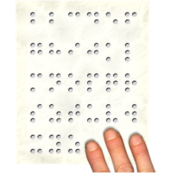
- New Zealand Sign Language

- Braille
- Easy Read

- large print
- audio.

This information has been written by Crown Response to the Abuse in Care Inquiry.
It has been translated into Easy Read by the Make It Easy service of People First New Zealand Inc. Ngā Tāngata Tuatahi.

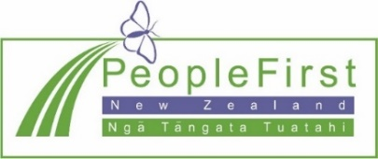
The ideas in this document are not the ideas of People First New Zealand Inc. Ngā Tāngata Tuatahi.
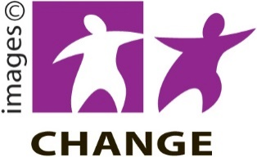
Make It Easy uses images from:

- Changepeople.org
- Photosymbols.com

- Sam Corliss
- Huriana Kopeke-Te Aho

All images used in this Easy Read document are subject to copyright rules and cannot be used without permission.

