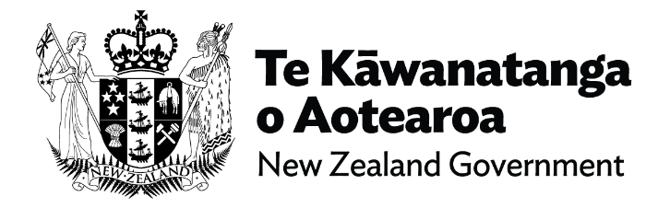

**12 November 2024**

# Public apology to survivors of abuse in care

# Survivor contribution, Fa’afete Taito

Malo lava le soifua ma le lagi e mama - Tēnā tātou katoa – Greetings

First of all I want to acknowledge again those survivors who have left us to join their ancestors. Rest easy. Moe mai rā I want to acknowledge all the survivors in this room, those listening in from the connecting events in Tamaki Makarau, Ōtautahi and here in Whanganui-A-Tara.

I would also like to mihi to the NZ Collective of Abused in State Care aka NZ CAST for organizing a survivor lead event at Pipitea marae as an alternative venue for watching this historical moment in time and for all the essential support and mahi they continue to provide.

There are many survivors present that have fought tirelessly for this day to arrive. We all know of Paul Zentfeld and the mahi he did to highlight the torture and abuse that occurred at Lake Alice. And Hake Halo who sent a letter to his mum by drawing a stickman cartoon character with a caption in Niuean saying ‘mum the man is putting wires in my head from a machine and it hurts’ which initiated the beginning of the end for Lake Alice.

Leonie McInroe who started the first civil litigation against the Crown for the horrendous abuse and torture she suffered at Lake Alice only to be stonewalled by the Crown tactics for over 9 years. She is still fighting for justice. I want to acknowledge Alby Epere and his wife April Mokomoko whose heartbreaking interview led to many coming forward at the beginning of the Royal Commission of Inquiry.

Also those in the faith based survivor community like Darryl Smith, Eddie Marriott and their fellow students for bringing out into the open the atrocities and despicable acts of abuse at Marylands - St John of God institutions. Also my Pasifika sister Frances Tagaloa who keeps reminding us about Faith - based abuse. Paora Moyle who spoke straight from the hip forever keeping the Royal Commission of Inquiry on their toes. Kath Coster and her survivor ribbons.

And I will always stand in support of our gang whānau who thousands of us joined after we were abused and neglected by the state. I was one of them.

So many survivors to thank and to each and every one of our thousands of brave survivors who came forward to recount your story of abuse to the Royal Commission of Inquiry I say fa’afetai fa’afetai fa’afetai tele lava thank you thank you thank you. Without you there would have been no today. And to all those thousands of survivors, who, for whatever reason did not come forward, we did it for you, we’re here for you. Kia kaha.

Over the past four months, two Taonga pieces were produced to forever represent survivors of abuse in care. These were made by two wāhine survivors.

Ngā Rākau Rikiriki - written by Te Pare Meihana is a book of poems that recounts and represents survivors stories. Deeply personal, often harrowing reading if you get a chance, sit with it and be grateful that wasn’t you. It echoes the sentiments that if survivors had been nurtured and loved, cared for by the state instead of discarded and ignored, we could have reached our full potential but we weren’t and here we are today.

He Kakano i ruia mai a Rangiatea - it means ‘The sacred seeds that have descended from the heavens’. Produced by Charmaine Anaru of Oamaru stone and tōtara, it speaks to the innocence and purity of newborn babies, with a scent that is bestowed upon us all at birth. The bottom half of this sacred seed is woven muka thread, extracted from the harakeke. This represents how survivors are connected from all walks of life.

The two tāniko woven kete on the side of the seed holds the bravery, courage and strength of survivors as we endured some of the most horrific and despicable acts of abuse that left a lifetime of trauma. The cavern has a rough exterior, similar to that which we have built as survivors to protect us from what we have had to endure. The poupou are carved depicting the mangōpare (the hammerhead shark). The mangōpare lives in the deepest darkest water unchallenged.

This taonga has a mauri (life force) that needs to be kept alive and not put into some backroom to collect dust. I appeal to the Prime Minister and the Lead Minister Erica Stanford to commit resources so the taonga can travel around the regions. A tangible action that would allow survivors to come together in a meaningful way to support one another under the mauri of the taonga. The taonga, like survivors, must not be shut in the dark. They can act as the conduit to bring our whānau into the light.

Many of us have learnt to live with our un-diagnosed trauma to the point it became a part of who we are. Six years ago, the Royal Commission of Inquiry came along and survivors were asked to tell their stories as a part of the evidential collection process. Many of us were conflicted to do so, including myself. On the one hand we had buried the trauma and just wanted to leave it there. It hurts to dig around the pain. But beyond that we wanted, needed and were owed some accountability for what had happened to us. So we took those first steps. And today we will finally see what accountability could look like.

I know that for my survivor whānau there are huge expectations for this day and beyond. The most important being that the redress will include an outcome that will keep our mokopuna safe from any further harm. That is the one non negotiable. You, the state, must commit to that.

My brothers and sisters of te whānau mōrehu, we can’t do anything about the abuse we suffered at the hands of the State but we can be responsible for our healing. Regardless of what happens today it is our collective power that will contribute most to our healing journey. We owe ourselves that.

To the other side of this shit fight, to you, the state - you owe us too. It’s not enough to say sorry. As any good parent knows, it’s what you do to heal the wounds of your actions and make sure it never happens again that really counts. Make it count.

End of information: Public apology to survivors of abuse in care | Survivor contribution, Fa’afete Taito

This Large Print document is adapted by Blind Citizens NZ from the standard document provided by the Crown Response Unit