


Abuse in care public apology:
Leader of the Opposition
Chris Hipkins
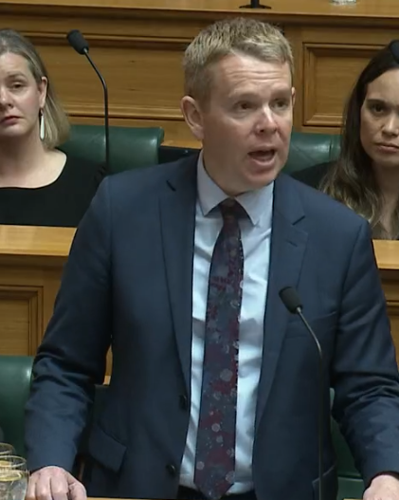

Published: November 2024

Before you start


This Easy Read document talks about abuse.



This information may upset some people when they are reading it.

This information is not meant to scare anyone.

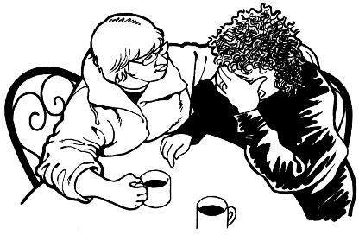
If you are upset after reading this Easy Read document you can talk to your:
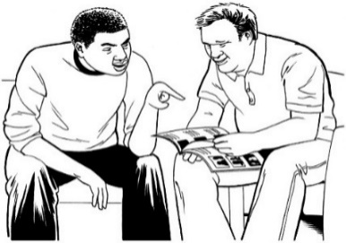
- whānau / family
- friends.


For more support you can contact a helpline called Safe to talk.

You can contact Safe to talk by:

Phone: 0800 044 334

Text: 4334


Email: support@safetotalk.nz

Website: www.safetotalk.nz

Safe to talk is open 24 / 7.



24 / 7 means you can call these helplines any time:

- 24 hours a day which means at any time in the day or night
- 7 days a week.

You can also contact the Survivor Experiences Service to share your experiences of abuse in:
- State care
- faith-based care
- other forms of care.


In New Zealand you can:

Phone: 0800 456 090
Text: 8328

Email:

contact@survivorexperiences.govt.nz

It does not cost any money to
call / text the Survivor Experiences Service.


If you are calling from Australia you can phone:

1 800 456 032



You can call this number:


- between 8:30 am and 4:30 pm
- from Monday to Friday.



These times are for the New Zealand time zones.

You can also send a text to the Survivor Experiences Service on:

+61 438 384 957

It does not cost any money to
call / text the Survivor Experiences Service.

About this document




On 12 November 2024 different parts of the Government made a public apology to people who had been abused while in:
- state / government care
- faith-based care.


Sorry

A public apology is when someone says sorry to a group of people in a way that means everyone can be a part of what is said.
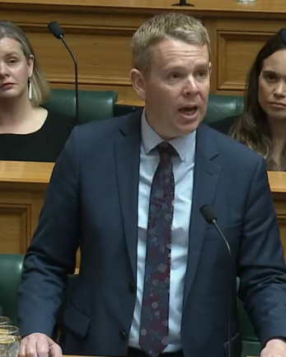

This Easy Read is a summary of the public apology made by the Leader of the Opposition Chris Hipkins.


A summary:
- is shorter than the original
message
- tells you what you need to know.

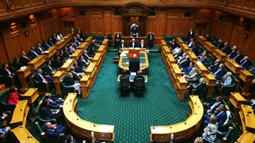
The Opposition means the Members of Parliament who are not part of the Government.

This document includes some quotes from Leader of the Opposition Chris Hipkins.

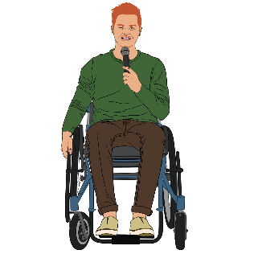
A quote is an exact copy in writing
of what someone has said.
“Hello”

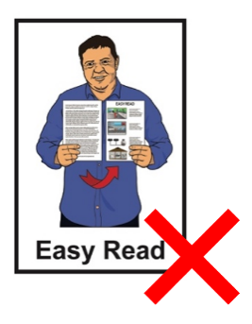
The quotes are in yellow boxes like this.

The quotes are not in Easy Read.


You can watch the video of the full speech by Chris Hipkins:

tinyurl.com/z4kx7kwf


The speech by Chis Hipkins starts at about 18 minutes into the video.

You can read the full speech by Chris Hipkins online at:

tinyurl.com/499mvzez

The full speech is not in Easy Read.

The apology from Leader of the Opposition Chris Hipkins

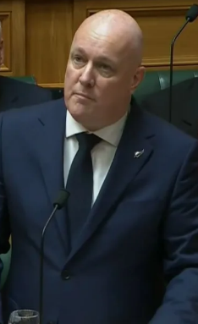
“Can I start by acknowledging and fully supporting the words of the Prime Minister in delivering the formal apology on behalf of successive Governments who have failed you, survivors, your families, whānau, kāinga, hapū, iwi, your communities, your support networks, and New Zealand as a nation.”

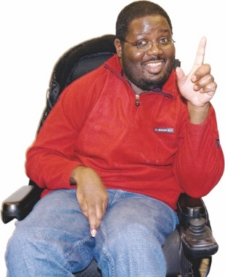
Acknowledging means saying you:
know about something

understand that something is important.

Successive means 1 after another.

Survivors are people who have been through abuse in care.


“I want to acknowledge all of you—those who are physically here at Parliament today, those who are watching all across the country, those who find it too painful to engage in this process at all, and those who have died before today finally arrived.”



Chris Hipkins said that abuse in care has harmed people from many communities like:
Māori

Pacific people
Pākehā.

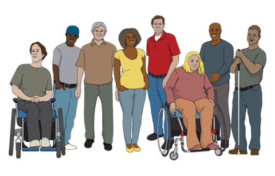
Chris Hipkins also said abuse in care has harmed people who are:

Deaf / disabled
in the rainbow community.


The rainbow community means people who are:

lesbian
gay

bisexual
transgender
intersex

asexual
other people who fit in similar groups.

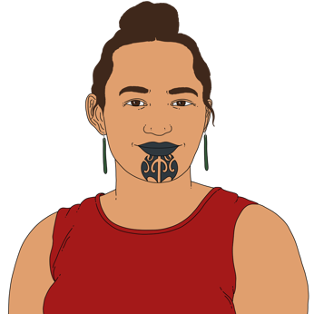
Chris Hipkins said abuse in care has done a lot of harm to:

takatāpui who are Māori members of the rainbow community
pacific members of the rainbow community which is sometimes called the MVPFAFF+ community

Sorry
“We are sorry.”

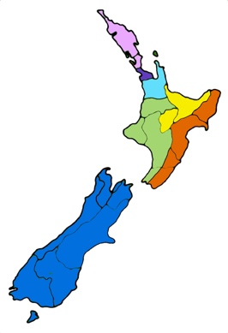
“Today, all of Aotearoa New Zealand will bear witness to the truth, to what survivors experienced, to our decades of wilful ignorance, denial, minimisation, and to our conviction to end such horror and vile acts from continuing.”

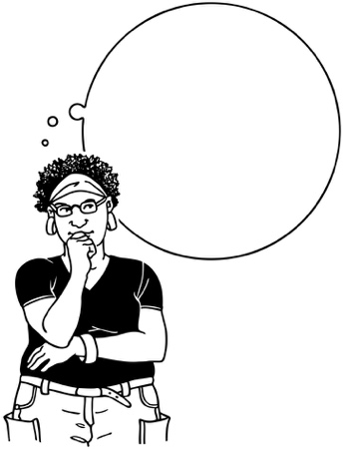

Bear witness means to see that something is true.


Wilful ignorance is when someone chooses not to find out about something.


Here minimisation means acting as if something is less important than it really is.

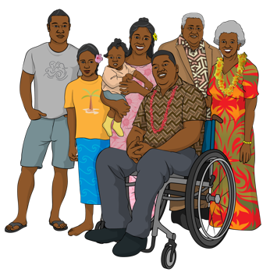
“Every corner of New Zealand has been affected by this abuse—a family member, a neighbour, a colleague, a friend.”

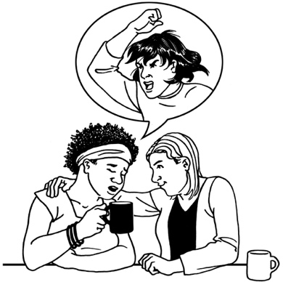
“To those who shared your stories with the inquiry, thank you.”

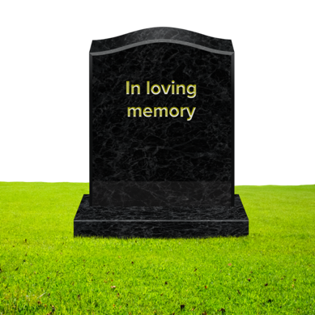
“To those who've chosen not to recount those memories, we wholeheartedly understand.”


“To those who died before they were given the opportunity to be heard, rest knowing that you are heard today.”

“I give my thanks to all of those who were involved.”

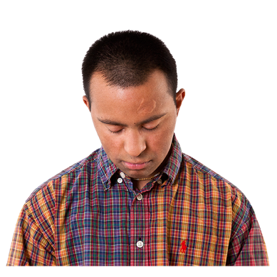
“While necessary and welcomed, for many the inquiry and associated events stir up and exacerbate the pain and the suffering, and I know that, for many, today will be painful.”

Exacerbate means to make something worse.


“The things that we speak about today rise from the worst of human nature.”

“They show us how immoral and reprehensible it is that we, as the Crown, not only allowed it to happen and ignored it but further punished those who spoke out.”
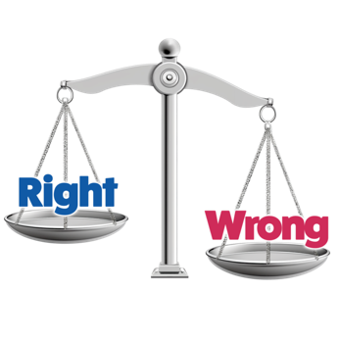

Immoral means very bad / wrong.


Reprehensible means something people should feel ashamed about.

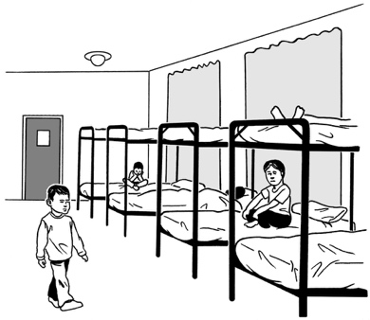
Chris Hipkins said a lot of survivors were put into care because of discrimination.

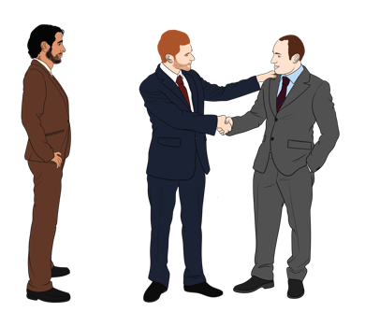
Discrimination is when people are treated unfairly because of things like being:
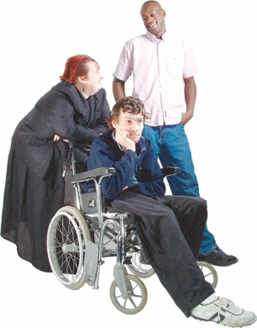
Māori
a man / woman / someone of another gender
disabled.


Chris Hipkins said survivors were harmed by people they should have been able to trust.

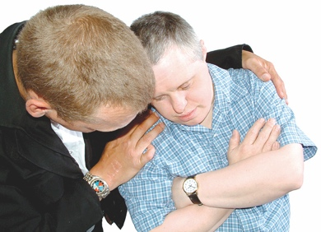
“You lived without care, affection, love, emotional support, and connection.”

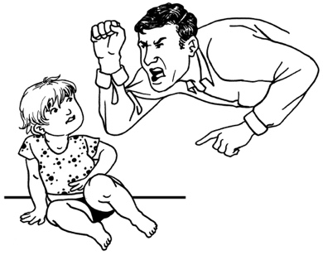
“Many of you experienced psychological and emotional neglect and abuse, being institutionalised and denied your personhood.”
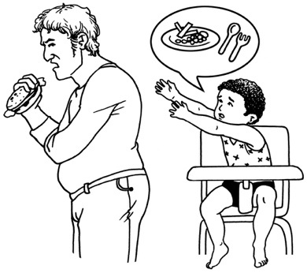

Neglect means not giving someone the care they need.

Here being institutionalised means being in care has left someone not knowing how to live in the community.


Here personhood means you can:
think for yourself
make your own choices.

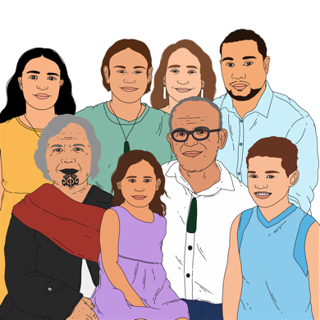
Chris Hipkins said abuse in care did not just harm survivors.

He said abuse in care also harmed:
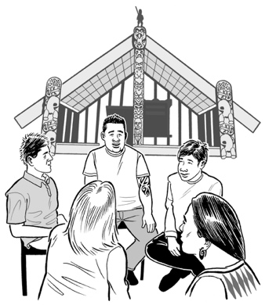
whānau / families
hapū
iwi
communities.

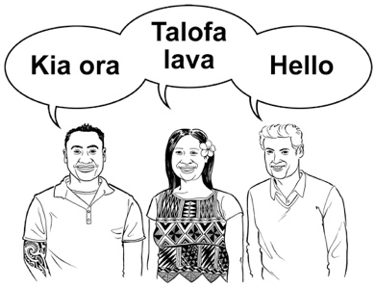
Chris Hipkins also said survivors were often isolated from their:
culture
language
sense of self which is understanding who you are.
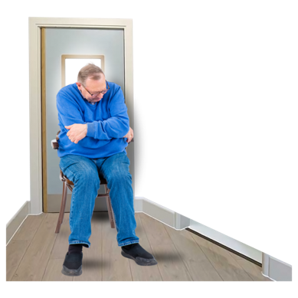
whānau / family.

Isolated means kept away from.

Culture is a way of:

thinking that a group shares
doing things as a group.

“Successive Labour Governments, Ministers, ministries, and State institutions had a role to play in this neglect, this abuse, this trauma, this torture.”

The Labour Party is the biggest party in the Opposition.

Chris Hipkins is the leader of the Labour Party.
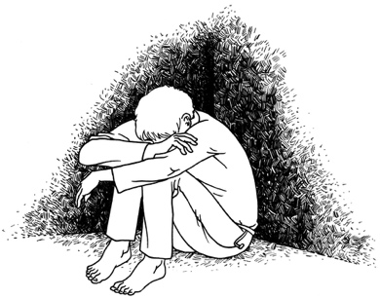

Trauma is what happens when you go through something very bad.


Torture means hurting someone very badly to:
punish them
make them do / say something.

“They allowed systems they governed to continue to place children, young people, and vulnerable adults in care unnecessarily, and to hurt them while they were there.”

Unnecessarily means it did not need to happen.

Chris Hipkins said people in the Labour party ignored survivors who talked about their abuse.
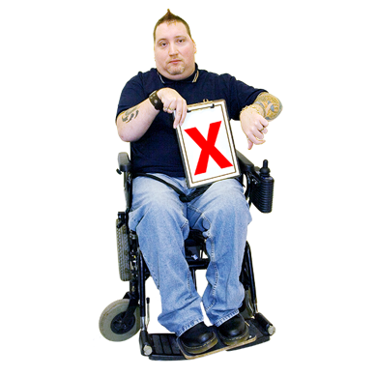

“That was wrong.”

“So today, I want to tell you on behalf of successive Labour Governments, we also formally and unreservedly say sorry for the neglect, abuse, trauma, and torture that took place in State- and faith-based care institutions.”

Sorry


Unreservedly means:
totally
without holding anything back.


“Today, I want to confirm that we hear you.”

“We hear all of you, and we are sorry that that took so long.”

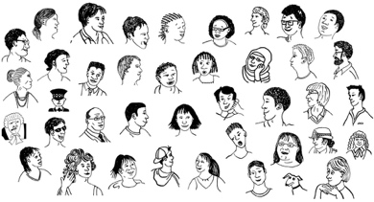
“To each and every one of you who endured all that suffering, to your families, your children, mokopuna, your kāinga, your hapū, your iwi, your communities, we see your scars and we hear you.”

Sorry

“And we are sorry.”

Here endured means coped with something for a long time.

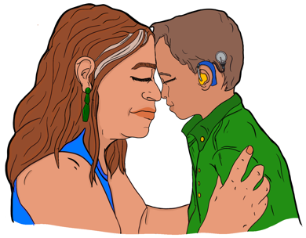
“You should have been safe, protected, and believed, and you were not.”

“That is the ultimate injustice that we, as representatives of the Crown, must also bear the burden of.”

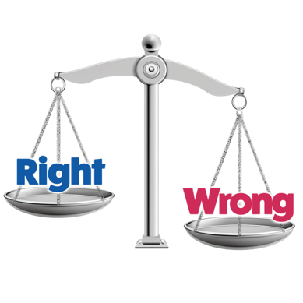
Here injustice means something that:
was not fair
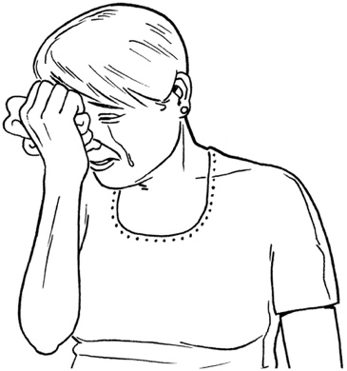
caused harm
should not have happened.

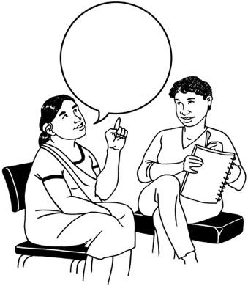
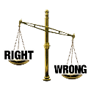
“I am sorry that the last Labour Government did not act more quickly to put in place an independent redress system.”

An independent redress system is a way of giving redress to survivors that is not controlled by the Government.

Redress means someone:
agrees that something bad has happened

does something to try to:
- put things right
- make up for any harm that has been done.


Redress can be things like:
saying sorry
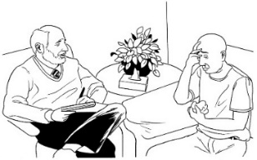
giving money as a way of saying sorry
giving other kinds of support like counselling.

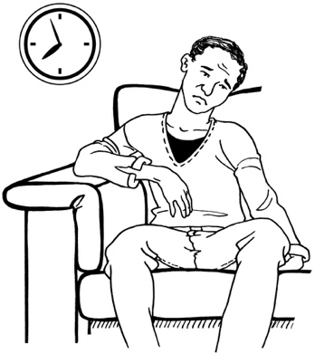
“Redress has taken far, far too long, to the point where many have already died or fear they might do so before getting any compensation.”


Compensation means giving something like money to make up for a bad thing that happened.

Chris Hipkins said that the Labour Party promises to work with the
Government to make redress happen faster.


He said that redress will cost the Government a lot of money.


He said the Government must give survivors the redress they are owed no matter how much it costs.

“I'm under no illusions that neglect, abuse, and trauma in State care still happens today.”


I’m under no illusions means I understand what is true.

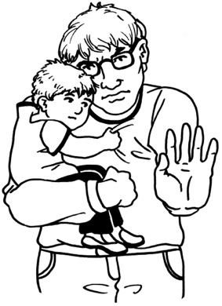
“For this apology to have any credibility, we must take concrete action to stop it.”

If something has credibility it means it can be believed.

“You've heard words before and now you want action—I hear you.”

“Survivors emphasise time and again that they don't want what happened to them to happen to one more person.”


Emphasise means say strongly.

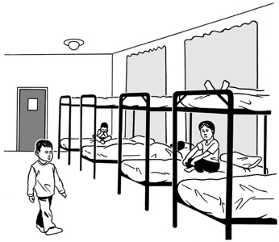
Chris Hipkins said we need to change our care system.

He said we should change things so most people do not need to go into care.


“But when people are in care, it should be a safe and warm space for all, as it should always have been.”

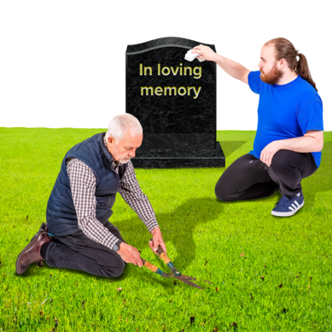
“We also support the Government to work with local authorities to honour the unmarked graves and to remove the names of proven perpetrators from public places.”
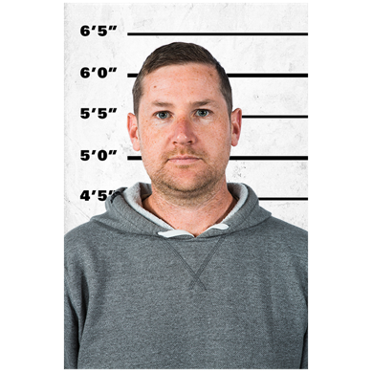

Perpetrator means someone who has done a bad thing.

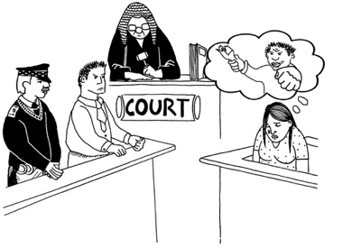
“For the guilty who remain nameless, we encourage the Government to ensure that all is done to hold those perpetrators to account.”

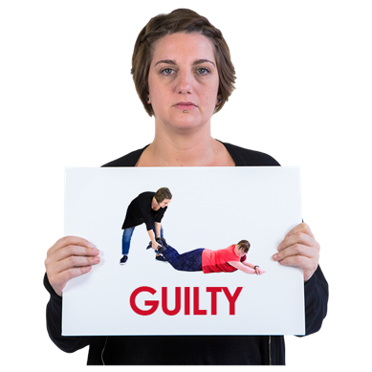
Here to hold someone to account means to make sure they:
own up to what they have done
do something to make up for what they have done.

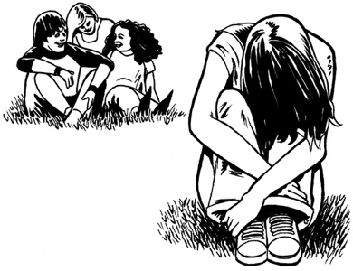
“I want to acknowledge in closing that for some and perhaps many of you, there will never be healing and closure.”

Sorry

“My hope is that this apology today offers at least some relief—that your fight to be heard has resulted in this apology.”


“The Royal Commission set out survivors' dreams for the future—he māra tipu, a garden of growth—where every child, young person, and adult is loved, safe, and cared for in a manner that supports their growth and development into a thriving contributor to society.”
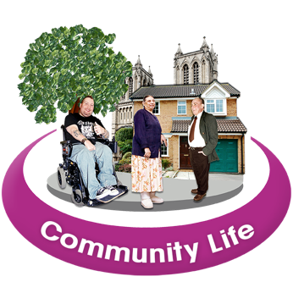

Here contributor means someone who can take part in their community.


“That's my dream too, and I hope that together we can achieve it for generations to come, and never ever again repeat the mistakes of the past.”

This information has been written by Leader of the Opposition Christopher Hipkins.


It has been translated into Easy Read by the Make it Easy Kia Māmā Mai service of People First New Zealand Ngā Tāngata Tuatahi.

The ideas in this document are not the ideas of People First New Zealand Ngā Tāngata Tuatahi.

Make it Easy uses images from:
- Changepeople.org


            - Photosymbols.com



- SGC Image Works
- Huriana Kopeke-Te Aho
- T. Wood.

All images used in this Easy Read document are subject to copyright rules and cannot be used without permission.

