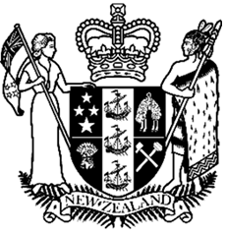
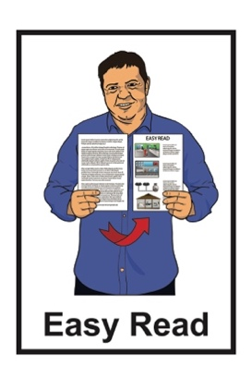

Abuse in care public apology:
Prime Minister
Christopher Luxon

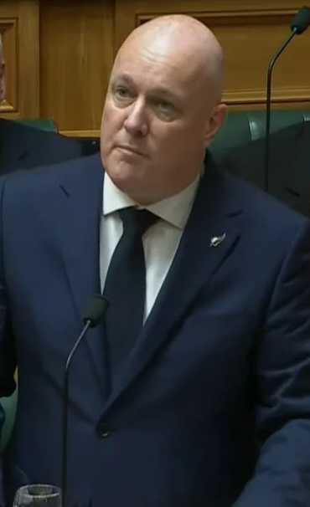
Gup

Published: November 2024

Before you start


This Easy Read document talks about abuse.

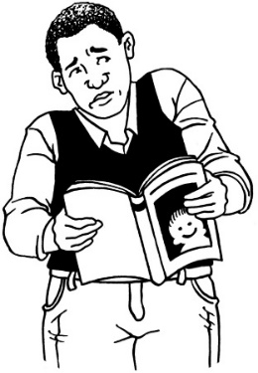

This information may upset some people when they are reading it.

This information is not meant to scare anyone.

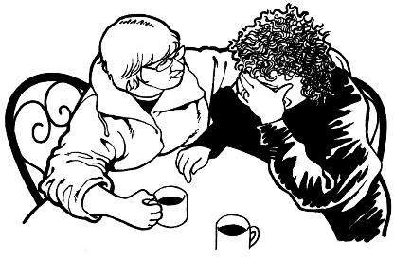
If you are upset after reading this Easy Read document you can talk to your:
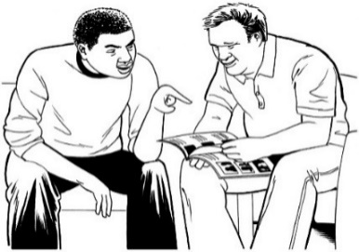
- whānau / family
- friends.


For more support you can contact a helpline called Safe to talk.

You can contact Safe to talk by:

Phone: 0800 044 334

Text: 4334


Email: support@safetotalk.nz

Website: www.safetotalk.nz

Safe to talk is open 24 / 7.

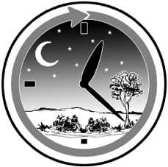
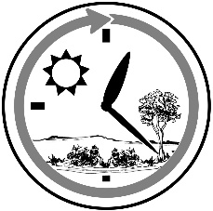
24 / 7 means you can call these helplines any time:
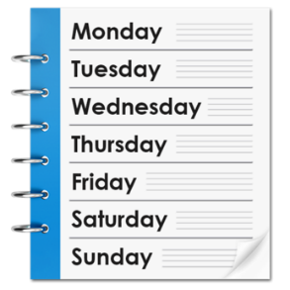
- 24 hours a day which means at any time in the day or night
- 7 days a week.

You can also contact the Survivor Experiences Service to share your experiences of abuse in:
- State care
- faith-based care
- other forms of care.


In New Zealand you can:

Phone: 0800 456 090
Text: 8328

Email:

contact@survivorexperiences.govt.nz

It does not cost any money to
call / text the Survivor Experiences Service.


If you are calling from Australia you can phone:

1 800 456 032

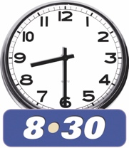
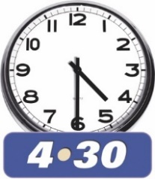
You can call this number:

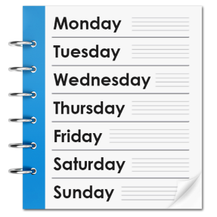
between 8:30 am and 4:30 pm
from Monday to Friday.



These times are for the New Zealand time zones.

You can also send a text to the Survivor Experiences Service on:

+61 438 384 957

It does not cost any money to
call / text the Survivor Experiences Service.

About this document



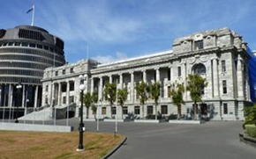
On 12 November 2024 different parts of the Government made a public apology to people who had been abused while in:
- state / government care
- faith-based care.
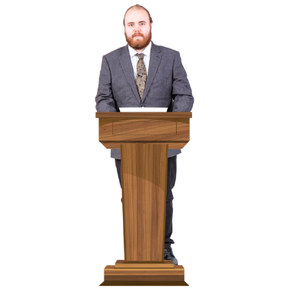

Sorry

A public apology is when someone says sorry to a group of people in a way that means everyone can be a part of what is said.

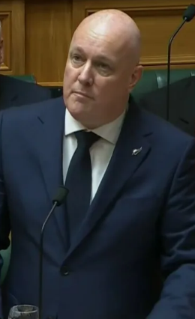
This Easy Read is a summary of the public apology made by the Prime Minister of New Zealand Christopher Luxon.


A summary:
- is shorter than the original
message
- tells you what you need to know.
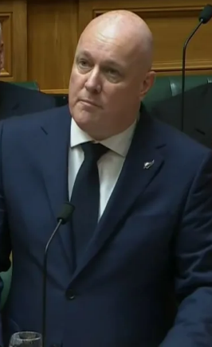

This document includes some quotes from Prime Minister Christopher Luxon.

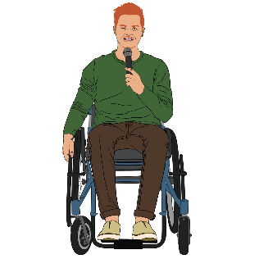
A quote is an exact copy in writing
of what someone has said.
“Hello”

The quotes are in yellow boxes like this.
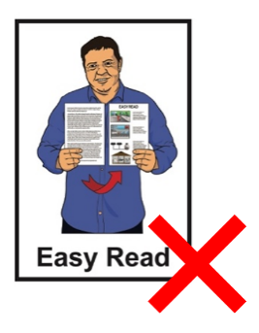

The quotes are not in Easy Read.

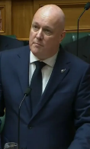

The full speech by Prime Minister Christopher Luxon is in other formats including:
video

Braille
Large Print.


You can find these versions of the full speech at this website:

abuseinquiryresponse.govt.nz/
for-survivors/public-apology-to-survivors-of/

The apology from the Prime Minister Christopher Luxon

Prime Minister Christopher Luxon said:

“Today I stand before you as the representative of not only this Government, but all of the governments that have gone before us to offer a formal and unreserved apology for the abuse you suffered while in state care, churches and other faith-based places.”

Here formal means something done in an official way.


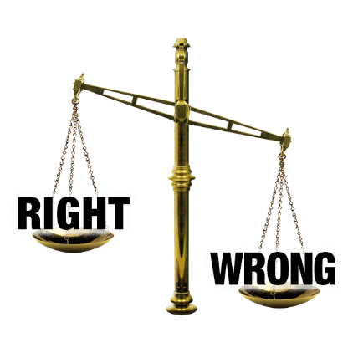
Unreserved means:
full
complete
honest.


Prime Minister Christopher Luxon said that:

it was his duty to recognise the abuse
recognises it should have happened a long time ago
he apologises on behalf of the Government.

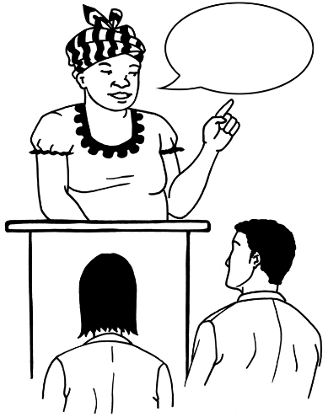
Recognise means someone says they:
understand something happened
and
talk about it.

“I am sorry you were not believed when you came forward to report your abuse.”

“I am sorry the State’s oversight of people in care was so poor.


I am sorry that many abusers were not made to face justice which meant that other people experienced abuse that could have been prevented.”

Here oversight means to:
watch what is going on
check that people are doing their jobs well.

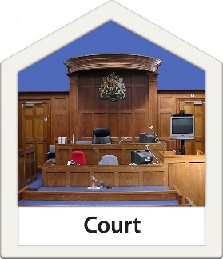
To face justice means things like:
going to court
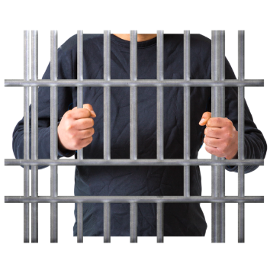
being punished for doing something wrong like going to jail.

“I am sorry the State did not act quickly and boldly enough to put much better protection in place for people in all care locations, and that those acting on behalf of the Crown lost sight of you.”

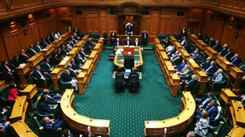
Here the State means:
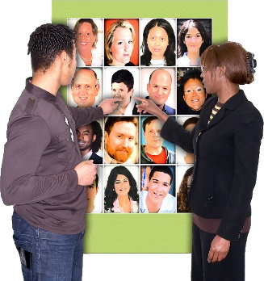
the government in charge of a country
people who work for the government.

Here the Crown means the New Zealand government.

“Some people suﬀered even more harm because of who they were.

Many Māori, Paciﬁc, deaf and disabled people suﬀered harsher treatment than others.
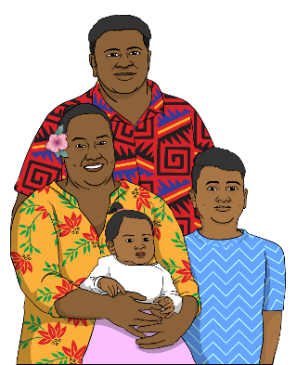

Māori and Pacific children suﬀered racial discrimination and disconnection from their families, language and culture.”

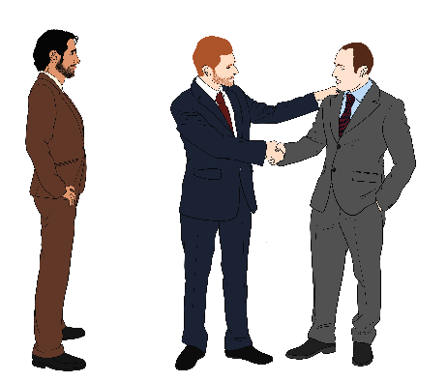
Racial discrimination is when people are treated unfairly because of their race.

For example they might be treated unfairly for being:
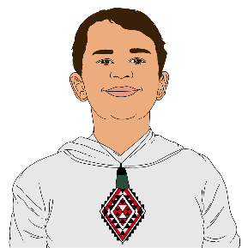
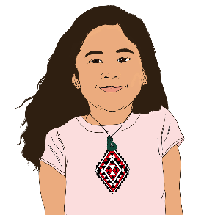
Māori
Pasifika.

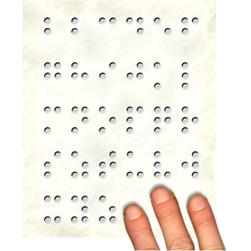
“Blind children were denied access to books in braille.

Deaf children were punished for using sign language.

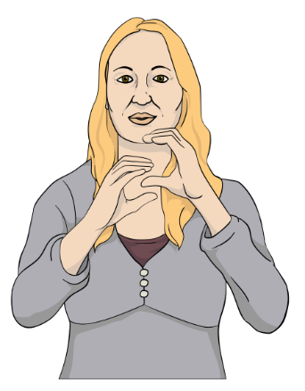
Children and vulnerable adults with intellectual disabilities were not supported to learn or communicate.

Some children and adults in care were targeted because of their sexual orientation or gender identity.”

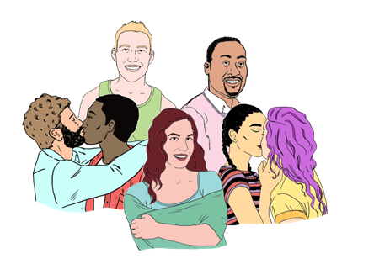
Sexual orientation means the gender of the people you:
are attracted to
want to have sex with.

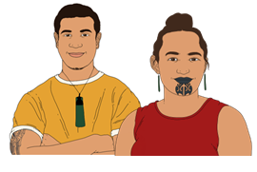
The genders we hear about most are:
man
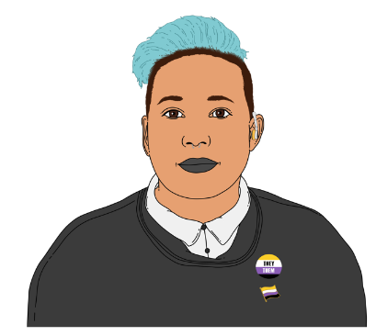
woman
non-binary which means people who are not a man or woman.


Gender identity means:
- how you feel about your gender
- what it is like to live with your gender.

“Some mothers were pressured or coerced by the State to give up their babies for adoption, often leading to long years of mental suﬀering for them and the children they were forced to give up.”

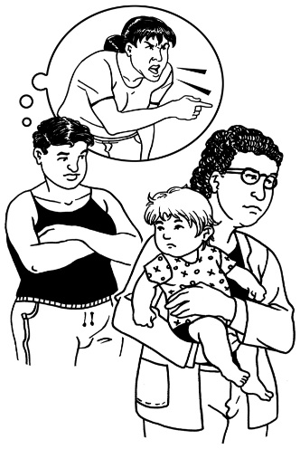
Coerced means being made to do something using:
force
threats.

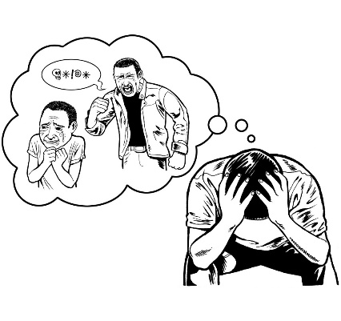
Prime Minister Christopher Luxon said he understands the abuse had a very bad impact on:
survivors
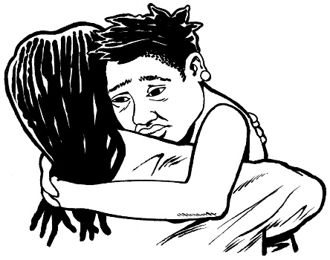
and
the families of survivors.

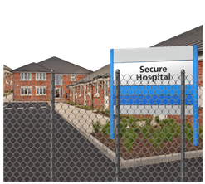
Prime Minister Christopher Luxon apologised to the survivors who were tortured at Lake Alice.


Prime Minister Christopher Luxon said he understands survivors had a very hard time getting help from government agencies when they reported their abuse.

“Many of you were denied knowledge of what happened to you because record keeping during your time in care was so poor or deliberately inaccurate.”

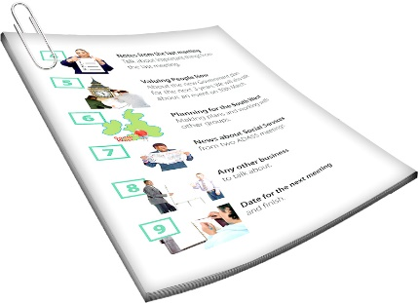

Here deliberately inaccurate means making information wrong on purpose.

“Your own personal information was often withheld, destroyed, lost, or wrong or incomplete.


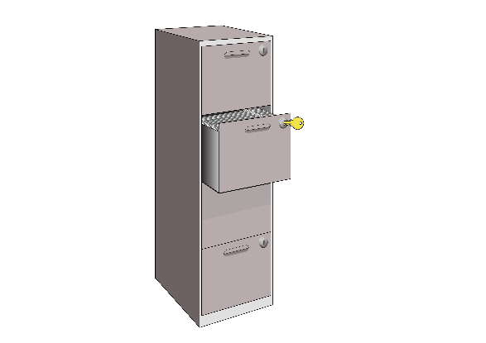
Often there was no record of your ethnic origins, your family and whānau, the harm you experienced, the complaints you made, your medical treatments, or what social workers said about you.”

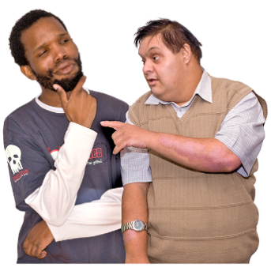
Prime Minister Christopher Luxon said he has told church leaders:
what he expects them to do
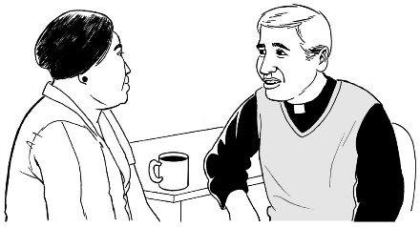
that they should be part of the redress system.

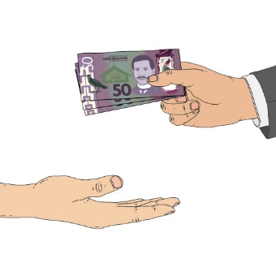
Here the redress system means giving survivors:
money
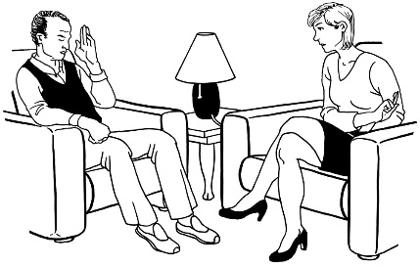
support for the problems the abuse caused in their lives.

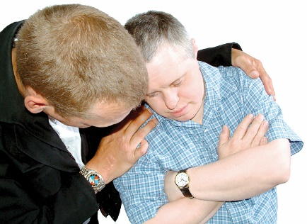
The 2 big lessons from the Royal Commission of Inquiry were the Government should:
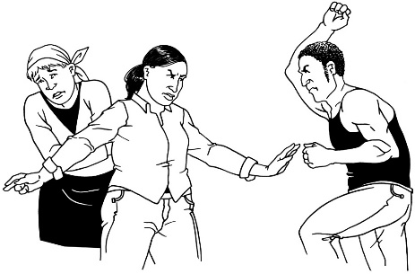
do the right thing by giving survivors support
stop abuse from happening in the future.


The future is a time that is yet to happen.

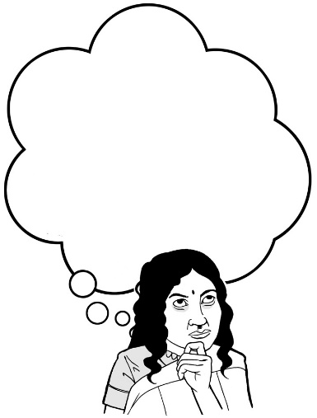


Prime Minister Christopher Luxon said the Government was thinking carefully about the 1 hundred and 38 recommendations from the
Royal Commission.

Here recommendations means things that would be good to do to make things better.
“I am pleased to announce today the Government has completed or started work on 28 recommendations in the report.

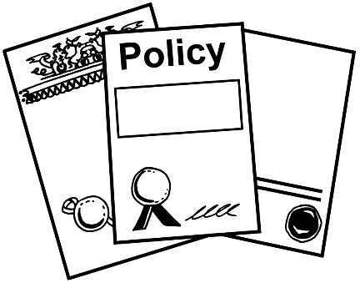
To demonstrate our commitment to change, this afternoon a Bill, that will introduce a range of measures to improve the safety of children and vulnerable adults in state care, will have its first reading in Parliament.”
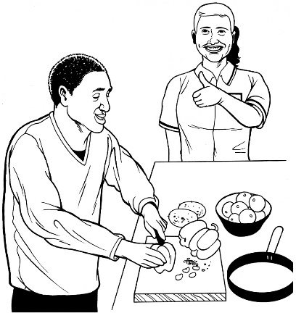
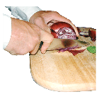

Here demonstrate means showing that you are doing what you said you would.

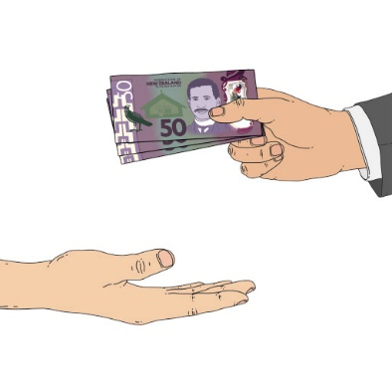
The Government will:

put 32 million dollars more into the redress system that is happening now
have a new redress system going next year
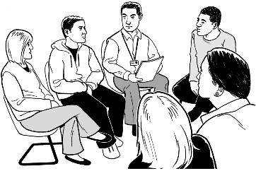

give 2 million dollars to support organisations working with survivors.

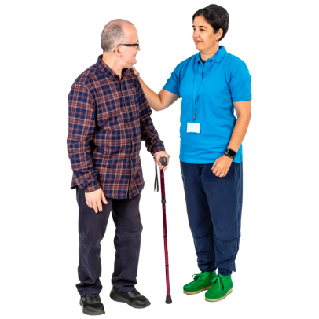

This is so it is easier for survivors to get support.

“One of the most important things we can do in light of the Royal Commission of Inquiry is improve safeguards to prevent the abuse of children and vulnerable adults in care.”



The Government is making changes like:
stopping the strip search of children in care

new rules about checking what people are bringing with them when they visit youth justice facilities
restricting who can work with young people.


Strip search means making people take off their clothes when they are being searched for things like:
weapons like knives
drugs.

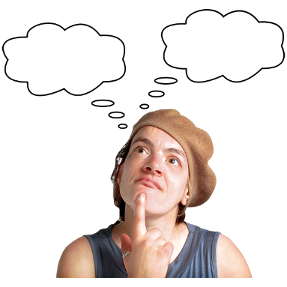
Here restricting means to be very careful about choosing something.

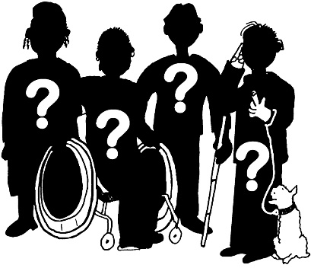
There will be changes made to the Crimes Act that will:
better show who disabled people are

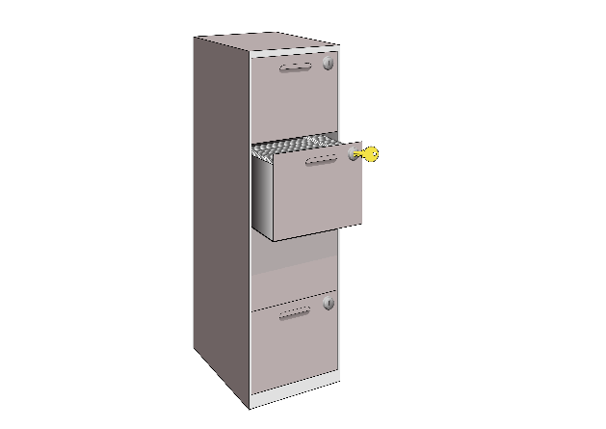
make record keeping at government agencies better.

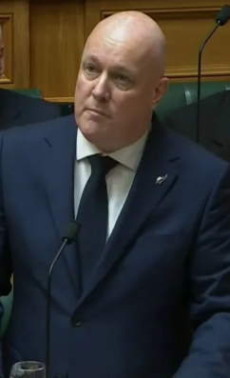
Prime Minister Christopher Luxon said:


“Today I am announcing a National Remembrance Day will be held on November 12 next year to mark the 1-year anniversary of this apology.

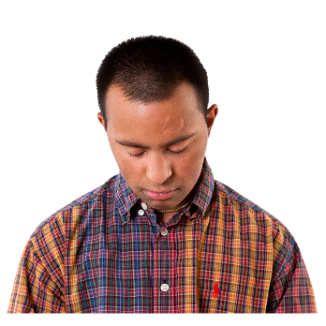
This will provide us with an opportunity to stop and reflect on what you endured and ensure we are doing all we can to prevent future abuse.”

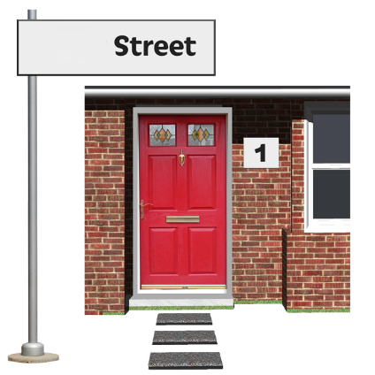
The Government is going to change the names of things named after people who were known to have been a part of the abuse like:
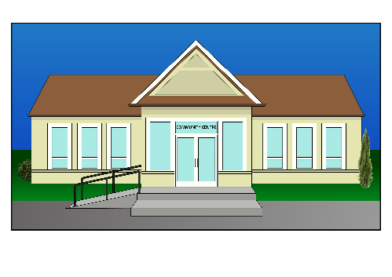
street names
public buildings like a library
public honours.
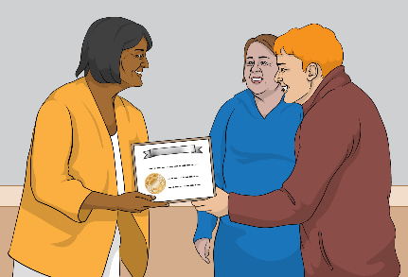
A public honour is being given a special award for doing a very important job.

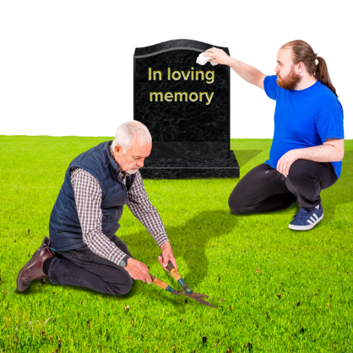
The Government will work with local authorities on unmarked graves at places where abuse happened to:
honour the people buried there
care for the graves.

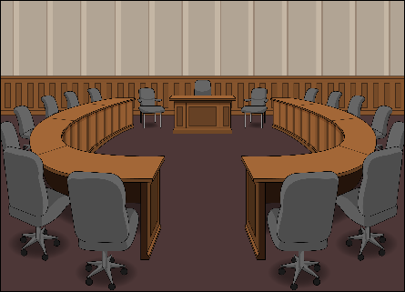
Local authorities means groups like:
councils in:
- cities
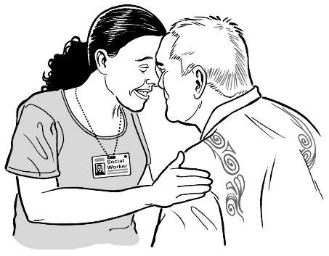
- towns
tāngata whenua / Māori leaders.


An unmarked grave is where a body is buried without:
a headstone
other people knowing they are buried there.

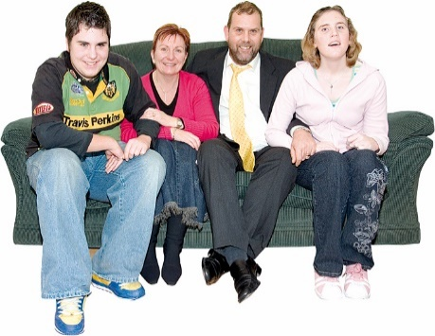
“I know there are survivors among you who have managed to overcome what happened to you and have gone on to lead fulfilling lives and have ensured abuse was never part of your own children’s lives.

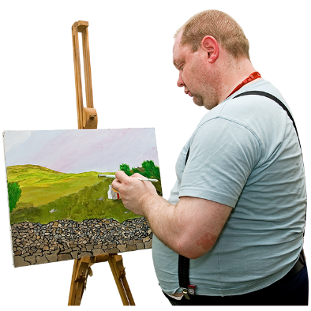
I applaud breaking that cycle that too often hangs like a curse over families.

It does not mean you have forgotten or forgiven what occurred.”
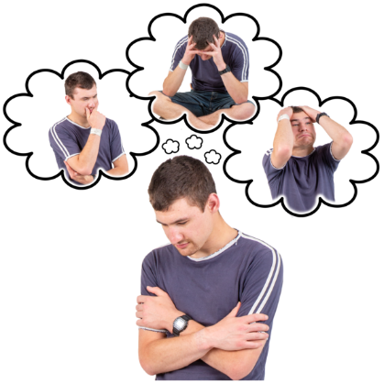
Here overcome means to:
deal with a problem
figure out ways to live with how the problem made you feel.


Here a fulfilling life means:
it is good
lots of interesting things happen
you are happy.

“It’s also about the future of others who may find themselves in care.

They will have a better experience thanks to your voice, your courage, and your persistence.”


Here persistence means to carry on doing something:
even though it is hard
until you get something changed.

“I would like to again thank those of you who told your stories.

You have been heard.


And you are believed.

You have helped achieve what you must have wished for yourselves – better protection to prevent the suffering of vulnerable and voiceless people.”


Prime Minister Christopher Luxon thanked:
the Royal Commission:
- staff
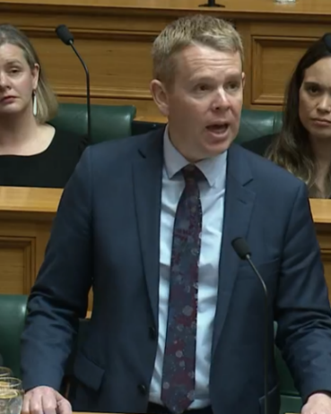
- commissioners
Leader of the Opposition
Chris Hipkins
the other political parties who had worked with the Government on the apology.

Prime Minister Christopher Luxon said:

“Finally, to the survivors of abuse in care, I hope this apology may help your healing.

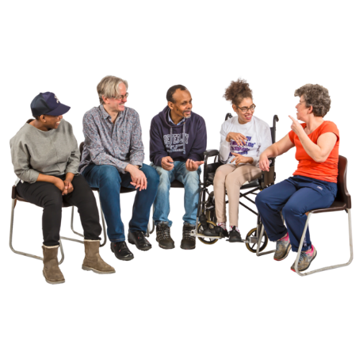
What happened is part of your life story, but not the only part.

This apology, which you may each take as personal, is now part of your story, too.”

This information has been written by Prime Minister Christopher Luxon.


It has been translated into Easy Read by the Make it Easy Kia Māmā Mai service of People First New Zealand Ngā Tāngata Tuatahi.

The ideas in this document are not the ideas of People First New Zealand Ngā Tāngata Tuatahi.
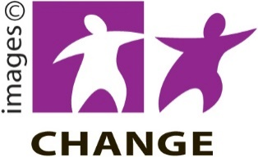
Make it Easy uses images from:
- Changepeople.org


            - Photosymbols.com



- SGC Image Works
- Huriana Kopeke-Te Aho
- T. Wood.

All images used in this Easy Read document are subject to copyright rules and cannot be used without permission.

